Nintendo: Competing on Global Video-Game Devices and Content

First Draft: January 29, 2020

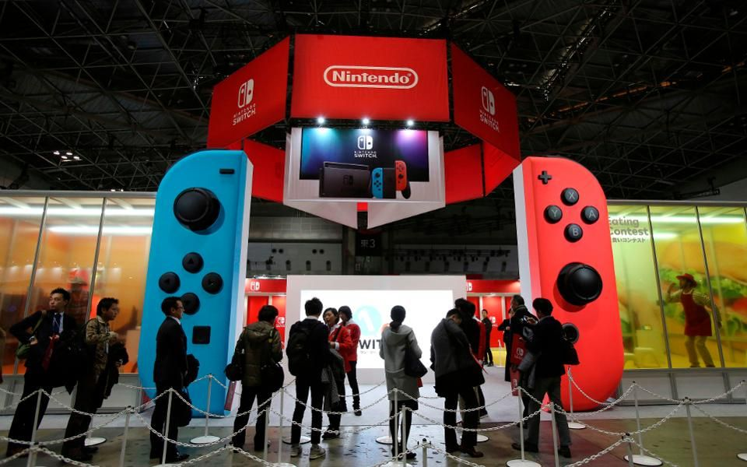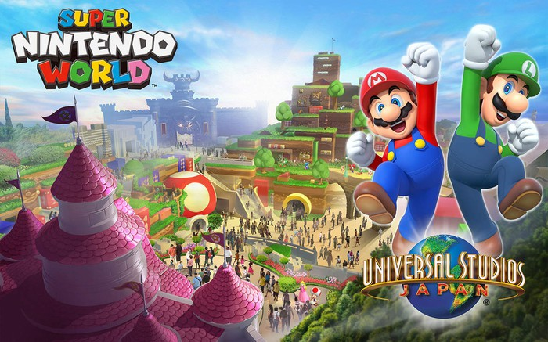

Current Situation
On its launch in October 2016, Nintendo Switch -- essentially a tablet that players can drop in a dock to play video-games on the TV, or take with them on the go – became instant hit. Bolstered by its game title -- The Legend of Zelda: Breath of the Wild -- the console has sold nearly 37 million units. By the end of 2018 it was the fastest-selling console in the U.S.

While the Switch is nearly three years old, next-generation consoles from rival companies like Microsoft and Sony won’t hit store shelves until 2020 at the earliest. The new Switch Lite, a slimmed-down mobile-only version of the console, plus hotly anticipated games like Pokémon Sword/Pokémon Shield and Luigi’s Mansion 3, should help. Nintendo does try to be innovative on the hardware front, but at the end of the day, it really is their software and their IP that makes them successful.

Nevertheless, what happens when those new competitors arrive, with their superior graphics and other high-end specs? And what about games-streaming platforms like Google Stadia, which could obviate the need for consoles entirely?

In addition, Tencent is helping Nintendo break into the Chinese market, but it may be making a bold play for Nintendo's beloved characters in exchange. Nevertheless, is this exchange of IP for market entry worthy, from the perspective of Nintendo?

Looking forward, Nintendo is seeking Super Mario World -- a Nintendo-themed area of Universal Studios Japan is set to be completed before the 2020 Summer Olympics. This theme park venture jointly developed with US-based Comcast is untested yet. The same are both a new Mario movie and a new Nintendo megastore under way. For instance, can Nintendo do without repeating the disaster of Super Mario Bros. released in 1993, which made $20.9 million at the box office on a budget of more than double this revenue?

Profile of Nintendo
Ostensibly a video-game company, Nintendo is really an intellectual property (IP) company, converting people’s seemingly endless love of its characters into profit. Its rebound is also thanks to the Switch -- a hybrid console and mobile device that has resurrected Nintendo’s hardware business.

The surprise success of 2016’s Pokémon Go -- an augmented-reality (AR) smartphone game made in collaboration with Niantic -- injected new life into the company. That set the stage for March 2017, when Nintendo unveiled its latest big release: the Nintendo Switch, essentially a tablet that players can drop in a dock to play games on the TV, or take with them on the go.



The unsung hero of the Switch system is the controllers, which are called “Joy-Cons.” While they can be used like typical gaming controllers, their internal components — accelerometers, gyroscopes, infrared sensors — allow them to be used in all manner of bizarre, fun applications. Nintendo Labo, for instance, allows gamers to build their own controllers out of cardboard, using the Joy-Con as the “smarts.” With the company’s new fitness-focused Ring Fit Adventure, gamers put the Joy-Con in a ring-shaped workout accessory to break a sweat while playing.

At the helm during this transformative period is Shuntaro Furukawa, who in 2018 became Nintendo’s sixth president. At 47 years old, he brings a different generational perspective than his predecessor, Tatsumi Kimishima, who was 68 when he stepped aside and became an executive advisor. Having grown up with Nintendo’s earliest video games, Furukawa shares the nostalgia that many middle-aged gamers feel for the company’s creations. Furukawa joined Nintendo in 1994 in the accounting department and later worked at Nintendo of Europe in Germany.

Mobile-Content Production
December 2016 witnessed one of gaming’s most beloved characters jumping onto the platform with the biggest-ever installed base in the world: mobile. With Super Mario Run, however, Nintendo did not embrace the free-to-play monetization strategies synonymous with mobile games, which drove the success of mobile’s biggest games – e.g., Clash of Clans, Candy Crush, Fortnite, and more.

Instead, Nintendo stayed close to its roots. Worried that in-app purchases might not resonate with fans of previous Mario-related games, Super Mario Run has no in-game purchases. Users can download a small portion of the game for free and unlock the full game for a one-off fixed payment. This payment -- higher than mobile gamers are used to -- does not fit the Switch’s platform.
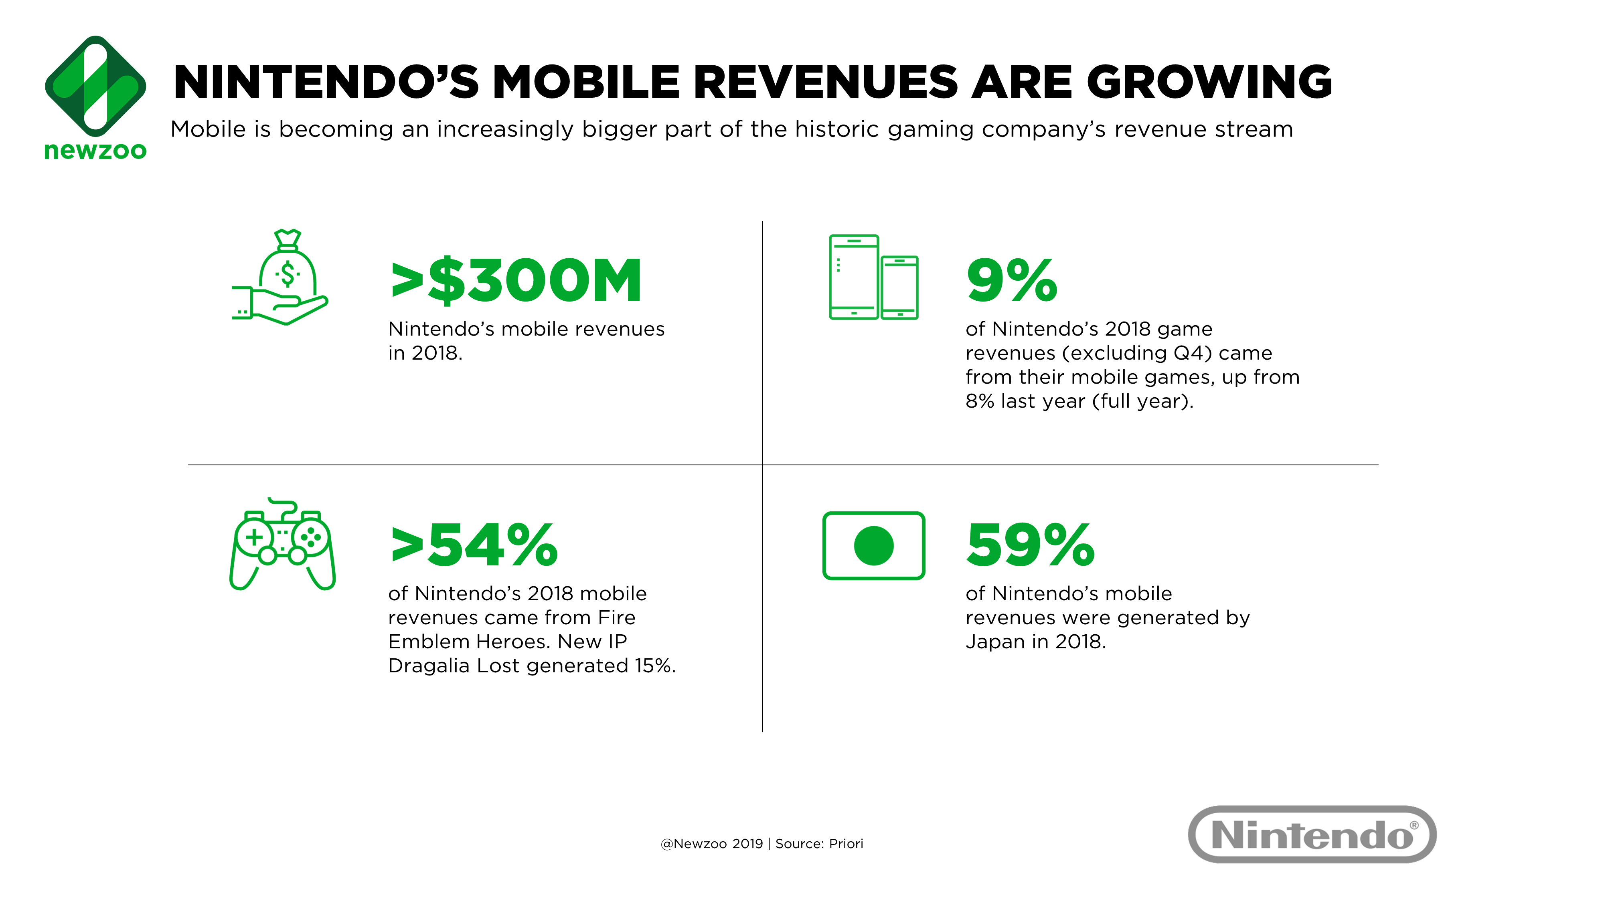

Nintendo’s next major release -- Fire Emblem Heroes – was launched in February 2017, just two months after the initial release of Super Mario Run. Fire Emblem is also an established franchise—particularly in Japan—but in the strategy/RPG genre, which is now one of mobile’s most prominent game genres. Unlike Super Mario Run, Fire Emblem’s monetization is more typical for the platform. The game is free to play and features an in-game currency (Orbs) that players can use to summon a random in-game character via the gacha monetization method, which is popular in Japan.

Though it has over 10 million downloads in 2018, Fire Emblem has far smaller installed base than Super Mario Run. Nonetheless, Fire Emblem generated over $200 million in 2018 —more than two-thirds of the company’s entire mobile revenues for the year. The game’s genre, aesthetic, and gacha monetization model resonated with mobile gamers, particularly in Japan.

In addition, Nintendo’s action RPG Dragalia Lost, was released in September 2018 and generated just under $50 million in 2018. What makes this even more impressive is that the game is a brand-new IP and was only available in Japan (66% of revenues), the U.S. (18%), Hong Kong (11%) and Taiwan (5%) in 2018. Despite not having a well-known franchise like Mario, or Fire Emblem attached to it, Dragalia Lost was Nintendo’s No.2 grossing mobile game in 2018.

The game ticks all the right boxes for mobile: it is a fast-paced title that can be played in short bursts. It also doubled down on the gacha monetization model, allowing players to unlock not only characters but also weapons and cosmetics. It was also the first mobile game that Nintendo did not co-develop with the game development partner -- DeNA. For Dragalia Lost, Nintendo partnered with Cygames, which has an impressive track record for gacha games.

Success on mobile can also affect a franchise’s performance across other platforms. Pokémon GO, while not directly published by Nintendo, was one of last year’s highest-grossing mobile games. It has also been a strong part of Pokémon’s renewed mainstream popularity, helping fuel the success and hype of 2018’s Pokémon Let’s Go titles for the Nintendo Switch, in addition to new Pokémon titles launching next year. It is a strong example of leveraging mobile to increase the popularity of franchises on console. Many big console/PC publishers are in the process of making their move into mobile, so all eyes are on Nintendo and its successes and failures on the platform.

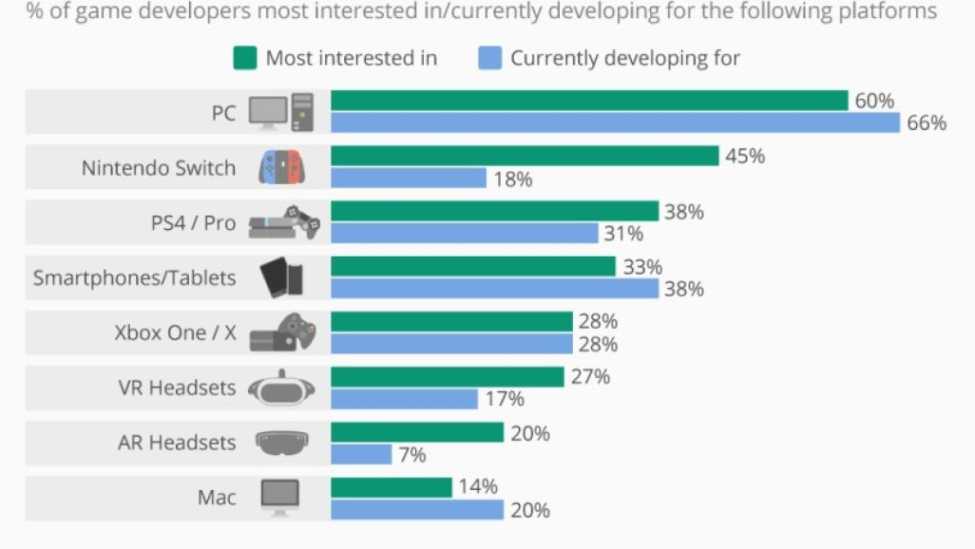

Finally, Nintendo Game Content Guidelines released officially in November 2018 are stated as follows. First, you may monetize your videos and channels using the monetization methods separately specified by Nintendo. Other forms of monetization of our intellectual property for commercial purposes are not permitted.

Second, we encourage you to create videos that include your creative input and commentary. Videos and images that contain mere copies of Nintendo Game Content without creative input or commentary are not permitted. You may, however, post gameplay videos and screenshots using Nintendo system features, such as the Capture Button on Nintendo Switch, without additional input or commentary.

Third, you are only permitted to use Nintendo Game Content that has been officially released, or from promotional materials officially released by Nintendo (such as product trailers or Nintendo Directs).

Fourth, if you want to use the intellectual property of a third party, you are responsible for obtaining any necessary third-party permissions.

Fifth, you are not permitted to imply or state that your videos are officially affiliated with or sponsored by Nintendo.

Last but not the least, we reserve the right to remove any content that we believe is unlawful, infringing, inappropriate, or not in line with these Guidelines.

Blockbuster Hardware Developments
The Switch, which was released in March 2017, has broken numerous sales records in its first year. The Switch is the exclusive home of some of today’s most well-reviewed games, and fans love that they can carry it around with them on their commutes or vacations. Nintendo, arguably stronger than ever and with a stock price flirting with its five-year high, is now looking for yet more ways to tap its deep bench of IP, from a theme park to a feature-length film.

Early in 2018, Nintendo announced that the Switch had become the fastest-selling console in U.S. history, and beat out all other rival consoles to be the top-selling console in the U.S. in December 2017. In Japan -- another important market -- its sales figures increased steadily throughout 2017, and global sales surpassed 10 million units in its first nine months. Nintendo recently said it expects to sell more than 15 million units by March.
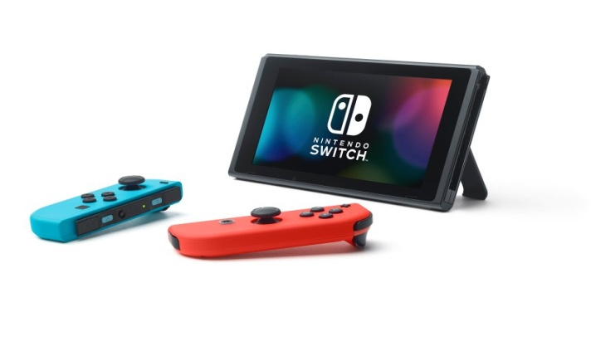
The success of the Switch was unexpected, mainly due to its ill-fated predecessor, the Wii U. The story of that console is almost antithetical to that of the Switch. In the UK, the Switch has outsold the Wii U already, despite only being on sale for 11 months, versus the five years the Wii U was available.

"Unfortunately what ended up happening was that tablets themselves appeared in the marketplace and evolved very, very rapidly," Shigeru Miyamoto, Nintendo executive and creator of Mario told NPR in 2015. "The uniqueness of [the Wii U's tablet] features were perhaps not as strong as they were when we had first begun developing them.”

Nintendo’s recent resurgence and subsequent stock price jump has been built largely on the back of the new console. The popularity of the Switch, which was far from guaranteed according to many industry commentators, was achieved thanks to a few key factors.

First is the Switch’s cheap, simple hardware. The console cannot (and does not expect to) compete with Microsoft’s XBox One, or Sony’s PlayStation in terms of processing prowess. Its internal components are outdated next to those consoles, incapable of running many of the latest AAA titles. However, the Switch has a trick up its sleeve, which has proven to be a major selling point: its modularity. The console exists basically as a tablet, which can be set into a dock and used on a TV, but which can also be seamlessly lifted out of that dock and played on the go. For Nintendo, a company with a long history of handheld gaming, this handheld/TV hybrid is an obvious next step, and one that has left its competitors trailing.

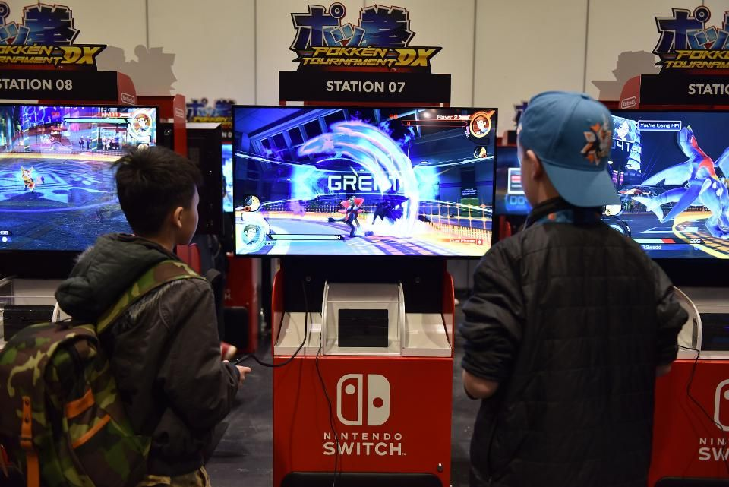

Thanks to this lack of reliance on new, expensive hardware, the console retails for much less than the XBox One or PlayStation 4 charged on launch. The Switch costs $299, while the PlayStation 4 launched for $399 back in 2013, and the Xbox One launched in the same year for $100 more. The updated version of each console, the XBox One X and the PlayStation 4 Pro, now cost $499 and $399 respectively.

Secondly, the Nintendo Switch has enjoyed huge success thanks to its lineup of popular game franchises. The Legend of Zelda: Breath of the Wild was hailed as Game of the Year for 2017. One of its closest rivals for the top spot was Super Mario: Odyssey. Both are available exclusively on the Switch. That’s not to mention other family-friendly favorites, such as Mario Kart 8 or Splatoon 2 (also exclusive to the Switch), or the upcoming Nintendo Labo, which will allow players to build and play with interactive models made from cardboard.

However, the company will be treading carefully while planning the successful transition of the third highest-grossing video game franchise of all time: Pokémon. Although Pokkén Tournament (a spinoff Pokémon fighting game) has already debuted on the system, the next fully-fledged entry in the popular series was confirmed to be coming to the Switch ahead of the console's launch. Although no release date or official announcement has been made, rumors suggest it will appear this year. The Pokémon series produced three of the top four selling games for the Nintendo 3DS, with more than 45 million games sold over the past three installments -- but some fans are wary of the move to a new console now.

“We haven’t had a jump like this since the GameBoy to the GameBoy Advance, which disconnected past generations from future generations of Pokémon games,” said Steve Black Jr., a Pokémon podcaster and live streamer. “I don’t believe The Pokémon Company will make that mistake again, but once something is shown, I think the people who are hesitant will be ready to fork out the money to jump onto the Switch bandwagon.”

Finally, Nintendo has won over third-party developers, something the Switch’s ill-fated predecessor was unable to do. The console has received backing from developers such as EA, Ubisoft and Bethesda, who have brought third-party titles like FIFA 18 and Wolfenstein 2 to the platform. This is in stark contrast to the Wii U, which struggled to attract large titles thanks to its poor sales, leaving Nintendo heavily reliant upon its own games to market the system.

The company is also ramping up online support for the Switch, an area that was oft-criticized on the Wii U. Nintendo Switch Online will launch in September 2018 and costs just $19.99 per year. “I think the real selling point for the new games are the online features,” said Black. “With games like Pokémon GO existing and doing online so seamlessly, it would be great to have an even easier way to play with others from your home.”

Mobile games, a new foray for the company, have seen continued growth as Nintendo has built out its offerings in the space. Traditionally reticent about bringing its coveted franchises to other platforms, the company launched Mario Run in late 2016. Despite its more than 20 million downloads, the game had not reached “an acceptable profit point” by the end of 2017, but more recent efforts, such as Fire Emblem Heroes, have been quiet mobile hits, and the company recently announced that the enormously popular Mario Kart would be making its way to mobile in 2018.

According to the Wall Street Journal, Nintendo intends to partner with more mobile developers in the coming year, and research has shown its mobile offerings help to serve as a pathway for console purchases for more casual gamers. For example, Nintendo has seen a rise in sales of Animal Crossing games since its fourth mobile game Animal Crossing: Pocket Camp was released in November 2017.

Having come from a low ebb in the wake of the Wii U’s dismal performance, it appears that Nintendo has gone back to its roots, with originality and creative gameplay emphasized over all else. It’s a formula that has so far proven very successful less than 12 months into a projected six-year lifespan.

Strategy Evolution of Nintendo
Under the incumbent CEO Furukawa’s leadership, Nintendo is committed to a strategy that has both helped and hurt the company in the past: A steadfast commitment to experimentation. Nintendo trusts its teams to experiment with freedom. Expansion can’t happen without the freedom to try something new, and the courage to step into unfamiliar territory. The cornerstone of Nintendo consists of game content, characters, and IP.

Back in the mid-2010s, Nintendo was in dire straights as it became clear the company’s flagship console at the time, the Wii U, was failing. With a “second screen” embedded in the controller, the system was a curious experiment, but a lack of compelling third-party games dampened sales. Nevertheless, the surprise success of 2016’s Pokémon Go injected new life into the company. That set the stage for March 2017, when Nintendo unveiled its latest big release: the Nintendo Switch, essentially a tablet that players can drop in a dock to play games on the TV, or take with them on the go.

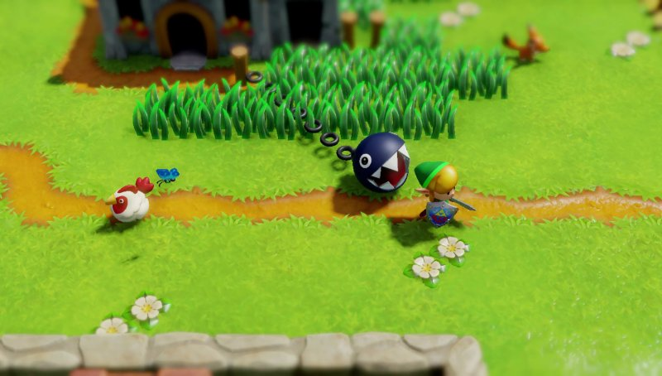

If the Wii U showed how Nintendo’s experimentation can go very wrong, the Switch is showing how it can go very right. Bolstered by game of the decade contender The Legend of Zelda: Breath of the Wild, the console was an instant hit. Nintendo has sold nearly 37 million Switch units; by the end of 2018 it was the fastest-selling console in the United States.

Furthermore, Nintendo Switch’s success relies mainly on quality content and usability. On the one hand, Nintendo Switch offers a Netflix-like, all you can eat, platform called Nintendo Switch Online with over 60 high-quality games for a $20 per year subscription fee. For example, it includes the famous The Legend of Zelda: Breath of the Wild, or Super Mario Odyssey, both highly rated by critics and fans. Many video game players believe Nintendo Switch is the only place to play the best games.

This game-streaming service was launched in September 2018; since then Nintendo has added new quality games every month. This investment in content production is the key to Switch’s success. In entertainment, consumers pay for quality content, now more than ever. With the Internet offering thousands of options to spend leisure time, entertainment companies need to compete more fiercely to retain the user’s attention.

On the other hand, Nintendo Switch is powerful and easy to use. Unlike its predecessors, Nintendo Switch is portable and, as such, it feels personal. Users can easily pause a game they are playing on the TV but pick it up again on their commute. Switch can become a personal accessory, very much like the smartphone. With its portability, players can use it all day long, show it to friends, and take it with them on their holidays.

Finally, Nintendo is seeking Super Mario World -- a Nintendo-themed area of Universal Studios Japan is set to be completed before the 2020 Summer Olympics. This theme park venture jointly developed with US-based Comcast. Nintendo has built around adored IP that’s in the theme parks, movies and merchandize businesses, which sounds like Disney. CEO Furukawa indicates that the theme park venture does not try to imitate peers, and is simply an extension of Nintendo’s corporate philosophy: A steadfast commitment to experimentation.

Global Video-Gaming Market
Now more than ever, gaming is at the heart of the entertainment business. The way consumers engage with and through games is constantly changing. Not only does this result in more overall engagement, but it also leads to entirely new segments of game enthusiasts. There are now more than 2.5 billion gamers across the world. Combined, they will spend $152.1 billion on games in 2019, representing an increase of +9.6% YoY (year-on-year).

Console will be the fastest-growing segment this year, growing +13.4% year on year to $47.9 billion in 2019. This is the second year running that growth in console games will outpace mobile gaming growth. Last year’s regulatory changes in China, as well as the absence of new global blockbusters, signaled slowed growth for mobile games. What’s more, rising anticipation toward the next generation of consoles will slow down the market during the second half of the year.

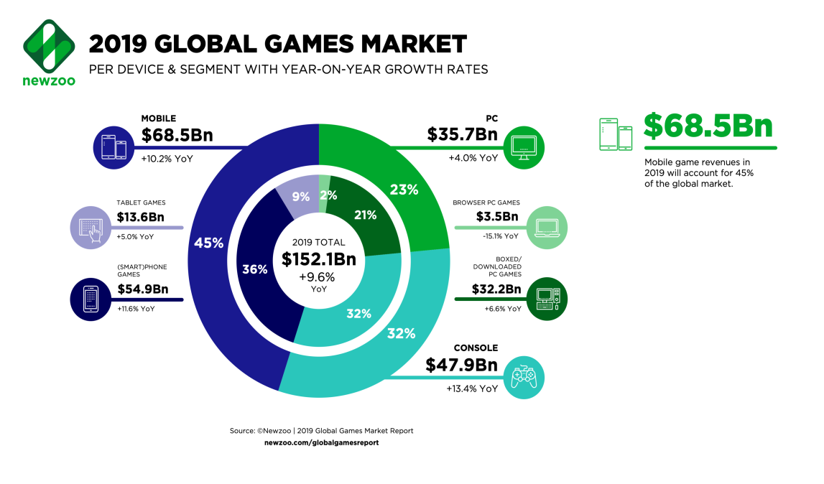
Mobile gaming (smartphone and tablet), meanwhile, remains the largest segment in 2019, growing +10.2% year on year to $68.5 billion—45% of the global games market. Of this, $54.9 billion will come from smartphone games. PC gaming will be both the smallest and slowest-growing segment, increasing +4.0% year on year to $35.7 billion. Despite the segment being smaller in size, PC’s status as the bedrock of innovation in the games market remains evident to this day. Nearly all of the most popular game genres, including battle royale and MOBA, can trace their roots back to PC gaming’s modding community.

In 2019, the U.S. will overtake China as the world’s largest gaming market by revenues. Overall, the U.S. games market will generate $36.9 billion this year, predominantly driven by its +13.9% growth in console game revenues. At $18.5 billion, console represents more than 50% of the total games market in the U.S.. Meanwhile, China’s nine-month licensing freeze on new games, as well as measures to reduce screen time among children, was deeply felt throughout 2019. Publishers, however, are now able to monetize their new games once more, but the consequences of the freeze and new approval process will still impact growth in the Chinese market in 2019. Japan, Korea, and Germany ranked from No. 3 to No. 5 for the same year.

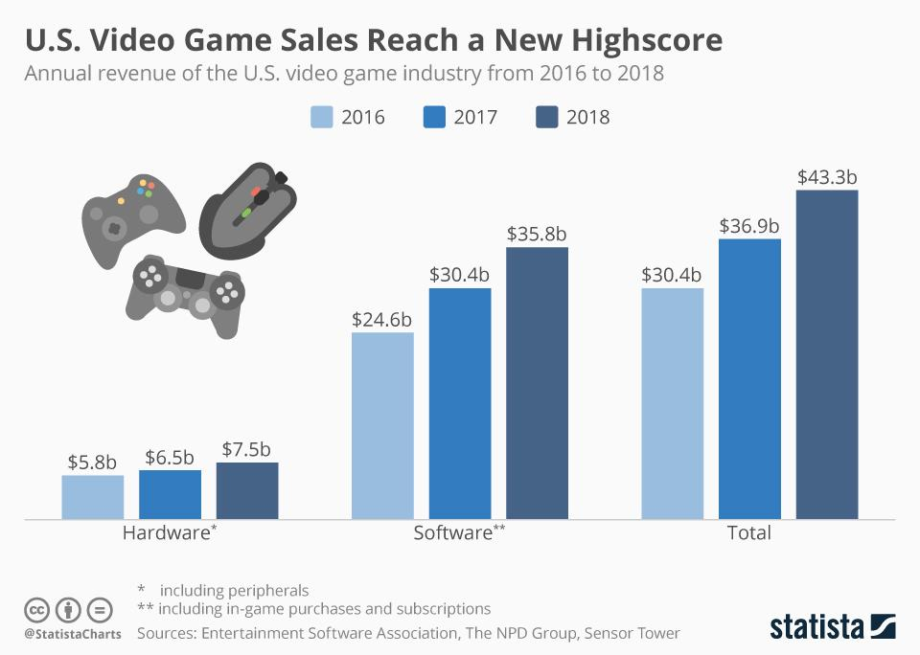

Looking forward, mobile gaming will generate revenues of $95.4 billion in 2022 and account for almost half of the entire games market. This will be driven predominantly by smartphones, with revenues of $79.7 billion by 2022. Although mobile is indeed still the world’s fastest-growing video-game market segment, growth is slowing in mature markets such as North America, Western Europe, and Japan. Emerging markets, including Southeast Asia, India, and Middle East & North Africa, will contribute most to the segment’s growth. However, a range of other factors are also contributors, including more cross-platform titles, more smartphone users, and improvements to both mobile hardware and mobile Internet infrastructure, including the rollout of 5G networks.

Revenues generated by the console segment will reach $61.1 billion in 2022, increasing with a CAGR of +9.7%. These revenues will dip slightly from the second half of 2019 to 2021, as the imminent release of the next-generation Xbox and PlayStation consoles will see consumers spending most of their gaming budget on hardware. However, the upcoming new Switch models, as well as the massive installed base of the previous (now current) console generation will contribute to healthy growth in the segment.

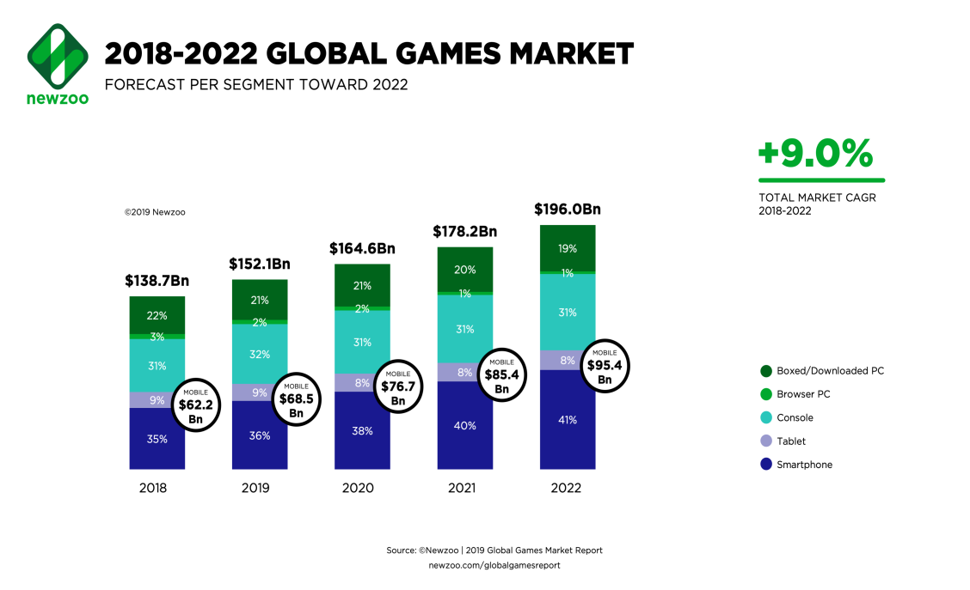

The overall PC gaming market will grow with a CAGR of +3.5% to total $39.5 billion by 2022. The ongoing consumer shift from browser PC games to downloaded/boxed PC games will reduce the browser segment’s revenues by almost half from 2018 to 2022. Downloaded/boxed PC games, though, will grow with a CAGR of +5.4%, generating $37.3 billion by 2022.

Growth in mobile game revenues will continue to outpace growth on PC in the coming years, resulting in a shrinking PC market share toward 2022. Mobile will also outpace console’s revenue growth; yet, console’s market share will remain relatively static.

Competitive Dynamics in Global Video-Gaming
The video-gaming business is changing fast -- 4K gaming, augmented reality and virtual reality. Marketers are paying attention by advertising their content on Amazon-owned Twitch and YouTube games. Game companies compete for users’ money, time, and attention as any other form of media and entertainment. The threats are many, but the toughest one comes from their smartphone competitors.

Thus, gaming companies must differentiate their hardware from that of tablet and phone manufacturers. They must upgrade their game offerings and avoid being overtaken by manufacturers of portable devices than can be used to play games. For the moment, companies like Nintendo differentiate their product clearly, through great unique content and hardware specifically designed to play games.

Nintendo ended 2017 in style as it posted record-breaking revenues of $9.2 billion for the full year, growing 172% year on year. This performance is enough to push Nintendo back into the top 10 gaming companies by software revenues for 2017 after an absence of three years. The Switch was the main driver of this success, with 60% of Nintendo’s revenues in 2017 generated by hardware sales. This is drastically different from Sony and Microsoft, whose hardware sales accounted for an estimated 34% and 26% of their 2017 revenues, respectively.

Most remarkable is that Nintendo generated these revenues with hardware and full-game sales only. The contribution to its gaming revenues from its smart-device business (responsible for Nintendo’s mobile games) was negligible at 3%, while subscription revenues and revenues from in-game transactions were almost non-existent. In this sense, Nintendo remains a very traditional gaming company in an industry that is rapidly changing, and not in the least by adopting the games-as-a-service model.

Subscription revenues have been very strong for Sony and Microsoft, while in-game transactions are the main growth driver for dominant Western publishers such as Activision-Blizzard, EA, Take-Two Interactive, and Ubisoft. In Japan, Konami, Bandai Namco, and Square Enix are shifting focus to mobile games, which are hugely popular (and profitable) in their domestic market.

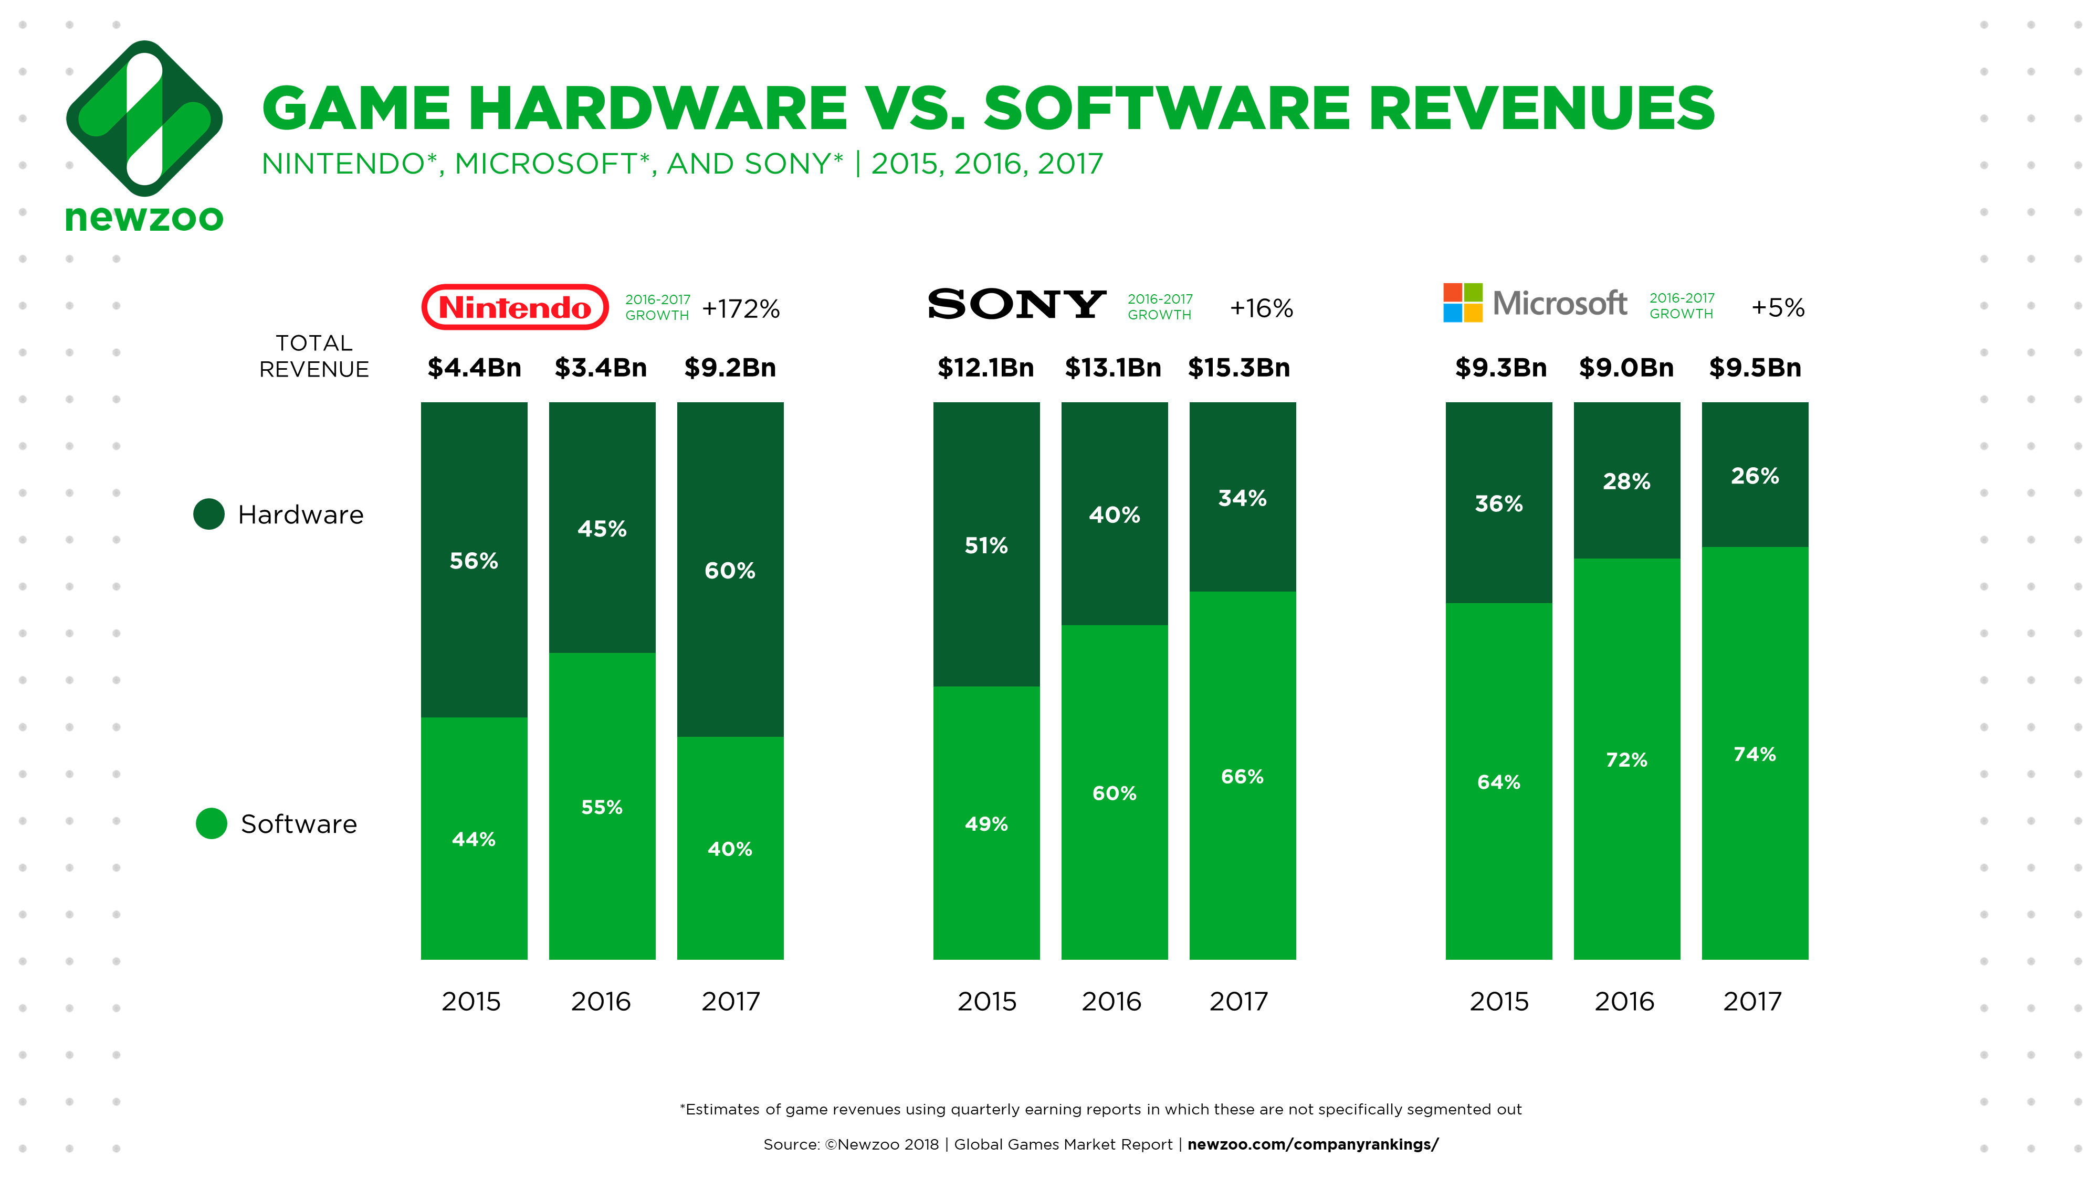

The share of Nintendo’s revenues from digital products and channels was only 16%, far lower than most of its peers. The industry average share of digital revenues for console game software in 2017 was 66%, up from 58% in 2016. The future for Nintendo is surely also digital and there are three obvious areas on which to focus.

Subscriptions, in-game transactions on console, and mobile gaming are untapped revenue streams that represent an extraordinary opportunity for Nintendo. Now that the Switch has been successfully launched, 2018 could well be the year that Nintendo succeeds in making serious progress in all three areas. The upcoming Mario Kart Tour for mobile devices and the launch of Nintendo Switch Online announced for September 2018 make it clear that Nintendo is eager to capture this opportunity. Together with the organic growth of its console software revenues, this could be worth $2.5 billion for the company. The big open question remains when and to what extent Nintendo will fully embrace in-game spending, both for console and mobile.

Just a few years earlier, Nintendo’s competitors had released their own cheaper consoles – e.g., PlayStation4 from Sony, and Xbox One from Microsoft. The respective accumulative sales of these two peers sold more units than Nintendo Switch. On September 20, 2019, Nintendo released a cheaper portable-only version of Switch – i.e., Switch Light.

The launch of Microsoft’s and Sony’s new consoles expected to make their respective debut in 2020 may dampen Switch’s sales. Nevertheless, Nintendo has already proven that quality content and an easy-to-use device are still the best strategies to achieve success; at least in the short-medium term.

Partnership with Tencent for Entering China’s Market
In April 2019, aside from the anniversary of the release of its iconic Game Boy, which is currently marking its 30th year, Nintendo cut a new deal with China-based Tencent. The collaborative agreement allowed the Game Boy’s modern successor -- the Nintendo Switch -- to finally break into China, the world’s largest games market.The company sold 17 million Switch units in 2018, and projected that a further 18 million will be sold in the year to come.

The deal also hints at Tencent’s strategic expansion in the lucrative gaming sector, particularly amid increasing scrutiny by Chinese government censors. Year 2018 was a bruising one for many games publishers in China, where Tencent was no exception. A regulatory crackdown on video games halted the publication of new titles for more than 9 months. At the end of 2018, the Chinese government set up a new body to review the ethics of games published in China, and approvals have slowly begun to resume since then.

New regulations, revealed on April 10, 2019, limited the number of games published each year and placed strict restrictions on the types of games for approval. For example, Mahjong and poker games are not accepted. These types of games, which are believed by regulators to encourage illegal gambling, accounted for 37% of the titles published in China in 2017. Games featuring blood and gore will also be rejected.

Tencent’s latest deal, which will see the hit Nintendo console being sold in China for the first time, brings clean, family friendly content to China’s gamers in the form of gaming’s most beloved mascot -- Mario. Switch consoles sold through Tencent will be bundled with just one title initially -- New Super Mario Bros U Deluxe.

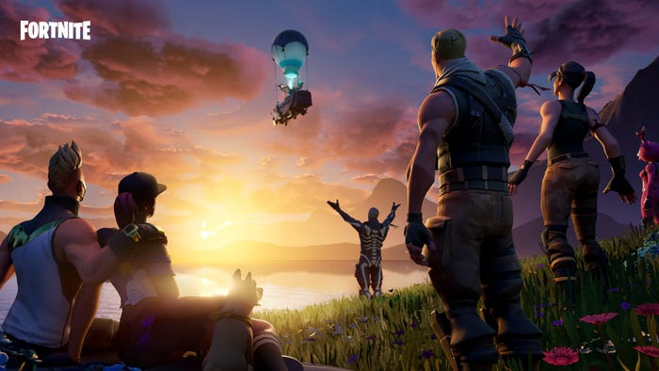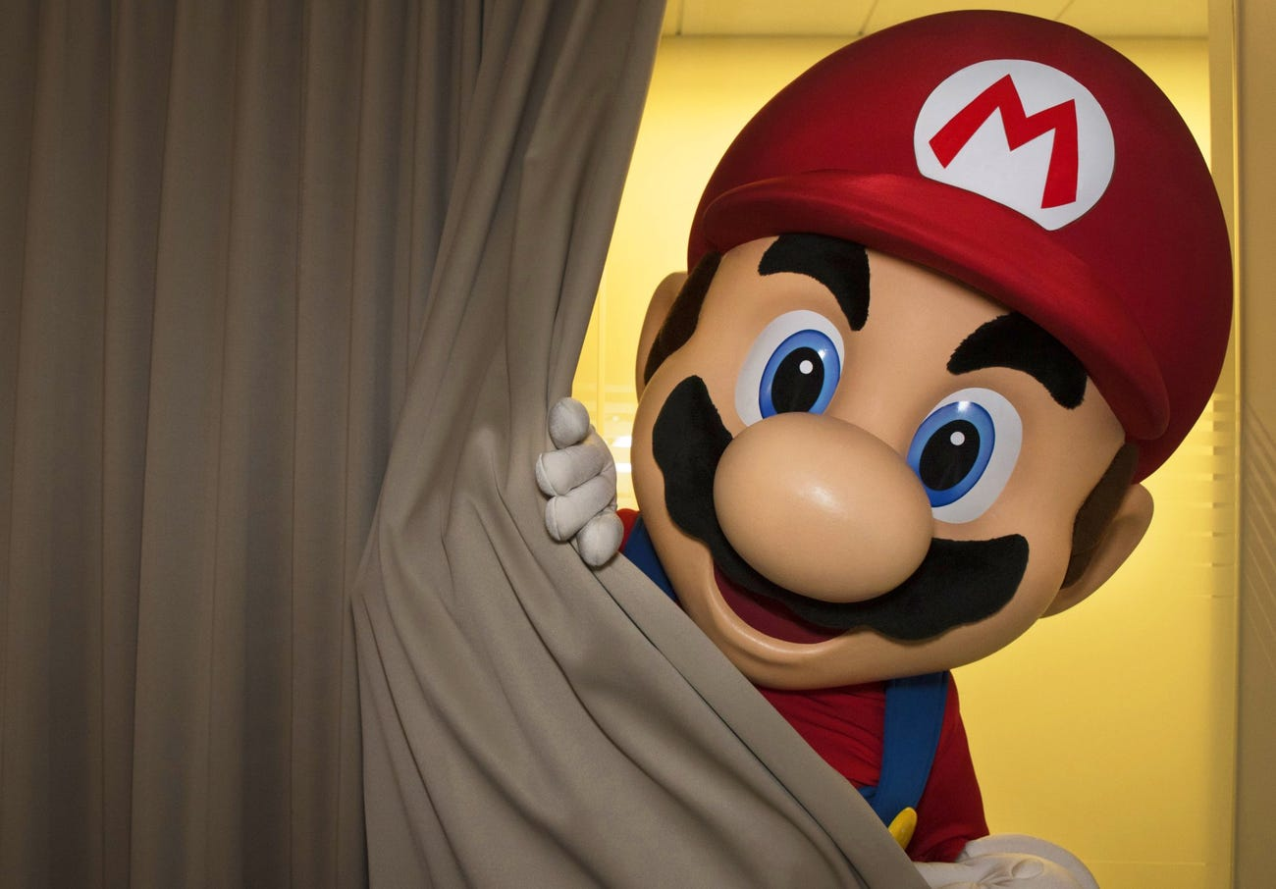

Originally published in 2012 for the Wii U and later brought to the Switch under a new title in 2019, New Super Mario Bros U Deluxe is exactly the kind of game China’s regulators appear to favor. This latest iteration of a traditional 2D Mario game is a high-quality platformer, appropriate for all ages–the type of game Nintendo has become synonymous with. The Japanese company’s roster of charming characters—from franchises like Mario, Pokemon, Zelda and Animal Crossing—haven’t been available to play in China since 2012, after an ill-fated joint venture known as iQue ceased publishing new hardware.

Now, however, both Nintendo and Tencent are now poised to benefit from what could ultimately be a fruitful partnership. “Nintendo has a lot of IP,” says Cui Chenyu, Shanghai-based analyst at IHS Markit. “If Tencent can adapt them for mobile, then they should be easier to get approved because Nintendo’s titles are more light-hearted than some of the hardcore battle games.”

For Nintendo, the deal opens up a pathway into the world’s largest games market. That market, although growth has slowed in recent years, is still increasing. “We estimate that China's games revenues will grow at a CAGR of +8.7% from 2017 to 2021—slightly lower than the global growth rate (+9.3%). To offset this slowed growth, it has become vital for Tencent to tap into more platforms and more gamer segments within its home market,” says Gu. “The Switch appeals to family gamers, a segment that is largely untapped by game and hardware companies—especially in China.”

Although the vast majority of China’s gamers are mobile or PC players -- consoles only accounted for 2% of China’s games market in 2018 -- the strength of Nintendo’s signature IP may cause some users to reconsider their purchasing habits. Importantly, the Switch can be played as both a portable handheld as well as a home console, giving it broad appeal in China’s mobile-first market.

Moreover, Nintendo’s console games have always been exclusive to Nintendo hardware, meaning the only way to play two of 2017’s most critically-acclaimed games, The Legend of Zelda: Breath of the Wild and Super Mario Odyssey, is on the Switch. This is not true of other top-selling titles, many of which are available across PC, Playstation and Xbox.

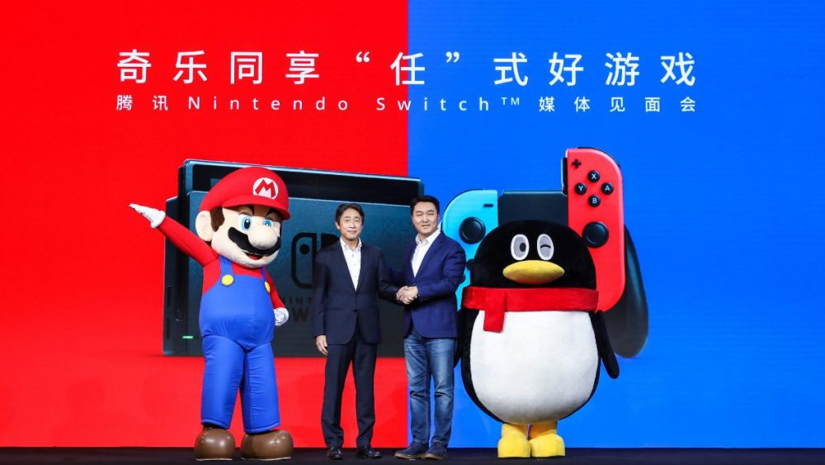

For Tencent, the upside of having some of the gaming world’s most beloved franchises under its banner is obvious. Aside from exclusive Switch hardware and software sales, Tencent will also be well-positioned to push Nintendo’s mobile titles to Chinese consumers. The outlook is in stark contrast to 2018, which saw the Chinese company record its first drop in profits since 2005 thanks to the gaming crackdown.

The Switch’s appeal should grow even further toward the end of 2019 as a new Pokemon title debuts on the system. Pokemon has proven time and time again to be a system-seller for Nintendo, and the release of Pokemon Sword and Pokemon Shield, expected in late 2019, will be no different.

Tencent may also be well-positioned to publish its own titles on the Switch globally thanks to the tie-up. Ghe deal could help Tencent’s globalization plans and could see Tencent bring some of its blockbuster titles, for example, Honor of Kings, to the Switch platform. Overall, Tencent is helping Nintendo break into the Chinese market, but it may makd a bold play for Nintendo's beloved characters in exchange.

Market and Financial Performance
In January 2020, Market Analyst Sensor Tower indicated that Nintendo’s mobile games had earned a combined $1 billion in revenue, up to January 26, 2020. This includes six games from Nintendo, starting with Super Mario Run in 2016. The latest, Mario Kart Tour, released in September. 2017’s Fire Emblem: Heroes is by far the most successful, which accounts for 61% of that $1 billion.

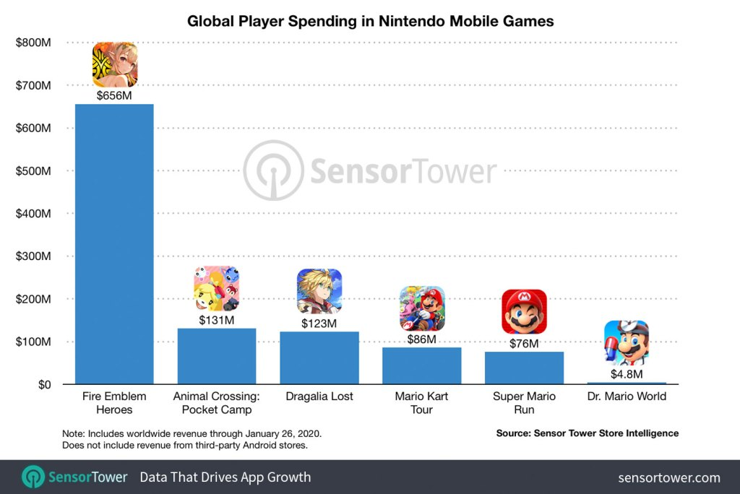

The three games with Nintendo’s main mascot’s name in them are performing the worst: Mario Kart Tour, Super Mario Run, and Dr. Mario World. The puzzle game Dr. Mario World is having an especially rough time, making up less than 1% of the $1 billion. Super Mario Run, which has more downloads than any of Nintendo’s other mobile offerings is the only premium game on the list. Paradoxically, its monetization strategy hurt its money-making potential – i.e., in-app transactions in free-to-play games dominated mobile, despite starring the most recognizable character in all of gaming.

Meanwhile, Dragalia Lost, is Nintendo’s only original IP for mobile, and the free-to-play RPG has managed to do well by earning $123 million. Nintendo’s mobile games have been most popular in Japan, with the country accounting for 54% of revenues. The U.S. comes next at 29%. Super Mario Run and Mario Kart Tour make most of their money in the U.S., but the other four bring in most of their revenues in Japan.

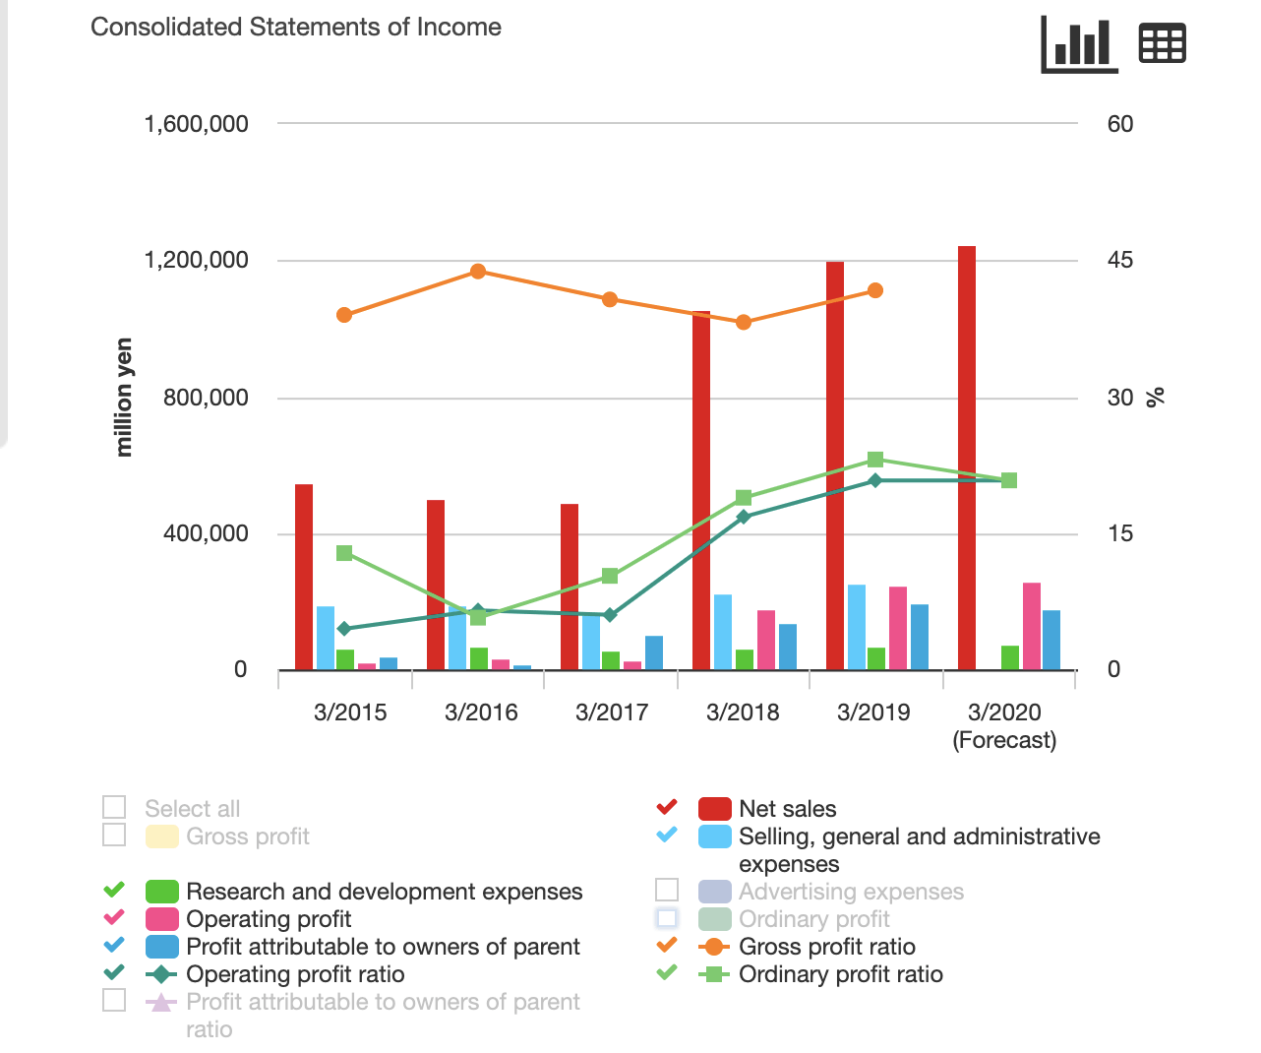

For Fiscal Year 2019, Nintendo has YoY revenue growth of 17.29% and has a strong financial position. The company owns some of the most popular franchises and is getting ready to exploit them further. Also, he gaming industry will continue to grow and if Nintendo can adapt as it has shown, it will produce growth and profits for years to come.

In 2017, Nintendo’s hardware revenues grew by 266% year on year to reach $5.5 billion, with 48% of these revenues earned in Q4 2017. This is more than both Microsoft and Sony, which earned $2.4 billion and $5.1 billion, respectively, with hardware. At 60% of total revenues, its share of hardware revenues is at the same time considerably higher than Microsoft’s and Sony’s. Part of this can be explained by the stage of the hardware cycle; Nintendo launched a new console in 2017, while Sony and Microsoft launched upgraded versions of their current generation.

Software sales typically follow hardware sales in the early phase of the console cycle. Nintendo’s software revenues in 2018 will likely grow stronger as console owners buy additional games for their brand new consoles. There is already a selection of popular titles to choose from, such as Super Mario Odyssey and Breath of the Wild, which are both considered “must buys” for every Switch owner. They are just two examples of Nintendo-exclusive games that surpassed the one million marks in unit sales in 2017.

Finally, if Nintendo were to release the confirmed Pokémon game for Switch in 2018, it would be the first core Pokémon game ever released on Nintendo’s TV console with a very high chance of becoming another blockbuster hit. Another boost to Nintendo’s console game revenues could come from enabling in-game transactions. Given the profitability of this business model for other publishers, it is almost unimaginable that Nintendo will stick to full game sales only.

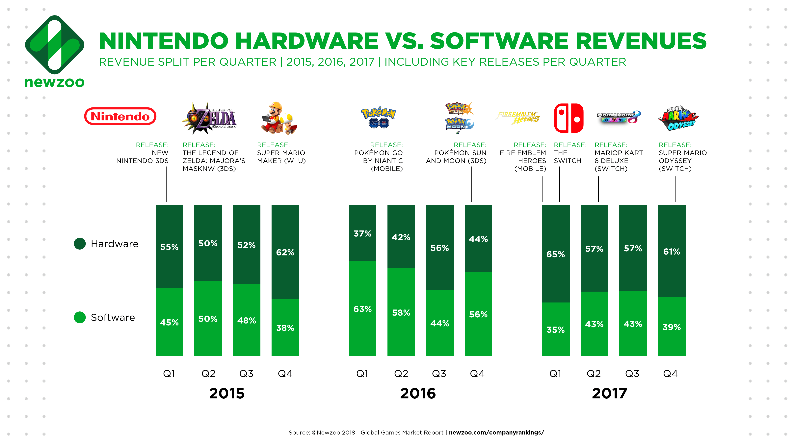

For Fiscal Year 2019, Nintendo has YoY revenue growth of 17.29% and has a strong financial position. The company owns some of the most popular franchises and is getting ready to exploit them further. Also, he gaming industry will continue to grow and if Nintendo can adapt as it has shown, it will produce growth and profits for years to come.

Prospect: Switching Tide toward Streaming Game Services
Despite China’s Licensing Freeze Policy in 2018-19, the Asia-Pacific region remains the biggest region by game revenues -- $72.2 billion, accounting for 47% of the global total in 2019. This represents year-on-year growth of +7.6%. China’s licensing freeze also impacted South Korean and Japanese publishers, with many increasingly depending on Chinese players for revenue growth. China remains the most important market in the region for the coming years, and will reclaim its spot as the #1 gaming market by revenue in 2020. The fastest-growing markets are emerging markets such as South East Asia and India, where Western and Eastern publishers are vying for players’ time and money.

Next, Nintendo has also been hesitant to embrace free-to-play games with in-game transactions, the dominant business model for most successful mobile games. If Nintendo unlocks the value of subscription revenues, mobile game revenues, and in-game transactions, it could add as much as $2.5 billion to its software revenues. Assuming its hardware revenues remain stable, its share of software revenues would still be below many competitors that have made the transition to digital and running games as a service successfully over the past years.

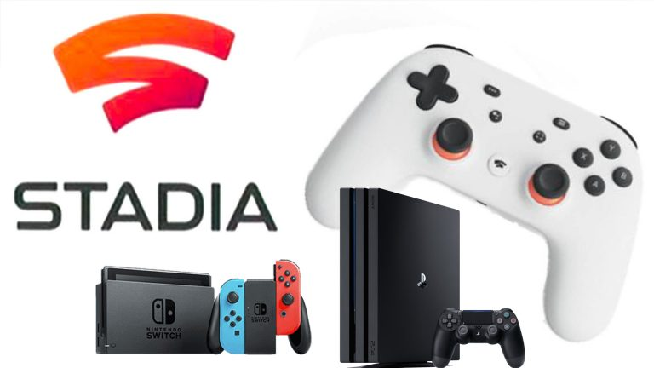

Thus, the key challenge for Nintendo is successfully moving from a traditional approach to development and marketing to running games as a service will require organizational change. That is exactly why it took traditional publishers, such as EA and Activision, years to catch up with the new business model and marketing tactics pioneered by nimbler mobile and PC gaming companies.

Finally, the video-game business seems poised for a shift. In a video for Stadia -- a forthcoming cloud-based streaming service -- Google proclaimed, “The future of gaming is not a box. It’s a place.” In addition, Amazon, firmly ensconced in millions of kitchens and living rooms with Alexa and Prime video, is also reportedly developing a subscription-based streaming service.

