Ant Group – Predator or Prey? Regulation-Driven Ownership Restructuring under the Risk of Bubble Burst

This Version: April 16, 2023

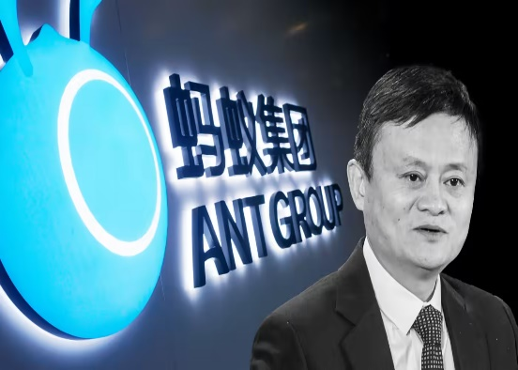

Current Situation
Were Chinese financial agencies’ interventions in Ant Group’s delayed dual listing in Shanghai and Hong Kong stock exchanges in 2020 a policy must before financial bubble burst? Is Ant Group a predator or a prey under the loose regulations on e-commerce-derived rampant consumer financing?

On January 7, 2023, Ant Group announced that Jack Ma no longer controlled the firm after its shareholders agreed to reshape its ownership structure. After the adjustment, Mr. Ma’s voting rights will fall to 6.2%. Before the restructure, Mr. Ma possessed more than 50% of voting rights at Ant.

The voting rights overhaul came after Chinese regulators pulled the plug on Ant’s $37 billion IPO in November 2020, and ordered the company to restructure its business. As part of the company’s restructuring, Ant’s consumer finance unit applied for an expansion of its registered capital from $1.2 billion to $2.7 billion. The China Banking and Insurance Regulatory Commission recently approved the application.

After the fund-raising drive, Ant controls half of its key consumer finance unit, while an entity controlled by the Hangzhou city government owns a 10% stake. Hangzhou is where Alibaba and Ant have been headquartered since their inceptions.

After the restructuring driven by China’s authorities, Ant Group focuses on three primary pillars of business. The first is digital payment and lifestyle service business centered on Alipay, which has been the core of its business until now. The second is digital FinTech service, which is a business providing unsecured loans and credit scoring services to consumers. The third is enterprise-oriented innovation business composed of the “Ant Financial cloud” and “AntChain”, a blockchain platform.

Overall, loose financial regulations on venture financing, cryptoasset trading, and consumer financing derivatives from e-commerce led to the problematic practices of Silicon Valley Bank, FXT Trading Platform, and Ant Group, respectively. There are serious challenges to the stability of global financial markets, either offline or online.

Ownership Restructuring
According to an official statement on January 7, 2023, Ant Group changed the exercise of voting rights of its major shareholders upon ownership restructuring. Jack Ma could no longer exercise voting rights jointly with persons acting in concert.

The adjustment intends to further enhance the stability of Ant Group’s corporate structure and sustainability of our long-term development. After the adjustment, Mr. Ma’s voting rights will fall to 6.2%. Before the restructure, Mr. Ma possessed more than 50% of voting rights at Ant via Hangzhou Yunbo and two other entities, according to its IPO prospectus filed with the exchanges in 2020.

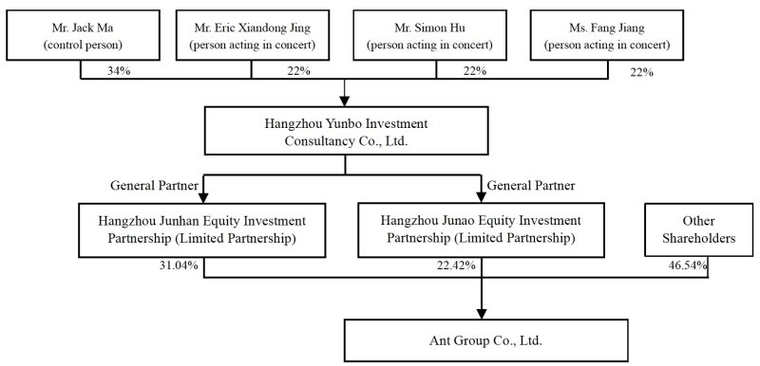

This adjustment also aims to further optimize corporate governance and to align the voting interests of shareholders with their economic interests. The shareholdings of Ant Group would become more transparent and diversified.

Prior to this adjustment, 53.46 % of Ant Group's shares were divided between Hangzhou Junhan Equity Investment Partnership and Hangzhou Junao Investment Partnership. Jack Ma owned 34% of the equity interests of Hangzhou Yunbo, while other shareholders held 22% each. Thus, Mr. Ma effectively exercised control over the voting results of general meetings of Yunbo Investment for matters relating to the exercise of its rights as a shareholder of Ant Group.

However, the ownership restructuring announced in January 2023 resulted in Mr. Ma, Eric Xiandong Jing, Simon Hu and Fang Jiang terminating their acting-in-concert arrangement for the voting of shares of Yunbo Investment.

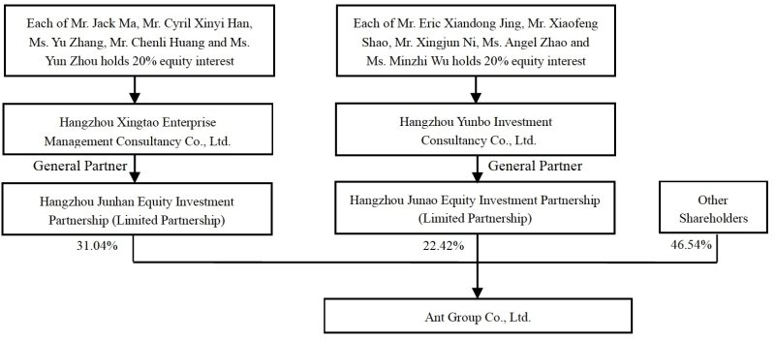

Yunbo Investment will withdraw from Hangzhou Junhan as its partner. Hangzhou Xingtao will be admitted to Hangzhou Junhan to replace Yunbo Investment as the general partner and executive partner of Hangzhou Junhan. Each of Mr. Ma, Cyril Xinyi Han, Yu Zhang, Chenli Huang and Yun Zhou will hold 20% of the equity interests in Hangzhou Xingtao.

Upon completion of the adjustment, major shareholders of Ant Group, including Hangzhou Junhan and Hangzhou Junao, will independently exercise their voting rights in Ant Group. No shareholder will, alone or jointly with another shareholder, have the power to control the outcome of Ant Group’s general meetings. Nor can any shareholder hold the power to nominate the majority of Ant’s board of directors.

Fintech Background
Fintech is disrupting the financial industry and the blockchain development companies in this sector have a major advantage going forward. The speed and scale of this disturbance will depend mostly on users adopting this new economy.

According to PWC’s study of financial services and fintech in 2018, about 77 percent of the financial services industry is planning to adopt blockchain by 2020. By 2020, banks, which were 1/3 of the organizations investigated, were inclined to incorporate blockchain into their activities, as recorded in a survey of eight of the 10 largest global investment banks following the blockchain path. This is complemented by a similitudinal estimate of the blockchain market growth of up to $7 milion by 2022, produced by strategic consultant Jeff Koyen from 360 Blockchain (a firm focused on investment in blockchain-using systems).

While blockchain promises to correct inefficiencies in most banks’ back-office set-ups notably in procedures like clearing and settlement, the most significant effect this technology will probably have is to reduce fraud and cyber attack in the financial world, significantly. Blockchain assists in curbing data breaking and other comparable fraudulent operations to enable fintech businesses to share or transfer safe and unaltered information through a decentralized network.

Moreover, the biggest challenge a fintech company face is trust. Banks and financial institutions have huge cash reserves using which they create secure networks on which banking transactions take place. Fintech companies lack funds which restrict them from developing or procuring a high-security system. As Blockchain is a series of immutable blocks, this allows companies to track the complete lifecycle of a financial transaction. Thus, the blockchain technology can enhance fintech companies’ capabilities for creating secure safe financial products.

Turn to the demand side. Smartphones have been transforming banking and financial systems. While most consumers have a mobile phone and a bank account — and perhaps a bank app on their smartphones — millions of people around the world have the phone but no bank. These under-banked markets, led by countries in Asia and Africa, have inspired fintech innovation that’s leapfrogging the technology available in the developed world. The sheer number of potential customers doesn’t ensure success.
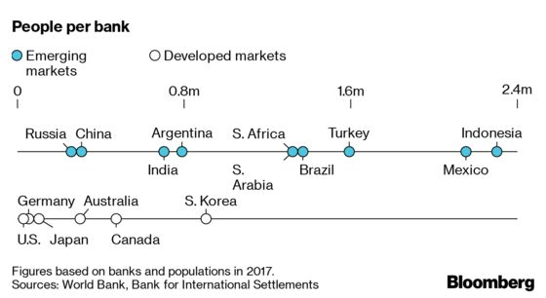

The winners are the companies that have devised business models that can profit in less developed markets, or that expand to serve wealthier customers. Ant Financial Services Group’s Alipay and Tencent Holdings’ WeChat Pay in China, Paytm in India, and Safaricom’s M-Pesa in Kenya are some well-known examples.

For fintech, regulatory authorities are presenting regulatory or regulatory sandboxes. In February 2018, the European Commission enacted fresh fintech regulations. These are recommendations on internet safety, blockchain, and cloud information services. Recommendations in the United States include fintech companies not controlled by a single government regulator or federal government regulator. No fewer than 10 federal agencies are engaged in these fintech regulations. The method of developing new rules has, however, already begun. Arizona was the first US state this year to launch fintech companies’ legislative sandbox.

Profile of Ant Group
Ant Group was initially launched to support online payments. In 2004, Alibaba Group launched Alipay to support online payment transactions on Alibaba.com and Taobao.com. Alipay quickly become the leading online payments service provider in China, claiming more than 50% market share and 47 million users by 2007.
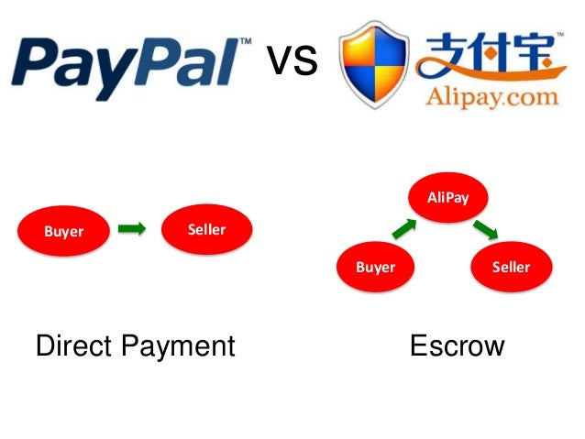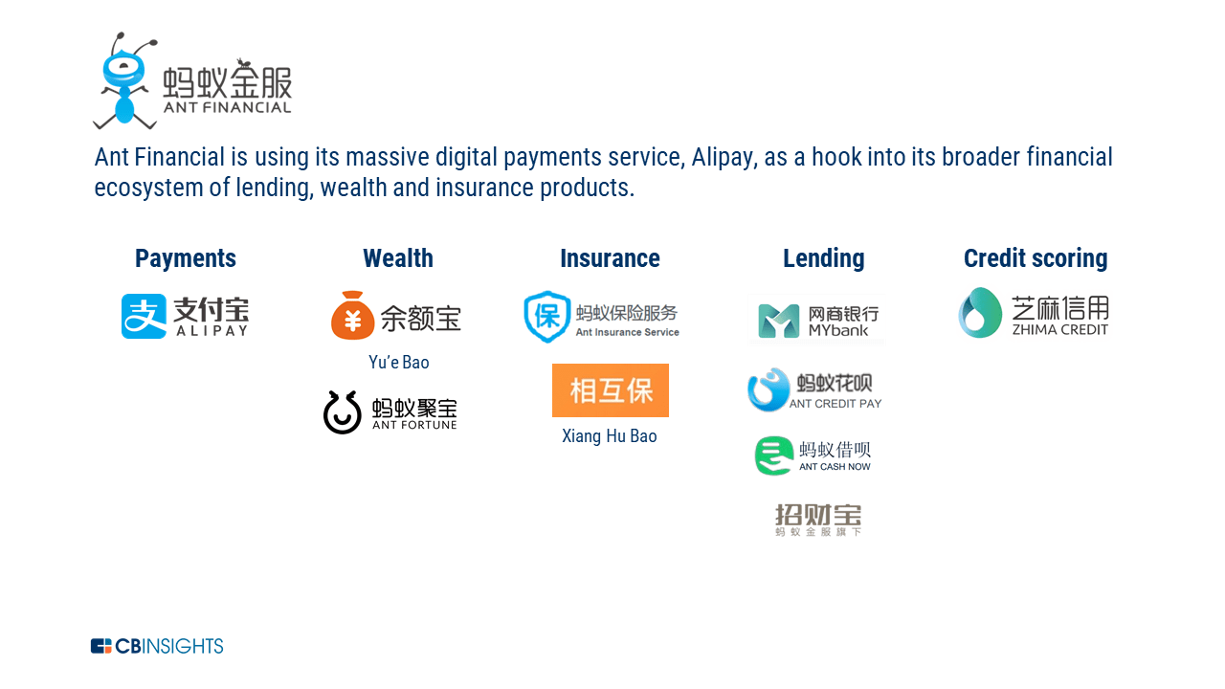

One of the key tenets of Ant’s strategy is its focus on providing an open platform for existing financial institutions to leverage Ant’s technology and tap into new users. As it shifts its revenue focus away from primarily financial services, Ant is prioritizing the tech services it provides to banks, asset management companies, and insurers. For example, asset managers offering target-date retirement funds on Ant Fortune have access to analytics to target customers and AI-based services.

Up to 2023, it has evolved into the largest fintech player globally. Ant encapsulated a fintech ecosystem that started with its dominant mobile payments service, Alipay, and expanded into credit scoring, wealth management, insurance, and lending.

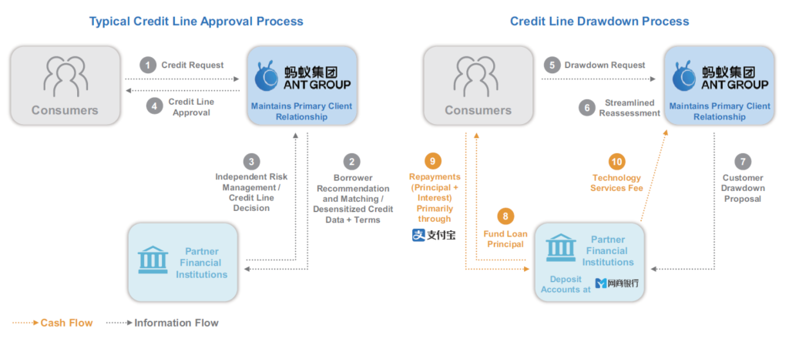

Ant’s globalization strategy has focused on striking partnerships and making minority investments with local partners. Southeast Asia, in particular, has been a major focus as Ant hopes to link its technology into partners across markets including Thailand, Indonesia, and the Philippines. In addition, Ant partnered with Openpay to expand its footprint in Mexico in March 2018.

In some cases, Ant has helped its partners by investing in ecosystem development around them. In India, for example, Ant has made a major investment in India’s leading mobile wallet Paytm. After seeing success with Paytm in India, Alibaba invested in Paytm Mall, the online retail branch of Paytm Group.

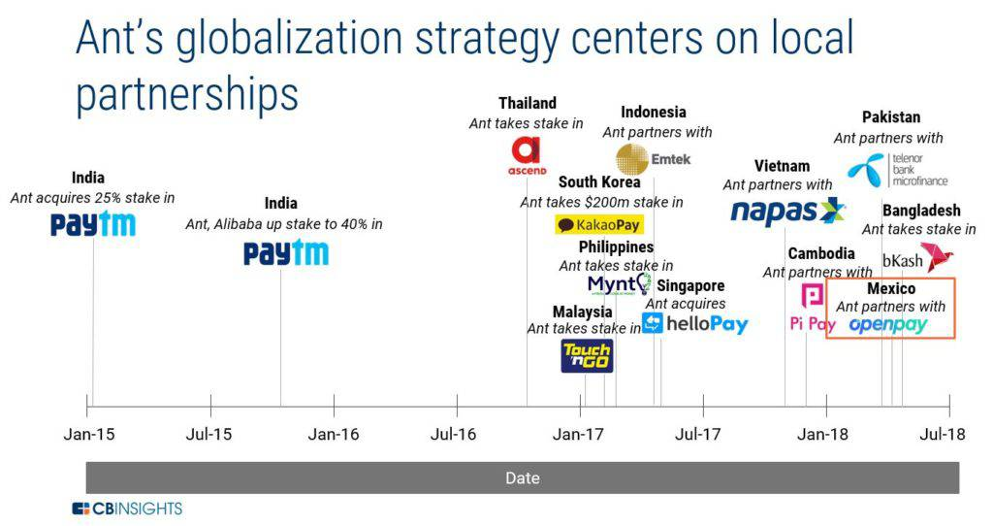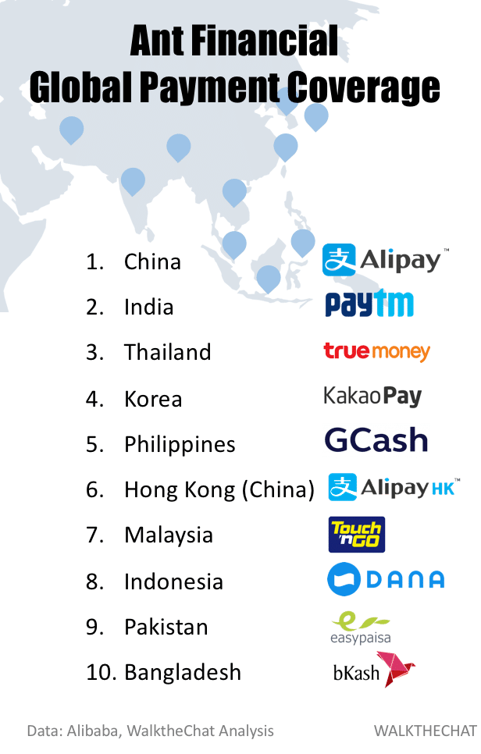

Perhaps Ant’s savviest moves have been in wealth management. Noticing that Alipay users were leaving leftover money in their Alipay wallets, Ant acquired a small fund manager called Tianhong Asset Management in 2013. The move was aimed at launching Yu’e Bao, a digital money market fund platform allowing Alipay users to invest idle cash sitting in their virtual wallets. Yu’e Bao quickly grew to become the largest money market fund in the world, with over 400M users and $211B assets under management today.

Regulation-Driven Change of Ant’s Business Model
As a leading company at the fore of FinTech in China, Ant Group has three primary pillars of business. The first is digital payment and lifestyle service business centered on Alipay, which has been the core of its business until now. Next, its digital FinTech service provides unsecured loans, credit scoring services, and the like to consumers. Last but not the least, Ant’s enterprise-oriented innovation business is composed of the “Ant Financial cloud” and “AntChain”, a blockchain platform.

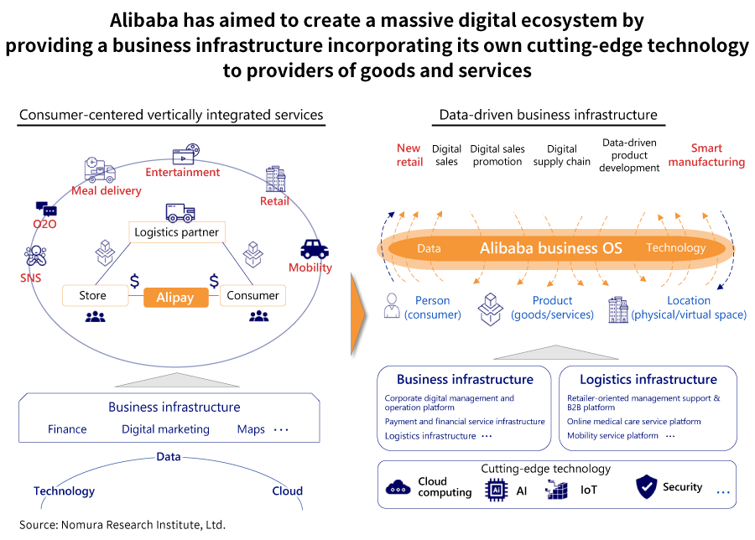

More than 60% of Ant Group’s income relies on its digital FinTech service, with nearly 40% of that coming from credit tech. These are microloans for consumers; when a consumer applies for one using the Alipay app, he is matched to a service of an affiliated financial institution, and the consumer receives financing from the financial institution via a bank under the Ant Group umbrella. This model allows financial institutions to attain a point of contact with many consumers, small-and-mid size business, and micro-enterprises that they were unable to approach in the past.

However, immediately prior to Ant Group’s listing scheduled in 2020, China’s regulatory authorities announced the Interim Measures for the Administration of Online Microfinance Business, which regulate online microfinance business.

The measures require that business operators that provide credit lending services contribute one-third of the funds used for financing. For Ant Group, most funds involved in financing come from financial institutions, with the group’s own funds making up a mere 2%. This regulation will inevitably cause a major impact on its earnings. This is the reason a sudden brake was put on the group’s listing.

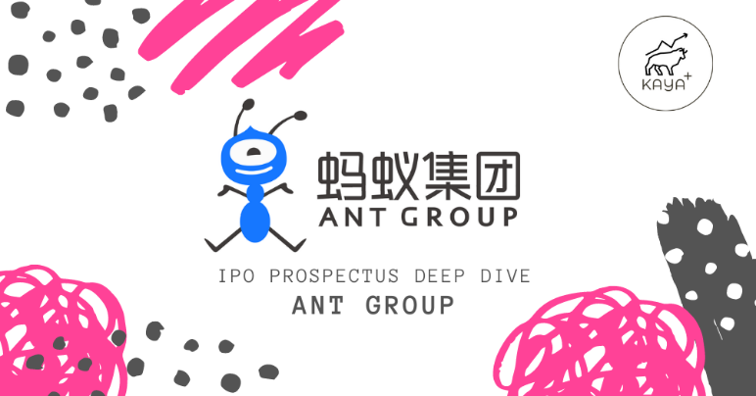

Meanwhile, Ant Group has its core competitiveness in the five core technologies with the acronym BASIC: Blockchain, AI, Security, IoT, and Cloud. It has the highest number of patent applications for blockchain technologies in the world and has commercialized its technologies and sold them externally in the form of AntChain.

In specific, Ant’s AI-based risk control system has been adapted to fraud detection and risk assessment to protect payment safety. It has also developed its own cloud system optimized for financial services, achieving high availability of 99.99% and otherwise clearly having core competence not possessed by ordinary financial institutions. As a result, Ant needs to clarify the boundary between its financial and technology services, and then redesign a business model in line with regulations.

Overall, payment services like Alipay and Tencent’s WeChat Pay rely substantially on for payment infrastructure. By taking advantage of their digital points of contact with consumers, they have also come to be used not just as an entrance to consumer services but also for public services like distribution of health codes for determining whether an individual has a risk of Covid-19 infection and digital consumption vouchers for promoting consumption after Covid-19.

As platformers have been transformed into a form of social infrastructure in China, the boundary between public and private interests has become blurred. Accordingly, China’s government has started increasing regulations on platformers that have captured a monopolistic status. Alibaba and Ant Group must not just come up with new growth strategies, but also achieve a strategy turnaround to cope with these regulations.

China’s Fintech Context
China has just 0.31 credit cards per capita, vs. 2.5 credit cards per capital in the US. Notably, card payments accounted for $5.7 trillion of US transaction volume in 2015. Because credit cards were not widely used in China, Alipay’s escrow-based system and broad accessibility resonated with consumers. In addition, China-based banks set strict requirements around credit card applications and lack strong tech expertise or direct-to-consumer relationships. As the designated online payment service for the 80M users on Alibaba’s Taobao marketplace, consumers naturally adopted Alipay.
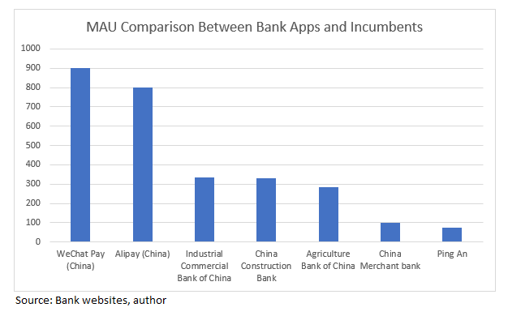

In what’s often referred to as “the consumer upgrade,” China’s consumers are increasing spend on travel, household goods, dining, fashion, and more. By 2008, Alipay was increasingly becoming an accepted payment method for retailers and service providers outside Alibaba’s ecosystem. When Alipay hit 100M users by 2008, China’s transition to a smartphone-based economy was just starting to take place. Between 2008 and 2014, China’s mobile internet users grew from 118M to 557M. At the same time, Alipay’s share in China’s mobile payments market grew to 83%.

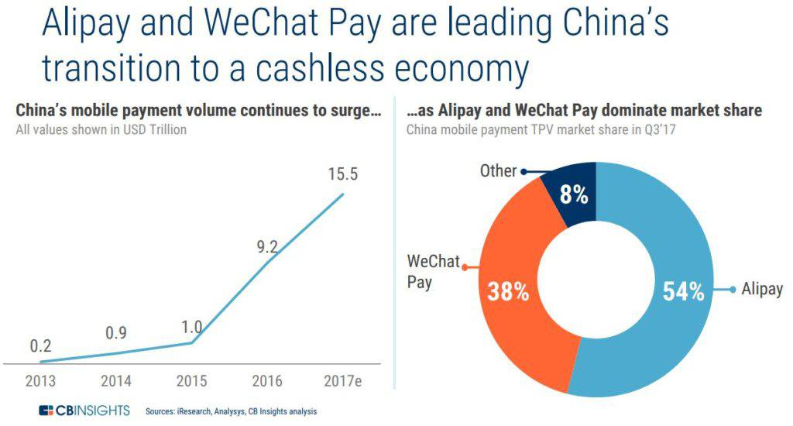

As China’s smartphone growth ballooned, Alibaba and other leading e-commerce platforms in China started to aggressively promote and market mobile shopping. The result was a near total transition of consumer interactions on Alibaba’s marketplaces to the smartphone. In 2011, Alibaba’s mobile e-commerce penetration in 2011 stood at less than 15%. By 2015, it had grown to close to 50%. In 2018, Alibaba’s mobile e-commerce penetration is expected to reach close to 85%, meaning that people are most commonly buying things on their smartphone.

P2P (peer-to-peer) money transfers also helped drive mobile payments in China. In 2014, Tencent created the WeChat Red Envelope feature, followed by Alipay’s launch during Chinese New Year in 2016. The product, which allows users to seamlessly send small amounts of money to others in the form of Chinese Red Envelopes, drastically changed how users engaged with virtual money transfer.

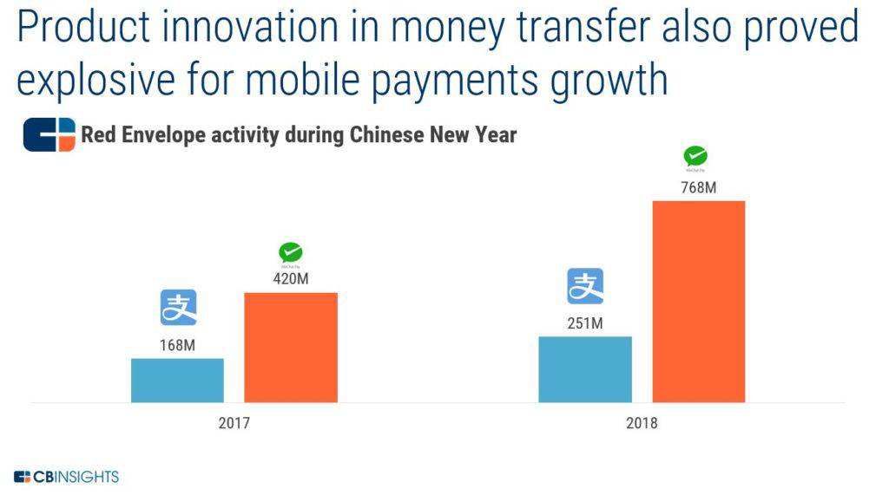

To regulate the explosion of P2P lending, China’s regulators set forth a number of laws and regulations in 2018. Such rules help cut the number of P2P lenders in China by half. Regulation has also had an effect on Ant’s growth. One of the most notable examples of this was Ant’s decision to limit the growth of its money market fund Yu’e Bao. With Chinese regulators exploring new licensing and minimum capital requirements rules, Ant imposed a ceiling of RMB 100K per individual, down from RMB 1M as it looked to reduce investment risk. In May 2018, Yu’e Bao went further, lowering its daily withdrawal limit from RMB 50K to RMB 10K.

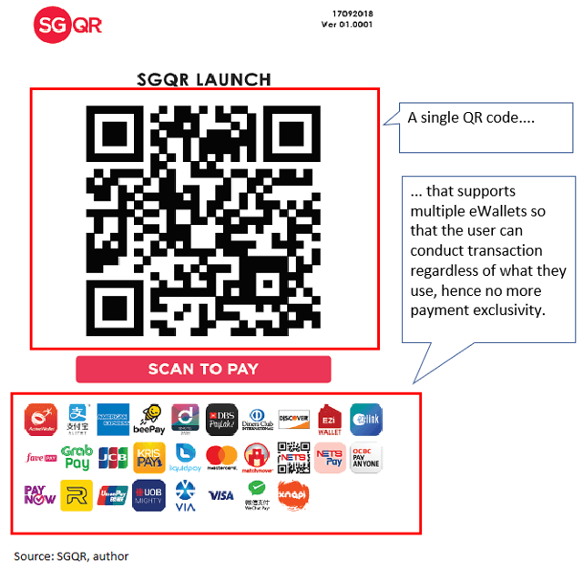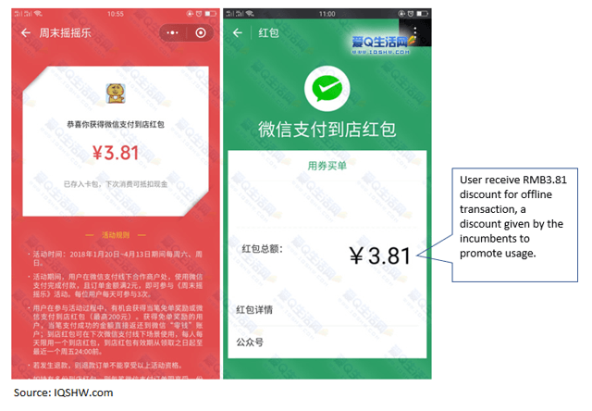

Moreover, PBOC established NetsUnion Clearing Corporation for non-bank online transactions. The PBOC’s “Fintech Development Plan 2019-2021” aimed to create a unified QR code that will allow interoperability between merchants and wallet users. If India’s UPI or Singapore’s emerging SGQR is any indication, we think this will further drive frictionless offline payments but at the expense of the incumbents in that it also will likely drive a proliferation of new entrants by scaled operators (ie. UnionPay, JD, Huawei) that challenge the existing duopoly by adopting the unified payment standard.

Historically, transactions from different companies were done by different banks under various terms which falls outside of the central bank’s supervision. NetsUnion was established so that everyone can follow the same standard and rules and that payment companies will no longer directly link with the banks. The establishment of NetsUnion resulted in added cost for the payment companies in terms of processing payment transactions. In order to avoid the added cost, payment companies will have to convert their merchants from indirect-link model to direct-link model.

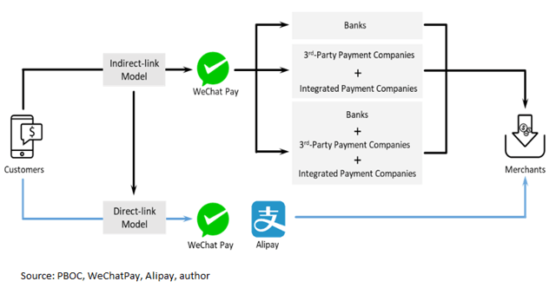

Under the indirect-link model, payment companies use the banks as merchant acquirers to establish relationships with the merchants. Settlement and clearing are done by the banks. On the other hand, under the direct-link model, payment companies act as a merchant acquirer and conducts settlement and clearing by themselves. Transactions by indirect-linked merchants (ie. established via merchant acquirers) are at most risk to the potential cost from NetsUnion.

NetsUnion charges no fee on payment processing vs. the bank handling fee is about 10bps. The imminent introduction of processing fee by NetsUnion on transactions done through the merchant acquirers will severely impact the unit economics of the payment incumbents.

In addition, China’s payment market is approaching maturity and will negatively impact the growth trajectory of Tencent’s fintech business unit and Ant Financial, although it will likely hurt Tencent more than Ant given Tencent’s leverage to the indirect model. In addition, evolving payment regulations will likely lead to a proliferation of new entrants who will disrupt the current duopoly.

Finally, the introduction of QR code will also accelerate the investment in facial recognition by the incumbents, therefore, pressuring their profitability. Moreover, NetsUnion’s imminent processing fee could severely squeeze the payment incumbents’ economics thereby forcing them to shift toward a direct link model. Finally, direct-link model by the incumbents could result in higher economics by taking share away from conventional merchant acquirers, forcing industry consolidation among the acquirers.

Ant’s Global Expansion amid Regulatory Headwind
Ant Group has been restructuring amid government crackdowns, which has complicated growth efforts and most likely hurt profits. In September 2021, China’s regulatory agencies for financial services ordered Ant Group to spin off its loans business from subsidiary Alipay.

To comply, Ant Group set up Chongqing Ant Consumer Finance Co., which houses short-term loan product Jiebei and virtual credit card Huabei—both of which have been used by a half-billion people in China. Regulators were reportedly concerned that Alipay was pushing these credit products to its vast app user base—compounding China’s growing household debt crisis.

In addition, the bulk of these loans were funded by commercial banks, creating unbalanced risk between Alipay and the banks. The new entity can extend credit from its own balance sheet or work with banks to extend joint loans. The government also had ordered more transparency of Ant’s consumer-loan practices.

However, the firm has struggled to court investors to fund its loans. It had to scale back a multibillion-dollar funding round after one of its biggest investors, China Cinda Asset Management Co., abruptly pulled out of the investment plan.

Facing a tighter regulatory environment in China, Ant Group looked for growth overseas in 2022. Before, Ant’s attempt to acquire MoneyGram International, a remittance company based in the U.S., failed in 2018. Besides, a change in foreign investment regulations in India prompted it 2018 to halt further investment in Zomato, a restaurant aggregator and food delivery startup.

In seeking alternative global expansion route, Ant ramped up Alipay+ -- i.e., its merchant solutions suite that launched in 2021 -- across Asia-Pacific. Alipay+ lets merchants accept several popular mobile wallets with a single integration.

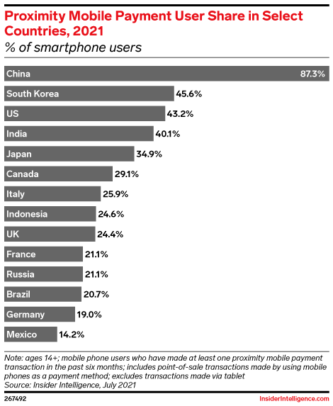

The solution can help Ant Group raked in more revenues and mobile volume outside of China. According to eMarketer’s estimate, 298.8 million people in Asia (excluding China) were expected to use proximity mobile payments by the end of 2022, up from 269.7 million year-on-year.

In addition, Alpay+ introduced D-Store, a one-stop shop for brick-and-mortar merchants that want to bring their business online. Popular brands like Burger King have already adopted the solution. D-Store is likely to thrive as ecommerce grows and makes up a larger share of total retail sales across Asia.

Overall, Ant has focused its offshore ambitions on building its presence in the rest of Asia, where it’s working with nine payment startups including the owners of Paytm in India and GCash in the Philippines, targeting billions of people. It’s also seeking to tie up more merchants abroad to use Alipay, so that its Chinese customers can use it while traveling.

Fintech Investments from Financial Services
To cope with the challenges from fintech, banks around the world have attempted to future-proofing by actively investing in fintech startups. Similar strategic moves are also taken in emerging markets. For instance, Thailand’s largest commercial bank – Bangkok Bank – initiated a Fintech InnoHub program in 2017 to serve as a fintech incubator in Southeast Asia, prior its follow-on equity investments or partnership.

The most active U.S.-based banks are Goldman Sachs, Citigroup, and JPMorgan Chase (JPM). Each has looked at deals with startups in a variety of areas, including consumer-facing personal finance applications and data analytics and aggregation capabilities that are deep in the back office. Payments and the capital markets business have driven a lot of the investment by these banks.

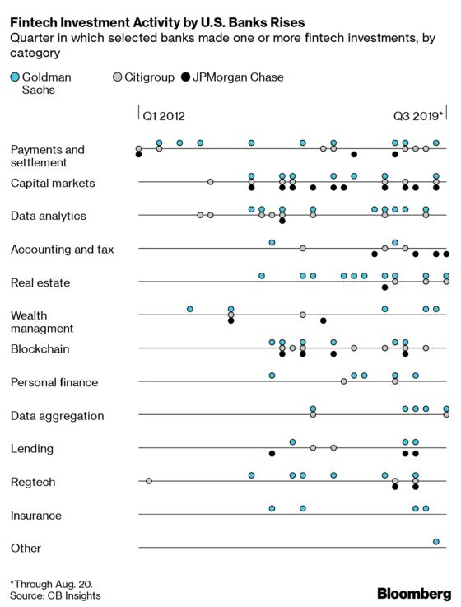

Rival banks don’t often invest in the same companies, but in the fintech space it’s not unheard of. Digital Asset Holdings, a blockchain startup, is backed by all three, for instance, while Plaid Inc., which connects bank customers’ data to third-party finance apps, is backed by Goldman and Citigroup. In 2018, Goldman acquired Clarity Money, a personal finance website in which Citigroup had previously invested.

Goldman Sachs and Citigroup are the most active investors largely because of their investment arms — Goldman Sachs Strategic Investments and Citi Ventures — which have participated in 21 and 11 fintech deals since 2018, respectively. As a result, the two banks continue to invest in a wide range of fintech sectors. Since 2017, Goldman Sachs has focused its fintech investments on real estate, data analytics, and payments & settlement. Betting on these subindustries aligns with Goldman’s digital strategy of scaling its consumer offering – i.e., Marcus.
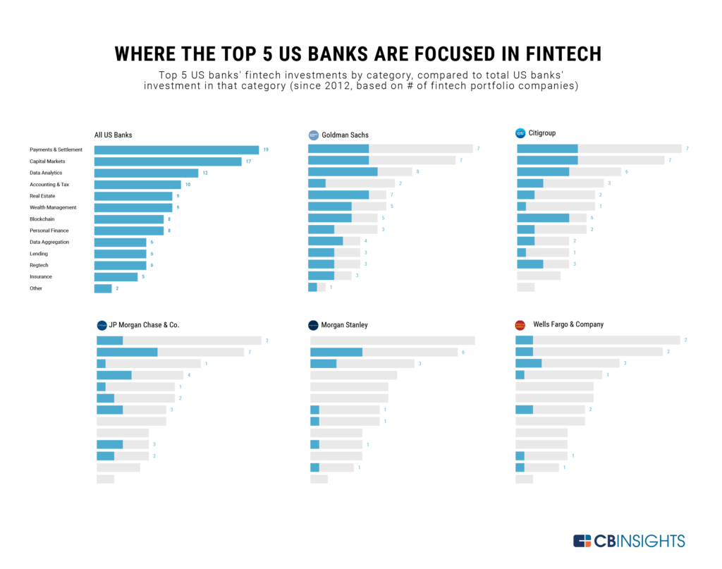
In addition, Citi has backed 4 blockchain, 3 capital markets, and 3 payments & settlement startups since 2017. Generally speaking, these equity investments fit into both banks’ strategy of building open banking infrastructure. In March 2019, Citi announced plans to build a “digital consumer payments business for institutions,” and there are rumors Citi may launch a Banking-as-a-Service (BaaS) platform.

Meanwhile, JPM remains focused on strengthening its capital market solutions and scaling its payments business. The bank has backed 4 capital markets startups and 4 accounting startups (including startups focused on accounts payable/accounts receivable) since 2017. At the same time, JPM also made bets on 2 companies in each of the payments & settlement, regtech, and lending categories. Other banks that have backed at least 5 fintech startups since 2012 include Morgan Stanley, Wells Fargo, Bank of America, and PNC Financial Services Group.

CyptoAsset Landscape and FTX Collapse
Cryptoassets include cryptocurrencies and stablecoins that may use such major cryptocurrencies as Bitcoins and US dollars as collaterals. After the industry downturn in 2021, all categories of cryptoassets suffer significant price declines. As a result, FTX trading platform filed for bankruptcy due to its misuse of clients’ money.

There are questions about how cryptoasset transactions will be implemented across an array of ledgers or how anonymized transactions can be regulated. Part of this will come in the consolidation of the industry and the continued struggle for interoperability between wallets and ledgers.

However, most of these questions will likely be answered by whoever tries first, and financial technology companies are by far the most eager to fill that role. The crypto ecosystem needed a platform that can be an investor’s backend system — tracking, management and taxes all in one.

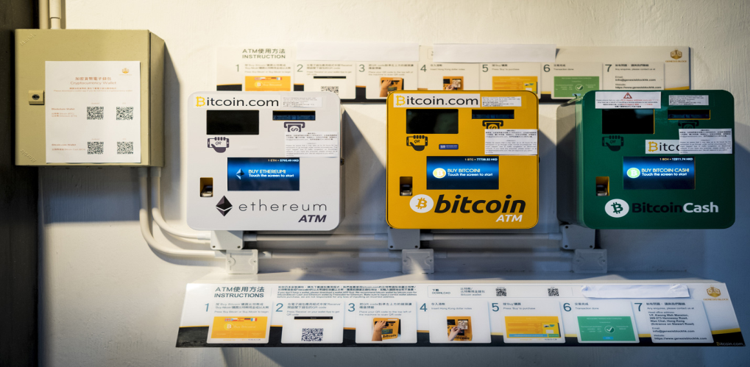

This necessity of innovation has been an evident trend throughout major areas of the cryptocurrency market. Fintech unicorns like Plaid and Chime have reached their valuations largely from investments by companies in the finance industry like Visa and Goldman Sachs that are curious about digital assets, but terrified of the uncertainty that surrounds them. Thus, cryptocurrency and fintech are gradually hooked up.

Fintech innovation is no longer dominated by scrappy startups—big tech companies are getting involved. Take the example of Facebook’s plan to launch a digital currency called Libra in 2020. The social network’s gigantic reach—more than 2.4 billion active monthly users — could draw a much wider audience to Libra than has used previous cryptocurrencies. However, the volatility of cryptocurrency has been an issue on assessing its future.

Prospect: Relaunching IPO with Revised Business Valuation
Loose financial regulations on venture financing, cryptoasset trading, and consumer financing derivatives from e-commerce led to the problematic practices of Silicon Valley Bank, FXT Trading Platform, and Ant Group, respectively. There are serious challenges to the stability of global financial markets, either offline or online.

Against this backdrop, the rise of Ant Group and its dominance in Chinese e-commerce-derived rampant consumer financing landscape has not gone unnoticed by China’s governmental agencies. A looming threat is the Chinese central bank’s creation of a digital yuan, which is part of a push to control the stability of its payment system. In addition, In its 2020 IPO prospectus, Ant warned that rising U.S.-China trade tension could threaten its business as it gears up for the IPO.

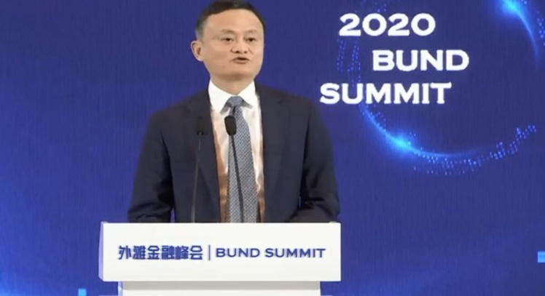

After Jack Ma’s assaulted remarks on the China’s financial system in October 2020, China’s financial regulators started to review and then undertake a series of policy measures to crack down such unregulated consumer financing practices. Since then, Ant Group has faced regular scrutiny from authorities, looking into everything from its escrow service to lending risks.

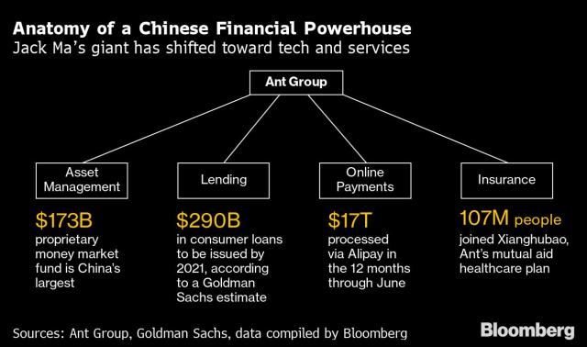

Initially, Ant Group filed for a dual-listing in Hong Kong and Shanghai in 2020. The then-valuation of $225 billion, making it the world’s fourth-largest financial company. In separate filings with the Shanghai and Hong Kong bourses, the owner of popular payment service platform Alipay for the first time disclosed financial details showing just how enormous its rapidly growing business is. In 2020 H1, Ant had revenue of 72.5 billion yuan ($10.5 billion), and net profit surged more than ten-fold to 21.2 billion yuan, according to the filings.

The Alipay app has connected with more than 1 billion Chinese users in a nation of 1.4 billion people, more than 80 million merchants and 2,000 financial institutions, the filings showed. Monthly active users on the platform reached 711 million as of June 2020. In 12 months through June 30, Alipay processed 118 trillion yuan of transactions within China and 621.9 billion yuan of cross-border transactions.

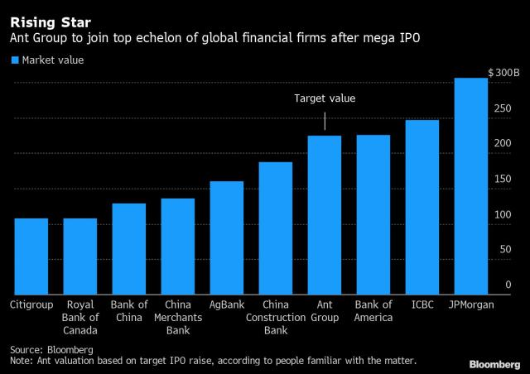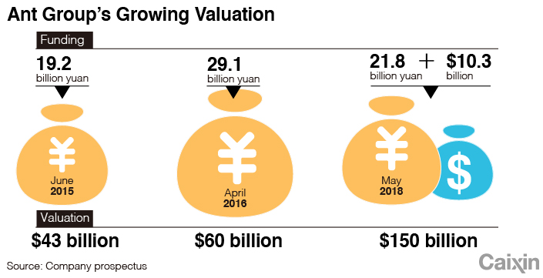

The delayed IPO was originally set to make Jack Ma even richer. Mr. Ma held 50.52% voting rights in Ant, via his control over shares held by Hangzhou Junhan and Hangzhou Junao, prior to massive ownership restructuring in January 2023. Mr. Ma said that he intended to reduce his shareholdings in Ant Group to no more than 8.8% in the future.

The 2020 IPO prospectus said that Ant — whose crown jewel was the Alipay online payments service — planned to sell at least 10% of its shares in the pair of listings. Nevertheless, China’s media Caixin revealed that Ant would like to sell about 10% of its shares into the Shanghai listing, and another 5% in the Hong Kong listing. At a current estimated value of about $200 billion, that combined 15% stake could see the company raise about $30 billion.

The robust growth of the digital finance technology platform boosted Ant’s profit margin by allowing more funds to remain in the company’s business ecosystem and improving its business efficiency. Online credit services have long been a cash cow for Ant. In 2020 H1, the CreditTech business division, which covers Ant’s consumer loan platforms Huabei and Jiebei and credit to small businesses, reported 59.5% revenue growth to 28.6 billion yuan.

Ant has also reported to be exposed to risky lending. The ratio of loans overdue for more than 30 days was 1.56% of total outstanding loans in 2019, up from 1.43% in 2018. Commercial banks’ ratio is almost 3%. Revenue from online wealth management services rose 56.25% in the first half to 11.3 billion yuan. Total assets managed on Ant’s wealth management platform topped 4 trillion yuan as of June 30, and Insurance service revenue grew more than 47% to 6.1 billion yuan in 2020 H1.

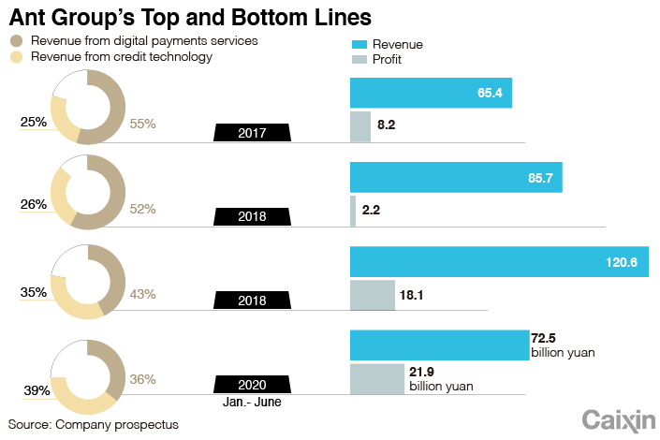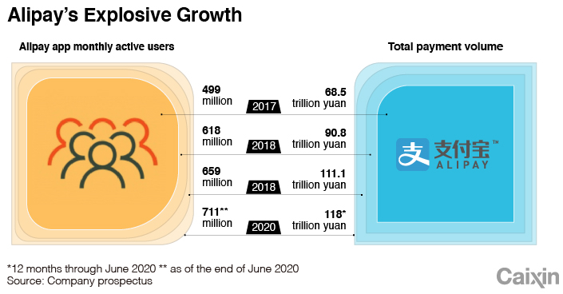

In its earnings report due on February 23, 2023, Ant Group contributed $145 million to its affiliate Alibaba’s earnings, which translated to an 82.3% drop. The year-over-year decrease in share of profit of Ant Group was due mainly to decrease in the valuation of certain overseas equity investments, resulting from changes in capital market conditions.

Finally, Ant Group’s latest valuation was trimmed again by Fidelity Investments, more than two years after the Chinese government torpedoed its record initial public offering. Fidelity cut its estimate for Ant by about 9% to about $63.8 billion as of the end of November from the end of May, 2022. That’s down from $235 billion just before Ant’s IPO was halted in November 2020.

