LVMH-Tiffany: Interrupted Trans-Atlantic Deal-Making in the Global Public Health Crisis
First Draft: July 2, 2021

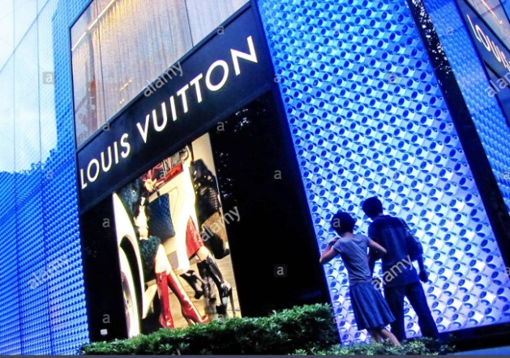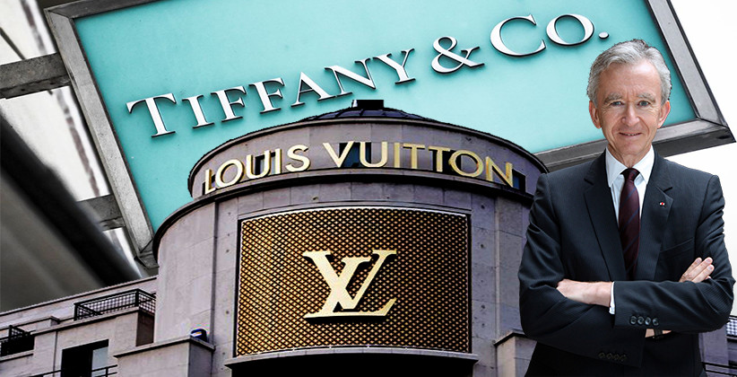

Current Situation
Not until January 8, 2021, the LVMH-Tiffany’s trans-Atlantic deal in the luxury industry was finalized. This high-profile global acquisition transaction was delayed amid COVID-19 Pandemic: Store closure due to city lockdowns in the US in 2020 undermined the enterprise value of Tiffany & Co. After a takeover premium cut from $135 to $131.5 per share with a $15.8 billion for the deal value, this interrupted deal was completed.

On November 19, 2019, LVMH agreed to buy New York jeweler Tiffany & Co. for $16.2 billion, adding a famed star to its portfolio that already boasts Louis Vuitton, Christian Dior and Bulgari. The acquirer took over the 182-year old Tiffany and its 300 boutiques worldwide at $135 a share. The price tag is higher than the $14.5 billion cash offer LVMH made in October 2019.

Tiffany & Co. has struggled to win over Millennials and Gen-Z consumers in the West, as young shoppers move away from traditional occasion-based gifting and as self-purchasing gains popularity. Complicated by the negative impact of synthetic diamond on sales momentum of natural diamond, Tiffany & Co. reached a definitive agreement of being acquired by France-based LVMH after sweetening the takeover premium.

From Tiffany’s perspective, LVMH’s financial and operation capabilities will not only enhance its performance in its major markets, but also allow it to cross-sell in other markets. LVMH has a much larger hold over the European market than Tiffany does with 29% of that divisions’ revenue coming from there (including 6% in France) compared to the 11% that Tiffany boasts. This gives the company the ability to easily expand certain product lines into other regions or to focus on cutting costs in order to generate synergies.

Target’s Profile: Tiffany & Co.
Tiffany & Co. was founded in 1837 in New York by Charles Lewis Tiffany. A retailer of fine silver and other luxury goods, the brand fast became famous for its watches, clocks and jewelry. In fact, its Atlas clock was a landmark by which many New Yorkers set their watches each day in the early 20th century. The brand had a starring role in “Breakfast at Tiffany’s” and is globally renowned for its Blue Book of ultimate luxury jewels.

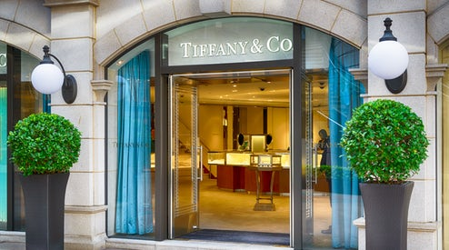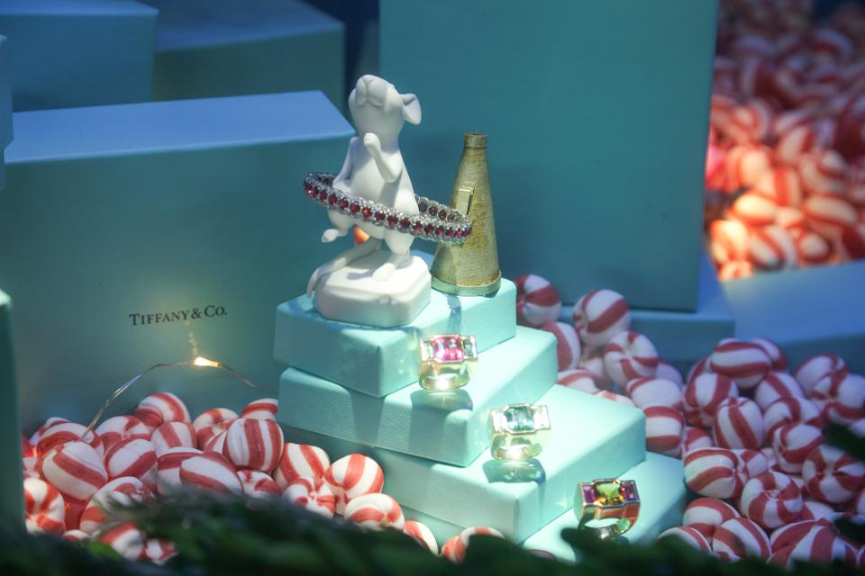

Tiffany & Co. has been updating its store experience, and recently hired former Barneys chief executive Daniella Vitale to reposition its brand identity. While the company continues to grow in China, it has struggled to win over Millennials and Gen-Z consumers in the West, as young shoppers move away from traditional occasion-based gifting and as self-purchasing gains popularity.

The Company’s segments include Americas, Asia-Pacific, Japan, Europe and Other. Through its subsidiaries, the Company designs and manufactures products and operates Tiffany & Co. retail stores around the world, and also sells its products through Internet, catalog, business-to-business and wholesale operations. The Company also sells timepieces, leather goods, sterling silverware, crystal, stationery, fragrances, and accessories.

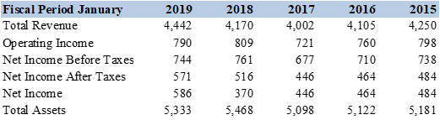

Tiffany’s merchandise offerings include an extensive selection of jewelry (92% of worldwide net sales in million US$ in fiscal 2018), as well as timepieces, home and accessories, and fragrances.
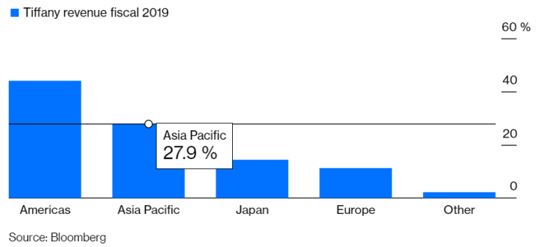

In addition, Tiffany, with 28% of the sales coming from China, is planning to “build more flagship stores in several Chinese cities”, allowing LVMH to ride further on the wave of luxury demand in China. According to analysis by Morgan Stanley, the nation’s share of luxury goods spending is forecast to reach 46% by 2025.

Acquirer’s Background: LVMH
Founded in France in 1854, Louis Vuitton became part of LVMH in 1987 when the conglomerate was created. Moët et Chandon and Hennessy, leading manufacturers of champagne and cognac, merged respectively with Louis Vuitton to form the luxury goods conglomerate.

The LVMH group comprises 75 exceptional Houses that create high quality products. It is the only group present in all five major sectors of the luxury market: Wines & Spirits, Fashion & Leather Goods, Perfumes & Cosmetics, Watches & Jewelry and Selective Retailing. LVMH currently employs 156,000 people across the world and reported sales of 53.7 billion euros in 2019.

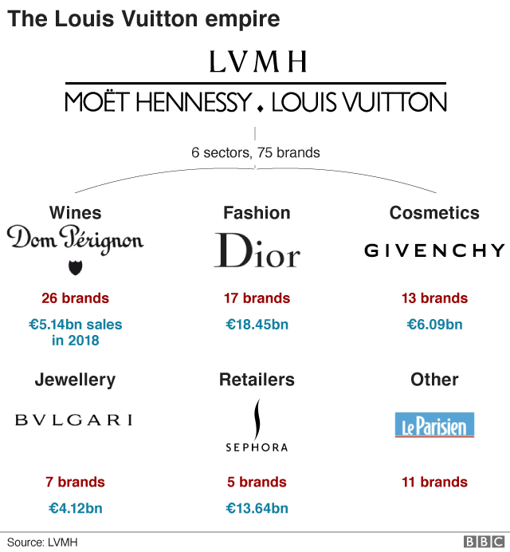

Size has brought more rewards. In the luxury goods industry with high fixed costs – i.e., spent on marketing, and on eye-watering rents for shops on flashy thoroughfares -- selling more translates into better margins. LVMH has achieved nearly double the industry’s growth rate in the past two decades, and last year sold over €46bn-worth of extravagance. That is more than three times the figure for Kering and Richemont, its nearest rivals.

One of the advantages of such luxury goods groups as LMVH is that with worldwide operations, they can easily find managers who have had jobs outside their home countries or can easily put people into such positions. This has contributed to the success of the groups’ flagship brands in the following two ways.

On the one hand, international operations are a source of inspiration. Fashion designers are more likely to produce creative collections if they had worked abroad. It is particularly beneficial to work in two to three foreign countries. At LVMH, the leading designers all bring cross-cultural perspectives to their work.

For instance, Phoebe Philo -- a Paris-born British fashion designer educated in London -- runs Céline from London. Marc Jacobs, who during his tenure at Paris-based Louis Vuitton expanded its product mix from travel accessories to clothing, was born and trained in the U.S. Karl Lagerfeld -- a creative director at Fendi and at Chanel -- often works in both France and Italy during the same day and has called himself “a one-man multinational fashion phenomenon.” The diverse cultural influences incorporated into their collections have invigorated their traditional luxury brands.

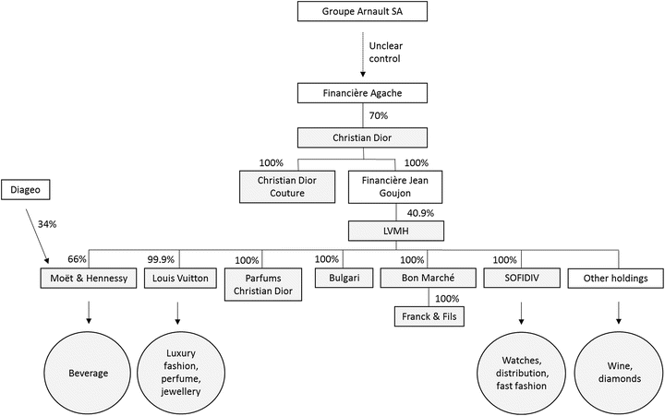

On the other hand, a global scope of operations also helps talents cultivate a better understanding of cross-cultural customers. Professional foreign experiences help talents serve as “bridges” between Switzerland, France, or Italy -- where many luxury goods are produced -- and the United States, Asia, and the Middle East – which are now their largest markets. Although Europeans can explain to customers what luxury means, they also must have experience in foreign markets to understand which aspects of luxury the customers there actually care about. For instance, in America consumers will buy watches for their functionality or performance, whereas in Asia it’s more about the prestige of the brand.

Acquisition Motives
The deal will bring LVMH’s substantial financial and market clout to help support Tiffany & Co.’s ongoing transformation efforts. It also boosts the French company’s presence in the US market. Within LVMH, Tiffany & Co. will be able to accelerate its ongoing strategy

This acquisition also allows LVMH to gain further ground on Swiss conglomerate Richemont, which has long dominated hard luxury with its ownership of Cartier and Van Cleef & Arpels. Jewellery was one of the best-performing luxury categories in 2018, according to Bain & Co, which predicts that the global $20 billion market will grow 7 percent annually.

The Tiffany Co.’s acquisition gives LVMH a greater degree of control over its hard luxury supply chain. That’s an increasingly desirable trait for luxury brands, under pressure to guarantee provenance and lock in supply in a competitive market. Tiffany & Co. employs more than 5,000 artisans to cut diamonds and craft its jewellery, rather than buying from middlemen.

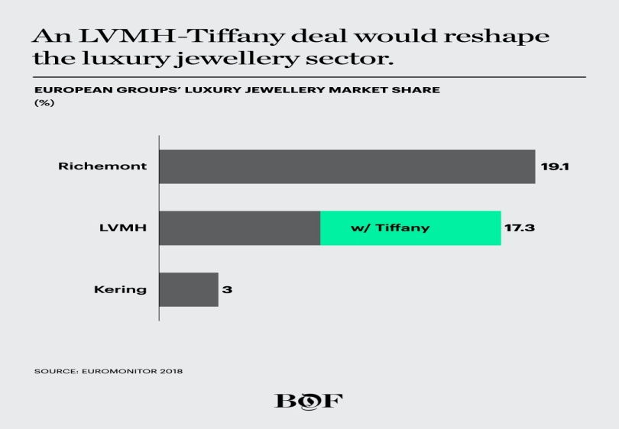

For LVMH, the strategic rationale for closing the deal is sound. After long dominating the market for "soft" luxuries including leather handbags and shoes, the acquisition of Tiffany would change the game for the French group by more than doubling its share in so-called “hard" luxuries, which include fine jewellery and watches. LVMH has long trailed Cartier- and Van Cleef & Arpels-owner Richemont in this space, though it gained ground with its 2011 acquisition of Italian jeweller Bulgari.

For Tiffany, too, which has lagged in modernizing its retail stores and marketing campaigns, being acquired by LVMH would bring welcome expertise in branding and customer experience in order to combat a tough North American market and accelerate progress in China.

Overall, going forward, LVMH is eyeing the opportunity to expand Tiffany & Co.’s market penetration internationally. The brand only generates 11 percent of its revenue in Europe, for instance. Longer term, the deal opens up the prospect of new product categories for the jeweller.

The Proposed Deal
On November 25, 2019, LVMH Moët Hennessy Louis Vuitton SE (LVMH) -- the world’s leading luxury group -- and Tiffany & Co. -- the global luxury jeweler -- announced that the companies had entered into a definitive agreement for the acquisition. LVMH acquired Tiffany & Co. for $135 per share in cash, in a transaction with an equity value of approximately €14.7 billion or $16.2 billion.

The deal, which should be completed by early to mid 2020, will bring the 182-year-old legendary Tiffany & Co. under the LVMH fold, which includes 75 other luxury brands, such as watch and jewelry legends Bulgari, Dior, Fendi, Hublot, TAG Heuer, Zenith and Louis Vuitton.

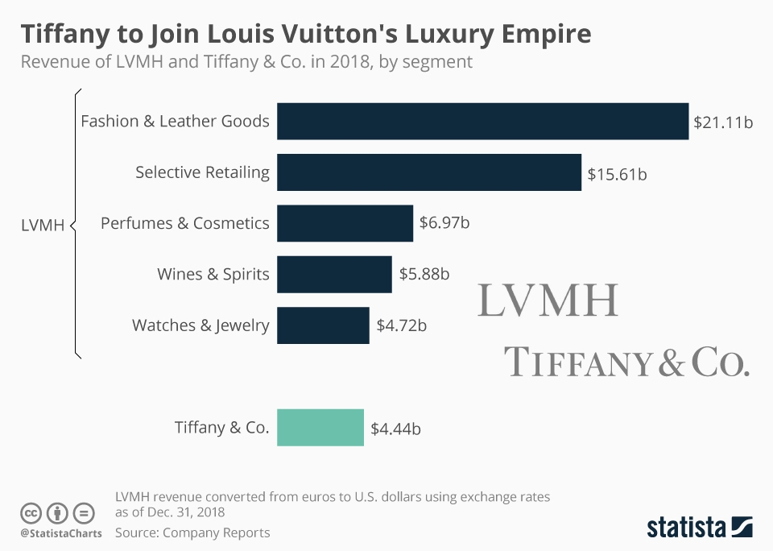

The all-cash acquisition is one of the largest ever for the French conglomerate known for its hard-charging deal making and surpasses its $13 billion deal for Christian Dior in 2017. The announcement ends a month of speculation, after reports that LVMH had approached the jeweller leaked in October. LVMH initially offered $14.5 billion for Tiffany & Co., but the company said the offer was too low.

That wasn’t the first time LVMH -- Europe’s second-most valuable company, with a market capitalisation surpassing €200 billion -- had set its sights on Tiffany. The conglomerate reportedly expressed interest in the jeweller prior to its takeover of Bulgari in 2011 — LVMH's last major investment in hard luxury.

Tiffany & Co. has resisted acquisition for years, but as one of the few independent global jewellery houses remaining in the market, analysts had long speculated that it would make an attractive, if expensive, target. Nevertheless, Tiffany & Co. has had a difficult time lately. In the H1 2019, worldwide net sales at Tiffany & Co. decreased 3% to $2.1 billion. The American jeweller is facing weak demand retail at home and abroad, and will likely need heavy investment to re-energize its brand and business.

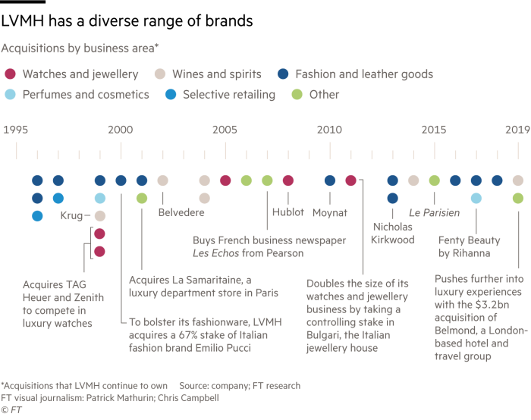

With the acquisition of Tiffany, LVMH, home to a vast array of luxury brands already, is looking to strengthen its position in the jewelry market and expand its presence in the United States. “We are delighted to have the opportunity to welcome Tiffany, a company with an unparalleled heritage and unique position in the global jewelry world, to the LVMH family,” LVMH CEO Bernard Arnault said in the company’s announcement of the deal.

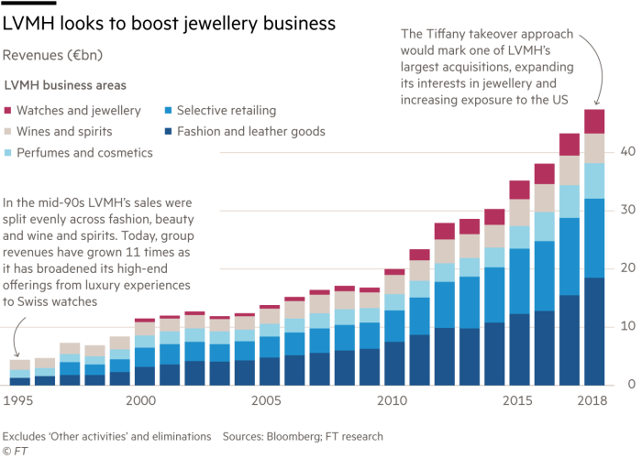

Already a market leader in what is often referred to as “soft luxury”, i.e. leather accessories, bags and clothing, the deal will roughly double the size of LVMH’s “hard luxury” business (i.e. watches and jewelry) at once. As the following chart shows, the French owner of Hublot, Tag Heuer and Zenith (among others) generated $4.72 billion in sales in the Watches & Jewelry segment last year. Tiffany’s revenue amounted to $4.44 billion in 2018, illustrating how big a boost the deal will give to LVMH’s ambitions in this particular segment of the luxury market.

The Interrupted Deal-Making Process
The LVMH-Tiffany’s trans-Atlantic deal in the luxury industry was finalized. This high-profile global acquisition transaction was delayed amid COVID-19 Pandemic: Store closure due to city lockdowns in the US in 2020 undermined the enterprise value of Tiffany & Co. After a takeover premium cut from $135 to $131.5 per share with a $15.8 billion for the deal value, this interrupted deal was completed in January 8, 2021.

This delayed acquisition could cement the place of LVMH at the peak of the luxury world. Its rise has been nothing short of dazzling since Mr. Arnault took it over three decades ago. Its shares have risen threefold since 2015, including a 60% run since January 2019. Worth around €206bn ($227bn), LVMH vies with Royal Dutch Shell as the most valuable firm based in the EU. The company dominates a structurally favored sector, buoyed by globalization and income inequality.

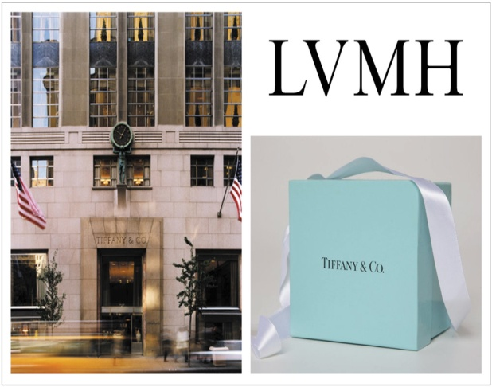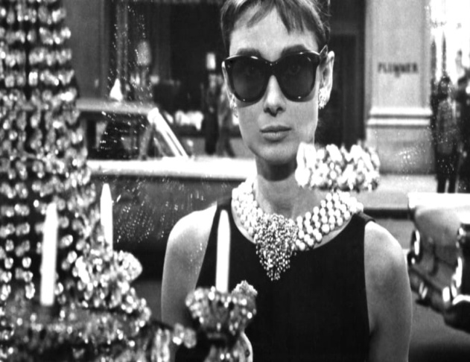

For more than 180 years, Tiffany has been synonymous with elegance, innovative design, fine craftsmanship and creative excellence. Founded in 1837, Tiffany today is the leading luxury brand originated in the U.S. and has more than 300 stores around the globe. The acquisition of Tiffany will strengthen LVMH’s position in jewelry and further increase its presence in the United States. The addition of Tiffany will transform LVMH’s Watches & Jewelry division and complement LVMH’s 75 distinguished Houses.

From the perspective of Tiffany, known for its delicate jewelry, distinctive blue boxes and an Audrey Hepburn movie, Tiffany maintained that the deal would ensure its long-term sustainability. The company has been trying to transform its brand to appeal to younger and more digital shoppers, and could use an owner with deep pockets to help expand its business.

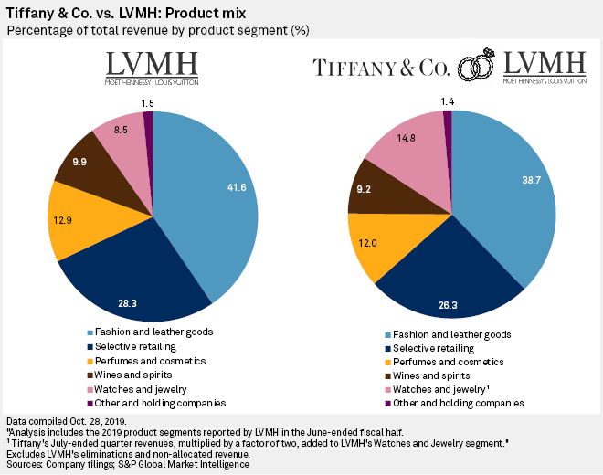

The offer comes as luxury goods companies have been wrestling with changing habits of shoppers who are increasingly buying online. They’re also purchasing secondhand luxury items from places like The RealReal.com. In addition, luxury companies are facing fears of an economic slowdown in China, a key area of business, while they’re already dealing with a slowdown in international tourism in the U.S.

Before this acquisition, Tiffany’s shareholders had pestered management to improve margins and raise sales fast, unduly hurrying its turnaround efforts. LVMH announced to give Tiffany time and money to renovate stores and push upmarket. LVMH did something similar in the post-acquisition of Bulgari, whose profits have risen five-fold since LVMH took it over in 2011.

However, the outbreak of coronavirus changed the odds of LVMH-Tiffany deal. On September 21, 2020, a Delaware court held a hearing on Tiffany & Co.'s case to force French luxury group LVMH and its Chairman and Chief Executive, Bernard Arnault, to move ahead with its $16.2 billion acquisition of the historic American jeweller, agreed upon in November 2019, just months before Covid-19 shuttered stores and pushed the profitability of luxury and fashion companies off a cliff.

After months of insisting it would honor the deal, LVMH has walked away — with both parties lashing out publicly against each other, throwing accusations of pandemic-era mismanagement left and right — and finds itself in a face-off against Tiffany in court. The French group claims it can't pursue the deal due to a French government request amid trade turmoil with the United States, while Tiffany claims the attempt to back out of the agreement is a means to negotiate a lower price. While Tiffany wants to expedite the case, LVMH is asking for a six-month delay.

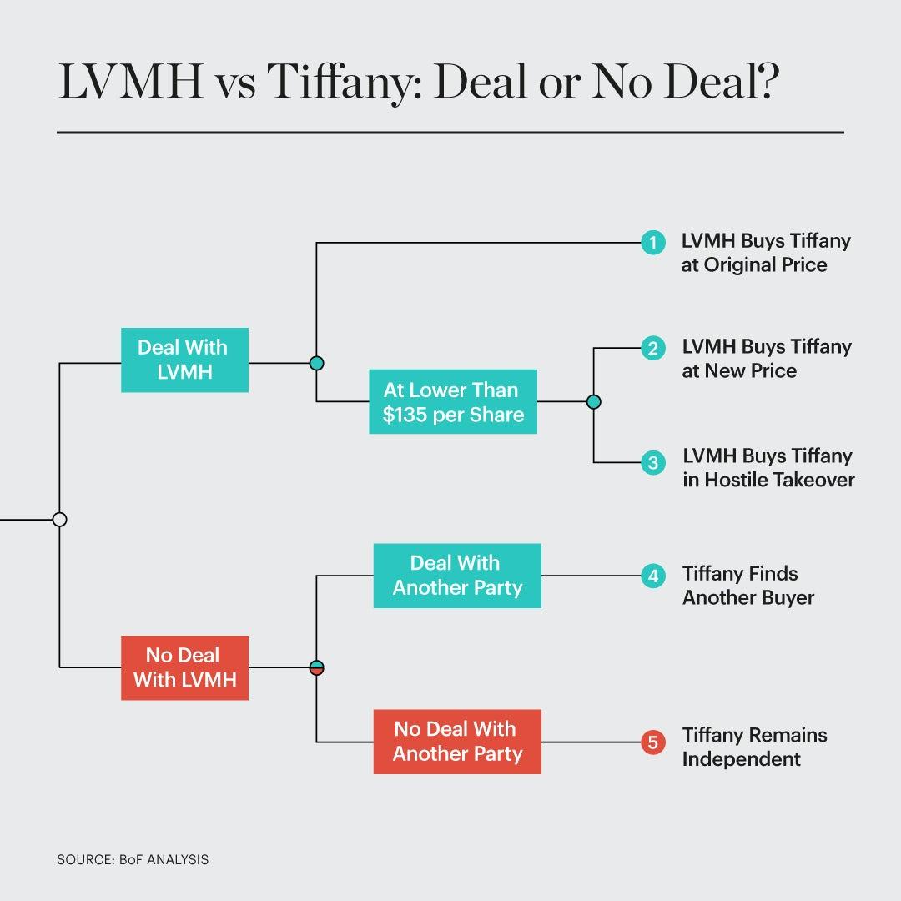

With 2020 came COVID-19 Pandemic, which forced store closures and crushed consumer demand, shrinking sales and margins for both firms. With luxury sales down an average of 41 percent in 2020 Q2, it’s no surprise that LVMH no longer wants to close at the original price.

While Tiffany's position is clear — the jeweller is pressing for the deal to go ahead at full price — LVMH’s objective isn't as easy to divine. Arnault has been interested in Tiffany for decades, and he doggedly and aggressively pursued this purchase at the height of the market. There are several scenarios in this interrupted deal-making process as follows.

Scenario 1: Tiffany gets LVMH to close the deal at the original price. Tiffany's case against LVMH is set to be tried in Delaware, a state which, as the legal base for many multinational companies, prizes its expertise and efficiency in litigating financial disputes. Multi-billion dollar merger contracts are familiar to judges there, who could review the case quickly and demand that LVMH move forward.

Scenario 2: The deal is done, but at a lower price than previously agreed. Tiffany's suit claims that before calling off the deal, LVMH had already deployed numerous tactics aimed at securing a lower price. But LVMH has so far revealed few details of its case for voiding the merger, and the strength of its arguments will be a key variable.

Scenario 3: Arnault goes hostile, tries to buy Tiffany on the public market. LVMH denied reports earlier this summer that it would buy Tiffany shares on the open market, taking advantage of the fact that the jeweller’s market capitalization is lower than the price enshrined in the deal. Even so, the market reports called attention to the fact that Tiffany's shareholding is fragmented, with many small stakes and shares traded openly on the market, making it a potentially viable target for a hostile takeover.

Global Luxury Goods Market
The global market for personal luxury goods is healthy, reaching a record high of $286.53 (260 billion euros) in 2018 — a 6% increase from the year before, according to consulting firm Bain & Co. Jewelry in particular has been one of the top luxury growth categories, enjoying 7% sales increase to a little over $20 billion in 2018. Luxury sales in the Americas reached $88 billion (80 billion euro) last year, a growth rate of 5%.

The U.S. luxury market has been helped by a strong economy and overall luxury spending by local consumers. However, a strong dollar has curbed spending by tourists from Asia and other countries. As a result, the U.S. luxury sales -- excluding jewelry -- have fallen 2.7% in 2019, compared to a 3.1% increase in overall retail sales, according to MasterCard SpendingPulse. In contrast, jewelry sales rose 2.6% year-on-year (yoy) in 2019.

From the perspective of Tiffany & Co., under the leadership of CEO Alessandro Bogliolo – the company has been trying to appeal to younger shoppers with more modern takes on jewelry. Since in earlier in 2019, it has launched a men’s jewelry collection, and has been increasing its marketing to a more diverse customer base like same-sex couples.

Tiffany has been also putting plans in place to appeal to a younger group of customers who are more used to shopping online and hunting for fashion deals. The company has notably highlighted ways customers can personalize jewelry and started letting people trace the origin of their diamonds.

Nevertheless, Tiffany’s U.S. sales have been stagnating as China’s slowing economy has weighed on spending by Chinese tourists, who make up a substantial portion of luxury spending. The strong dollar has also made Tiffany products more expensive for consumers outside the U.S.

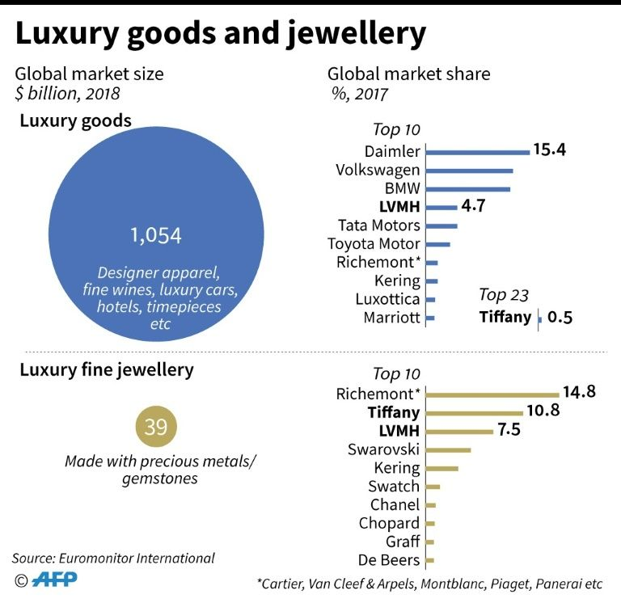

China’s sales in mainland China continue to be strong, according to Tiffany. To maintain its momentum, Tiffany was either opening or upgrading its flagship stores in three key metropolitan areas: Beijing, Shanghai and Hong Kong. It was also expanding its airport duty-free store networks. In Q3 2019, the company relocated and upgraded its directly owned store at the Hong Kong airport.

Cultural Heritage
Art inspires the creation of LVMH exceptional products thanks to a mastery of exquisite craftsmanship and the rare métiers that are an integral part of LVMH’s cultural assets. These unique cultural assets contribute to the exceptional reputation of luxury products around the world. LVMH thus naturally plays a prominent role in initiatives that support art and culture in order to share our passion for creativity with the widest possible audience.

Established in 2011, Les Journées Particulières is a three day affair inviting the public to experience the craftsmanship and unique Houses under LVMH. In this annual event, LVMH opens its doors to 55 brands, spread across 76 locations and 13 countries. Passed down through generations, Les Journées Particulières is a look behind the scenes at the artisanal excellence and “savoir-faire” of all the trades of each LVMH Group House.

Created by Antoine Arnault, heir to the LVMH Group and head of communications and image, in 2018 Les Journées Particulières placed an emphasis on the five senses, the passion for art and strive for excellence that is the brand’s identity. This world exclusive event allowed participants to take part in guided tours, interactive workshops, one of a kind tastings within Chaumet’s salons on Place Vendome, TAG Heuer and Hublot in Switzerland and even at the Acqua di Parma perfume house in Italy.

Since 2018, Les Journées Particulières has been expanding its international reach onto four continents. For instance, the public are invited to visit and partake in events hosted by wineries Cloudy Bay in New Zealand, Terrazas de Los Andes in Argentina and Napa Valley’s Newton. In the beauty sector, attendees can visit exhibitions and demonstrations organized by American brands such as Sephora and Benefits Cosmetics. Combining tradition and innovation, Les Journées Particulières provides the opportunity to discover the workings behind the scenes on the preservation of the cultural heritage and generations of expertise that is so unique to the LVMH Group.

LVMH’s M&A Capabilities
In 1984, Bernard Arnault learned that Christian Dior was for sale. Its parent company Boussac had filed for bankruptcy and the French government was looking for a buyer for the Paris-based brand that owned a number of companies, including Dior. 35-year old Mr. Arnault – who had spent the previous 10 years heading up the construction firm founded by his grandfather – took $15 million from his family, combined it with $45 million from French financial institution Lazard Frères, and purchased Boussac in a quest to get his hands on the famed French fashion house.

Within two years of acquiring Dior, Mr. Arnault had pushed Boussac into the black, laying off 9,000 workers and selling off Boussac's disposable-diaper division and most of its textile operations for $500 million. While that deal helped Mr. Arnault to leapfrog from his family's $15 million-a-year business to a company 20 times as large, an ever acquisition was to follow.

In 1990s, Mr. Arnault’s spree to gain control of Louis Vuitton Moet Hennessey, the merged fashion house and spirits company, in which Arnault first invested in the late 1980s. Since then, Arnault has spent billions of dollars and worked doggedly to amass no less than 70 luxury brands under the umbrella of what is now coined LVMH Moet Hennessey Louis Vuitton. The major milestones of brand acquisitions of LVMH before the Tiffany’s deal are stated as follows.

First, founded in 1952 as a couture and ready-to-wear brand, Givenchy has been part of the LVMH Group since 1988. Then, Kenzo -- the womenswear and menswear brand -- was acquired by LVMH in 1993 for $80 million. In addition, LVMH took over Guerlain in 1994. This French brand consisting of perfume, cosmetics, and skincare, was owned and managed by members of Guerlain family from its inception in 1828 to 1994. Next, Arnault bought into Céline’s capital in 1987, but it was only in 1996 that this brand was bought out and integrated into the LVMH Group for 2.7 billion French francs ($540 million).

Second, LVMH has held a majority stake in Marc Jacbos -- the New York-based brand founded in 1984 -- since 1997. Marc Jacobs, himself, became the creative director of womenswear for Louis Vuitton in 1997, staying until 2013, when he left to focus on his eponymous label. Acquired by LVMH in 1999, Thomas Pink is a recognized specialist in high-end shirts in the U.K. LVMH is understood to have paid around 30 million pounds to Thomas Pink's owner, the Irish Mullen family, for two-thirds of the company.
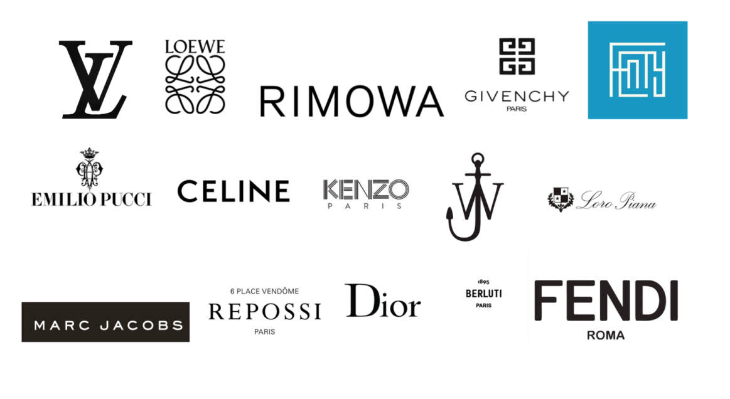
Third, Fendi – an Italian company founded in Rome in 1925 -- has been part of the LVMH Group since 2000. In July 2000, LVMH and Prada both acquired ownership stakes in Fendi. In December 2001, the former bought latter’s stake in Fendi, increasing its share in this target to 51 percent. The company further increased its ownership stake to 84 percent in February 2003.

Fourth, LVMH acquired Bulgari -- an Italian jewelry brand -- in an all-share deal for $6.01 billion. In this deal, the Bulgari family members sold their 50.4 percent controlling stake in exchange for 3 percent of LVMH. In addition, LVMH acquired a 41.7 percent stake in Repossi -- a family-run Italian jewelry brand -- in November 2015. The company increased its stake in Repossi to 69 percent in 2019.

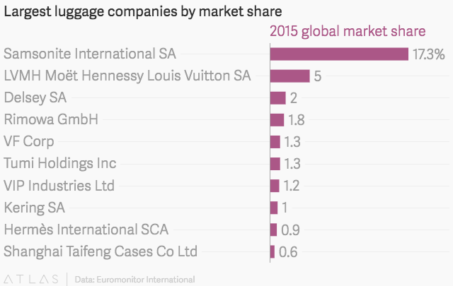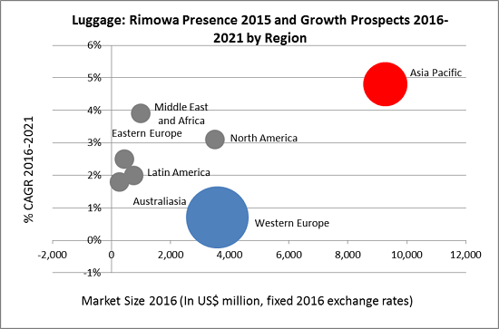

In particular, LVMH acquired an 80 percent stake in Rimowa -- a German luggage company, which was founded in 1989 -- for 640 million euros in October 2016. Year 2016 was a bumpy year for the uxury goods market, plagued by the decline in luxury spending by Chinese tourists, plunging oil prices which have led to a major currency shake-up in Latin America and Russia, terrorism threats in traditional luxury goods markets like France, and further economic upheaval triggered by Brexit.

In a market that is becoming increasingly saturated, the impending exit strategy of Rimowa, starting with the initial purchase of an 80% stake by LVMH, revealed the company’s uncertainty in surviving in the luxury goods market alone. Moreover, the global luxury travel goods industry saw decline of 4% from 2014-2015 with Rimowa’s key region, Western Europe, facing an even sharper decline of 12%. With a gloomy outlook for the luxury goods market due to an increasingly volatile global economic situation, coupled with Samsonite’s acquisition of Tumi, Rimowa was in a vulnerable position.

LVMH may have paid less than the EUR640 million it paid for Rimowa if the former had waited a little longer, due to the continued pressure on the luxury goods market. However, the Rimowa deal allowed LVMH to enhance its reputation as a luxury house, and to strengthen its foothold in the luggage industry.

Last but not the least, on April 25, 2017, LVMH bought out the Paris-based couture house – Christian Dior -- in a $13.1 billion deal. Prior to the deal, Groupe Arnault -- the private holding company holding owned and controlled by Bernard Arnault -- was the only declared major shareholder in Christian Dior. There were two parts of this deal-making:

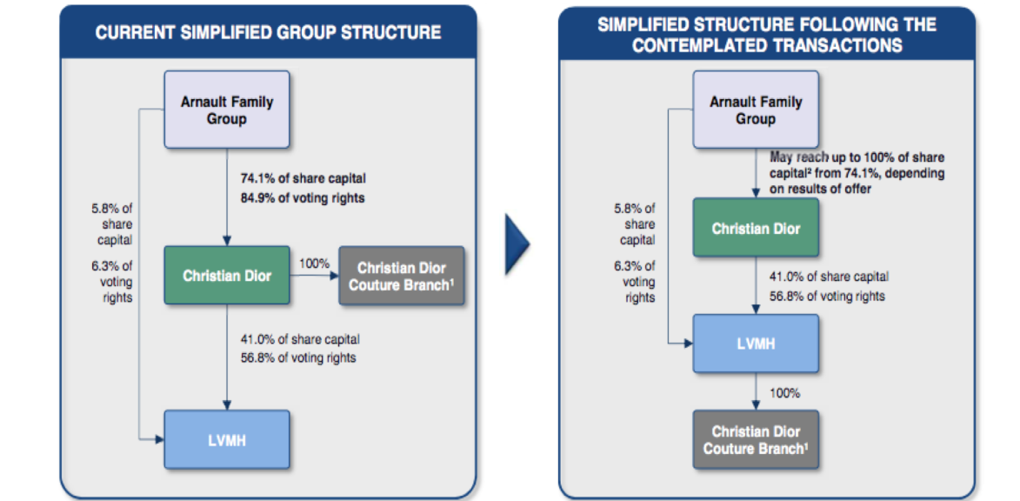

In part one, Groupe Arnault offered to buy the 26 percent of Christian Dior it had not already owned for €172 per share in cash and 0.192 Hermès International shares for each Christian Dior share. These values represented a 14.7 percent premium over Christian Dior’s latest share price and an 18.6 percent premium over its one-month average.

In part two, LVMH acquired Christian Dior Couture from Christian Dior for an enterprise value of €6.5 billion. The deal fused together the entire Dior brand, creating further synergies between Christian Dior Couture and the Parfums Christian Dior, the latter of which had been already fully owned by LVMH.

LVMH’s Performance Prior to the Announced Offer
The share prices of luxury goods powerhouses like LVMH, Hermès, and Kering all increased substantially in 2019. Since January 2019, LVMH has increased 59%, Hermès climbed 34%, and Kering grew 27%. The luxury brands are selling well with Europeans and Americans, though the three companies have been strongest with Chinese consumers.

For the full year of 2019, LVMH's revenue rose 15% with 10% organic growth. Its profit from recurring operations grew 15% as its net profit improved 13%. Those robust growth rates suggest that LVMH's core businesses remain well-insulated from macro headwinds. The company faced some challenges throughout 2019, but its strengths still outweighed its weaknesses. Its gross margin dipped 40 basis points to 66.2%, but tighter cost controls kept its operating margin unchanged at 21.4%. LVMH also raised its full-year dividend 13% to €6.80 ($7.51) per share, which includes a €2.20 payment in December 2019 and an upcoming payment of €4.60 in April 2020.

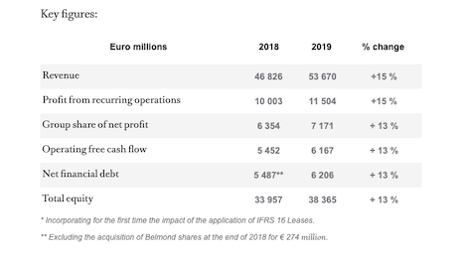
First, LVMH's fashion and leather goods revenue rose 20% (with 17% organic growth) in 2019 and accounted for 41% of its top line. Its profit from recurring operations grew 24% and accounted for 65% of its total operating profit. It attributed the unit's growth to the "remarkable" growth of Louis Vuitton and Christian Dior. Both brands expanded their reach with exhibitions and new stores during the year. LV notably reached for younger consumers with a new esports partnership with Tencent’s League of Legends.
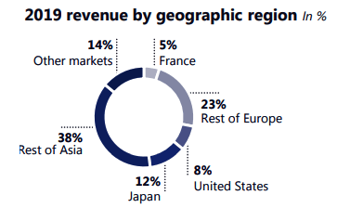

LVMH also promoted Fendi with a final tribute to the late Karl Lagerfield, rolled out new boutique stores and a high-end perfumery collection at Celine, unveiled new designs at Loewe, and reported "good progress" at Loro Piana, Rimowa, and Berluti. In short, LVMH's core business continues to widen its moat against high-end rivals like Kering and Chanel.

Next, LVMH's wines and spirits revenue rose 8% (with 6% organic growth) and accounted for 10% of its full-year revenue. Its profit from recurring operations, which accounted for 15% of its operating profit, improved 6%. It attributed that growth to a "normalization" of stock levels in the U.S. and higher sales in China ahead of the Chinese New Year. It noted that Hennessy cognac became the world's top premium spirits brand during the year, and that champagne sales -- which softened in the third quarter -- accelerated with stronger sales of pricier brands.

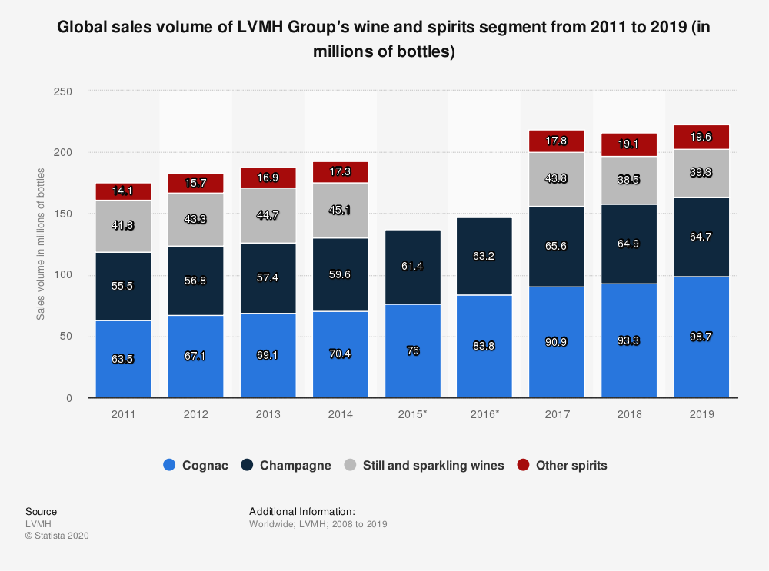

In addition, LVMH's watches and jewelry sales grew 7% (with 3% organic growth), accounting for 8% of its top line. Its profit from recurring operations rose 5% and accounted for 7% of its operating profit. Bvlgari, Chaumet, and Hublot all generated strong sales, while TAG Heuer -- a laggard in recent years -- streamlined its distribution network and worked on new designs. LVMH's upcoming acquisition of Tiffany, which is set to close in mid-2020, should further strengthen this business.

Moreover, LVMH's perfumes and cosmetics business, which accounted for 13% of its sales and 6% of its operating profit, experienced strong demand for flagship brands like Dior, Guerlain, and Givenchy. Rihanna's Fenty Beauty brand gave it a boost in western markets, while skincare products gained ground across Asia. As a result, the segment's revenue rose 12% (with 9% organic growth) for 2019. However, its profit from recurring operations grew just 1%, due to the exceptional depreciation of certain young American brands.
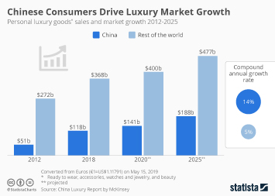

Lastly, LVMH's selective retail business, which generated 28% of its revenue and 12% of its operating profit, saw strong growth at Sephora -- especially in Asia and the Middle East -- which offset a slowdown at DFS in Hong Kong. Its total revenue rose 8% (with 5% organic growth), but its profit from recurring operations only rose 1%, indicating that the macro headwinds were pressuring its brick-and-mortar margins.

Prospect: Opportunities Ahead for Economy Reopening
Benefited from the governmental stimulus funds in both the U.S. and U.K., LVMH’s market and financial performance have grown unexpectedly well amid COVID-19 Pandemic since 2020 Q1. There has been strong demand for luxury goods across the borders, which propelled LVMH CEO Bernard Arnault to the top spot of the richest people in the world in 2021 Q1.

As a premium brand retailer, USA-based Tiffany & Co. used to reject any takeover attempt from potential buyers – especially those international luxury goods giants. The combination between LVMH and Tiffany & Co. underscores the polarisation within the luxury-goods industry between top-performing groups such as LVMH, Kering and Hermès, which benefit from size and scale, and some smaller brands such as Tiffany, which are struggling.

Nevertheless, as regulatory, trade, and economic uncertainties persist, the market is likely to continue at a slow pace in 2020, with companies in wait-and-see mode, particularly in North America where many transactions are on hold due to trade tensions, a slowing US economy and because presidential election years historically bring market volatility.

