Alibaba’s “New Retail” Strategy-Guided Ecosystem Stretching: Exercising Growth Options on French Sun-Art in China

First Version: June 26, 2021
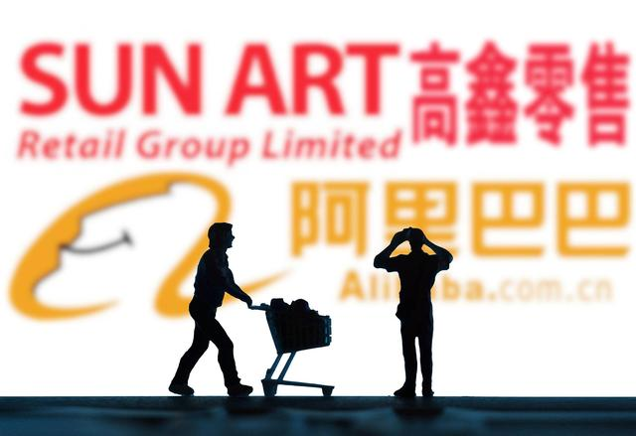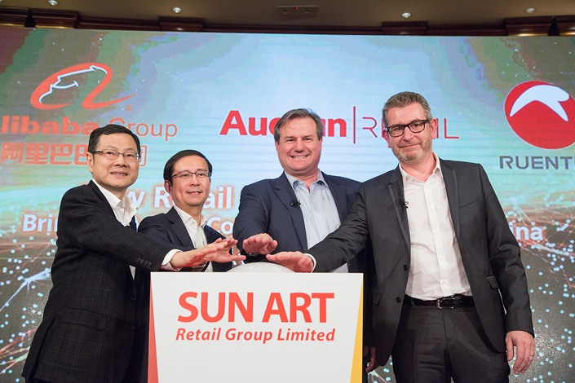

Current Situation
In exercising its growth options on China’s largest hypermarket network – Sun Art Retail Group, Alibaba Group has enhanced and stretched its retail ecosystem built upon its “New Retail” strategy. New Retail is the integration of online, offline, logistics and data across a single value chain. Moreover, it is an initiative aimed at connecting online and offline retail and digitizing stores in order to provide a better customer experience.

By the end of June 2021, the company has invented the supermarket of the future, which includes shopping bag conveyer belts, personalized food recommendations and facial recognition payments. This ecosystem-stretching effort has been benefited from Alibaba’s two-stage acquisitions of Sun Art in 2017 and 2020, respectively.

On October 19, 2020, Alibaba Group made a $3.6 billion acquisition of a controlling stake in China's largest hypermarket chain, Sun Art Retail Group. This latest deal help Alibaba leverage its technology prowess and strengthen its retail ecosystem in the fast-growing online grocery in China amid COVID-19 Pandemic.

Before the deal, Alibaba had held a 21% equity ownership in Sun Art through its equity-link deal in 2017. The former attained an additional 51% equity interests on the latter, through its purchase of a 71% share in A-RT Retail Holdings from France-based Auchan Retail International. Post-transaction, Alibaba’s stake in Sun Art increased to 72%.
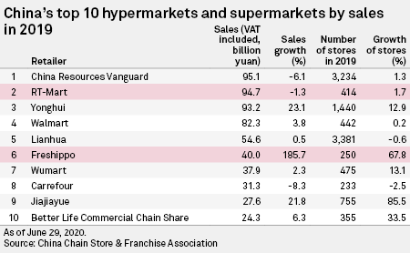

Since the outbreak of the coronavirus, the surge in online grocery sales has significantly outpaced the overall e-commerce market, rising 35.4% for the first three quarters in 2020, compared to 9.7% in all online retail. It also marks the acceleration from the 28.9% increase in online food sales on the year-on-year basis. Alibaba's ability to digitize offline retailers and the support of the Taobao and Tmall online marketplaces will enable the company to meet the rising demand for online groceries.

As part of its latest exploration in New Retail, Alibaba started the Community Marketplaces business enhanced by its acquisition of Sun Art in 2020. The company’s Community Marketplaces business is supported by our next-day pickup fulfilment services and the supply capabilities of Freshippo, Sun Art and other partners. Given the initial success and long-term growth potential, we established a new business group in 1Q 2021 to consolidate the resources and capabilities of the Alibaba Ecosystem in order to accelerate the growth of its Community Marketplaces business.

Introduction
COVID-19 generated an increase in demand for online sales of physical goods due to quarantine restrictions imposed in many countries. Overall retail sales declined by 1% in a group of seven countries in 2020 included in a survey report of United Nations, while online retail grew by 22%. China also has the largest online retail sales of US$1,414.3 billion in 2020, followed by the U.S. with $791.7 billion.

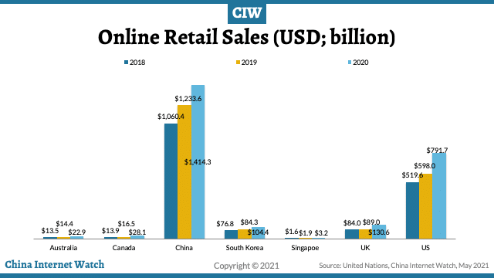

The COVID-19 Pandemic has significantly changed consumer behavior in China and could intensify the rivalry between Alibaba Group and Tencent Holdings in the low-priced online grocery segment. As China shifted to what has been dubbed a stay-at-home economy, consumers ordered fewer restaurant takeouts and cooked more, bought more home cleaning and personal hygiene products, and ordered fewer fashion and discretionary items. Sales of items such as yoga mats, pajamas and kitchen utensils also surged.

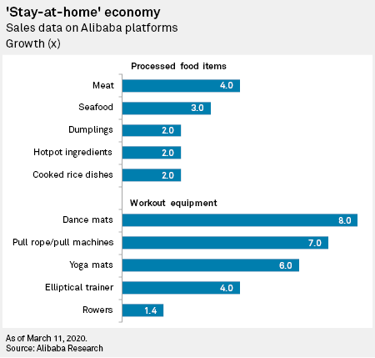

As the pandemic hits, the whole world did not have much choice but to enhance the speed of digitalization in their regions, with remote working and e-commerce being more active than ever. The already robust China speed was essentially on steroids after the COVID outbreak. The pandemic has further propelled digital developments and applications in China, which has been witnessed in a surge of e-medicine, online education, service robots, etc.

Thus, a surge in online sales as a result of store closures and quarantines imposed during the coronavirus outbreak has given further urgency to Chinese hypermarket operators' developing e-commerce efforts.

Shares of Sun Art Retail Group and Yonghui Superstores, two of the country's largest brick-and-mortar retailers, rallied during the outbreak due to strong online sales of essential consumer goods, including groceries. Sales were aided by the Chinese government's opening of a "green channel" to ensure a constant supply of food and essential items despite the travel and logistics restrictions that were in place amid COVID-19 Pandemic.

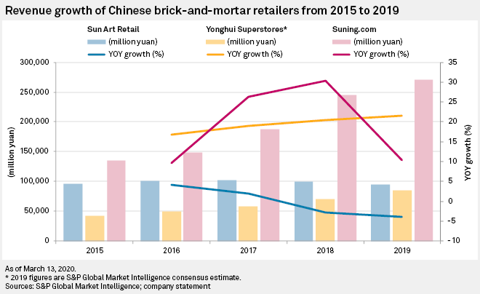

Strategic Motives
“As the COVID-19 pandemic is accelerating the digitization of consumer lifestyles and enterprise operations, this commitment to Sun Art serves to strengthen our New Retail vision and serve more consumers with a fully integrated experience,” Alibaba chairman and chief executive officer Daniel Zhang said.

In essence, Alibaba is striving to disrupt various forms of retail by integrating online technology into traditional retail modus operandi to enhance the overall customer experience. This 2020 strategic move followed a three-year initial equity link with Sun Art completed in 2017, Alibaba decided to exercise its growth options on scaling up its equity investment on China’s largest hypermarket network.

Sun Art-operated RT-Mart is China's largest hypermarket chain by sales with a 14.1% market share. The addition of its 481 hypermarkets and three supermarkets to Alibaba's more than 200 Freshippo supermarkets will create the largest operator in the combined hypermarkets and supermarkets space. The combined sales figure surpasses China Resources Vanguard Co. and JD.com-backed Yonghui Superstores Co.

With more than 75% of Sun Art's stores located in 3rd, 4th and 5th-tier cities as of the end of 1H 2020, the deal could enhance Alibaba's access to the smaller urban areas that have been instrumental to the rise of community buying platform Pinduoduo. Sun Art intended to open 30 mini-stores in 2020 as it sees expanding its footprint of smaller, community-based sites as an inevitable path to growth. The COVID-19 outbreak has shifted the sales of daily necessities online. Daily necessities have become high-frequency purchases after the pandemic, so the acquisition will help Alibaba to secure a stable supply chain for these items.

Given the existing relationship with Alibaba, few of Sun Art's operations need to be changed post-acquisition. However, Alibaba may integrate the supply chain and inventory of Sun Art and its entities like Hema (or called Freshippo outside China) . The full integration of sourcing, logistics and operational systems could give Alibaba improved bargaining power and the ability to cut costs at a scale that its closest competitors can hardly catch up with.

The Acquirer: Alibaba Group
Alibaba Group’s China consumer-facing businesses include China retail marketplaces, Local Consumer Services and digital media and entertainment platforms, serving the Chinese consumer sector, which is a RMB41.9 trillion (US$6.4 trillion) market for the fiscal year ended March 31, 2021.

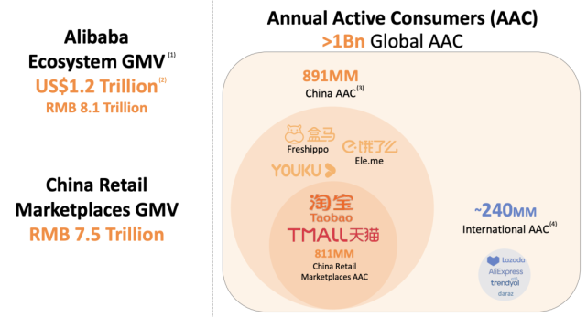

The company’s international retail marketplaces, which include mainly the AliExpress cross-border retail platform and Lazada in Southeast Asia, served approximately 240 million annual active consumers during the same period. Its China and international consumer segments combined to serve over one billion annual active consumers and generated RMB 8,119 billion (US$1,239 billion) in gross merchandize value (GMV).

In addition, Alibaba’s digital infrastructure, such as smart logistics and cloud computing, which enables and underpins across our platforms to serve its major commerce, local services and entertainment businesses, gives us unique technology-driven capabilities to meet changing consumer demand and help its enterprise customers and partners achieve digital transformation.

Thus, this cutting-edge digital infrastructure enables Alibaba to digitize offline retailers and to support the Taobao.net and T-mall online marketplaces. The strategic objective is to meet the rising demand for online groceries. The company also holds a majority stake in electronics retailer Suning.com and an 18% interest in Lianhua Supermarket Holdings.

The Target: Sun Art Retail Group
Sun Art is a leading retailer with hypermarket and fast-growing e-commerce businesses in China. Sun Art Retail operates its business with hypermarkets, superstores and mini stores under RT-Mart, RT-Super and RT-Mini. As of 31 December 2020, Sun Art Retail had a total of 484 hypermarkets, six superstores and 24 mini stores in China with a total gross floor area of approximately 13.07 million square meters, covering 232 cities across 29 provinces, autonomous regions and municipalities.

The company operates the Auchan and RT-Mart hypermarkets. It fulfills orders for Alibaba's Taoxianda fresh produce platform and enjoys membership and supply chain integration within Alibaba's ecosystem. RT-Mart's online revenue of 2019 grew 6.5% following its integration with Taoxianda in 2018. As a result, Sun Art had been well-placed to transition to an online-first model in 1H 2020.

When it comes to corporate strategy, Sun Art aims to synchronize hypermarkets, superstores and mini stores, to integrate online and offline business, to develop multi-formats as well as omni-channels. The strategic objective is to become a leader in digital transformation and a benchmarking enterprise for New Retail.

A major challenge for Sun Art’s current strategy adopted is the emergence of niche grocery apps, such as Ding Dong and MissFresh. Sun Art faces competition from upstarts that are also backed by Alibaba and JD.com: Alibaba's Hema and JD.com's 7Fresh are high-tech supermarkets that are open 24/7 and offer round-the-clock deliveries for online orders. Both Alibaba and JD.com, who have ramped up online grocery offerings, reported large increases in online grocery orders during the coronavirus outbreak.

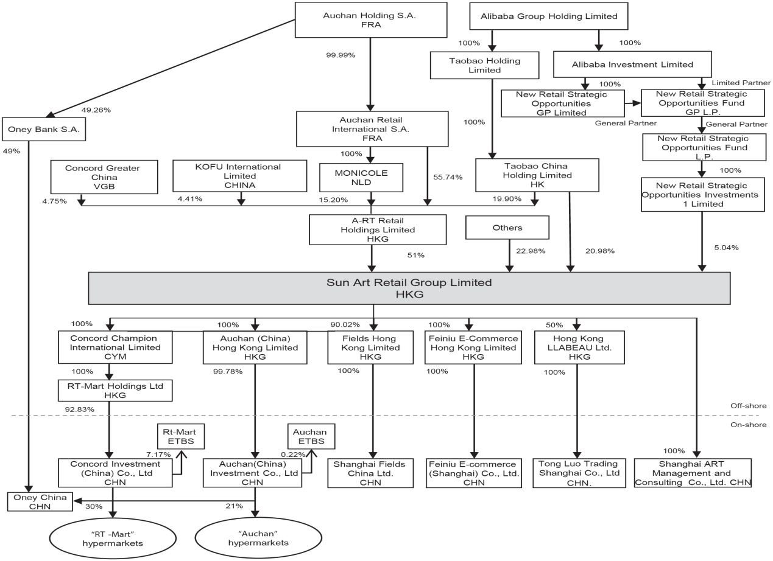

Prior to the buyout offer made by Alibaba in 2020, Sun Art has 7 institutional owners and shareholders that have filed 13D/G or 13F forms with the Securities Exchange Commission. These institutions hold a total of 904,148 shares. The top two institutional investors held near 72% of Sun Art’s shares outstanding.

Thus, though the structuring of Sun Art is complicated, the institutional shareholdings make the acquisition feasible. On June 30, 2020, Sun Art’s Interim Report showed that the persons or corporations (other than Directors or chief executives of the Company) who had interests or short positions in the shares and underlying shares of the Company or its associated corporation(s) which were recorded in the register required to be kept under section 336 of the SFO as follows.

Key financial figures are summarized as follows. Sun Art's rental expense as a percentage of revenue increased to 9.8% in 2018 from 6.5% in 2011. Prolonged store closures and reduced operating hours during the lockdown will drive up the rental expense during 1Q 2020, putting pressure on the retailer to move more towards an asset-light, e-commerce business model.

The calculation of Sun Art’s earnings per share is based on the profit attributable to equity shareholders of the Company of RMB 2,062 million (six months ended 30 June 2019: RMB1,766 million) and the weighted average of 9,539,704,700 ordinary shares (six months ended 30 June 2019: 9,539,704,700 ordinary shares) in issue during the interim period.

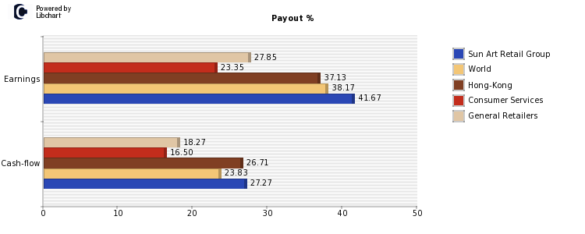

Regarding the dividend policy, Sun Art maintained its current dividend of HKD 0.15 per share as of March 31, 2021. The company’s payout on earnings is currently 41.67%, which is higher than the market average, and companies of Consumer Services industry, which are 38.17% and 23.35% respectively.

Sun Art opened up many flagship stores for diverse retail methods in 2020. Larger malls have suffered from the competition of online sales in recent years. Their market share continues to decline. At the same time, consumer demand for a convenient shopping experience is growing. That is why the expanding network of small-scale neighborhood stores is an important development in the industry.

Overall, Sun Art is likely to undergo cannibalization between its online and offline sales amid its new retail transformation. In addition, the grocery market in China is highly fragmented with a lot of room for online players to consolidate.

“New Retail” Business Model: Hema as the Showcase
Hema is the showcase for Alibaba’s “New Retail” strategy, which pays the way for the future of retail. Part of Alibaba’s success in designing a store around a smartphone app is due to the high mobile phone usage in China. Most internet traffic in China is generated on a mobile phone vs. only 48% of web traffic in the U.S.

Coined by Alibaba’s Founder Jack Ma in 2016, “New Retail” is “the integration of online, offline, logistics and data across a single value chain.” It is an initiative aimed at connecting online and offline retail and digitizing stores in order to provide a better customer experience. Alibaba is evolving to establish New Retail infrastructure, empowering brands with data. Leading brands are gaining an edge by using the emergence of New Retail as an occasion to build a new consumer-centric model while at the same time creating operations that are more efficient.
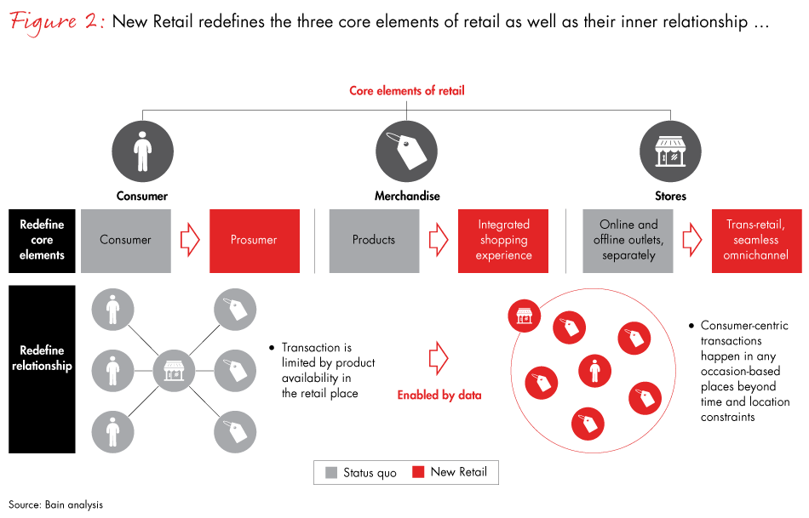

Customers enjoy the shopping experience at Hema with millions of people signing up for the Hema shopping app and more than 60% of Hema’s gross merchandise value (GMV) coming from online orders. To get a sense of how quickly Alibaba is expanding these stores consider the fact that Amazon opened eight Amazon Go stores in the same amount of time that Alibaba opened 100 Hema supermarkets.

It does not look like the growth of Hema stores is slowing down anytime soon, because Alibaba plans to open 2,000 of these stores by 2023. There are the following key elements of this New Retail Business Model in Hema as follows.

1. Scan and go. To shop at Hema customers have to download the Hema mobile app. Once it is downloaded customers shop by scanning QR codes on each item they wish to purchase then the item is added to their digital shopping cart. Scanning a product’s QR code also provides the customer with information about the product including how fresh it is. Other data that is available includes nutritional information, customer reviews, recipes the customer can make using the product as well as delivery options if the customer wants the item delivered to their home.

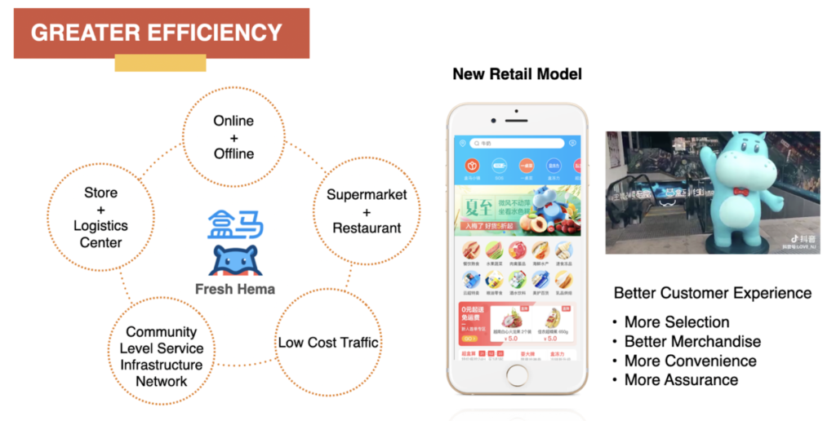

2. Personalized shopping recommendations using artificial intelligence. The Hema app also remembers shopper buying behavior and leverages machine learning to make personalized product recommendations for customers.

3. Digital price tags. Products have digital price tags that can be updated in real time. They can be particularly useful if Hema wants to, say for example, update the price of seafood based on market rates. It also allows the retailer to ensure that prices online match in-store when necessary.

4. Stores as fulfillment centers. Employees pick online orders in store and once they have been picked they are placed on a conveyor belt that carriers the order to the back of the store to get it ready for delivery.

5. Digital payments including facial recognition. When customers are finished shopping they pay using Hema's mobile app which is linked to Alipay. This online payment has more than one billon monthly active users.

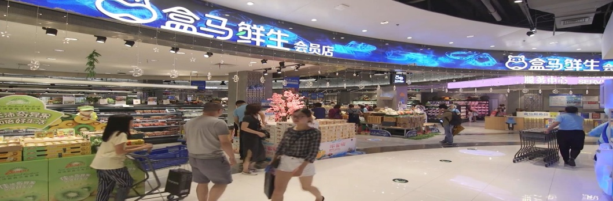

6. Super fast delivery (even faster than Amazon). Customers shopping at Hema can have groceries delivered in 30 minutes for free, if the delivery address is within three kilometres of a Hema store. This applies to customers that shop in store and want their orders delivered to their homes or if they made the purchase online. This service is even faster than Amazon’s.

7. Stores as delivery hubs for other retailers. To improve its delivery capabilities in China, in 2018 Starbucks added Starbucks Delivers Kitchens within selected Hema stores. The partnership allows Starbucks to leverage Hema’s delivery capabilities to service Starbucks’ online orders quickly and efficiently.

8. Experiential retail. Hema supermarkets are essentially grocery store / restaurant hybrids where customers can shop for groceries as well as sit down and have dinner with their family if they choose to. Customers like the fact that they can easily choose a fresh piece of seafood and then it is cooked fresh for the customer to eat while they are at the restaurant.

9. Automated service using robots. In one of Hema’s supermarkets there is a restaurant called “Robot.He” where the majority of food dishes are delivered to customers using robots. Employees do something they haven’t gotten the robots to do yet, and that’s cook the food. When a customer arrives at their table they simply scan a QR code at the table then they can order food using, of course, the Hema app.

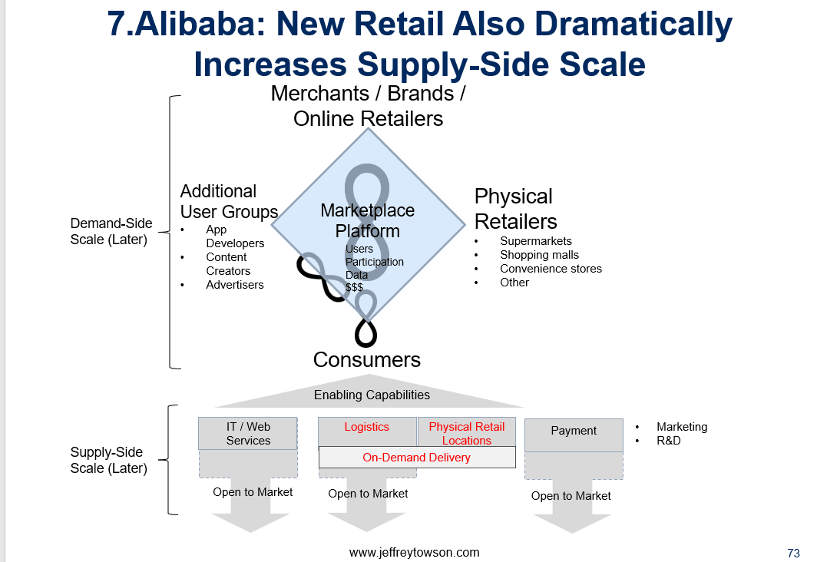

Finally, the key to unlocking the full value of Alibaba’s Community Marketplace model is not only about the standalone P&L (Profit and Loss) of the business, but also about the operating efficiency and servicing capabilities of the retail ecosystem. The servicing capabilities can generate far greater value than operating efficiency. Alibaba has the most sophisticated and efficient commerce infrastructure in China, with comprehensive product and service offerings to serve consumers of diverse segmentation and demands.

Evolution of the Deal-Making
On November 21, 2017, Alibaba Group announced to invest US$2.9 billion to buy over a 36.16 percent stake in Sun Art Retail Group from Taiwan-based Ruentex Group. Auchan Retail SA, an existing shareholder of Sun Art, raised its holding in the retailer to 36.18 percent, leaving Ruentex Group with just 4.67 percent. Auchan Retail is a French international retail group and is one of the largest hypermarket and supermarket chains in the world.

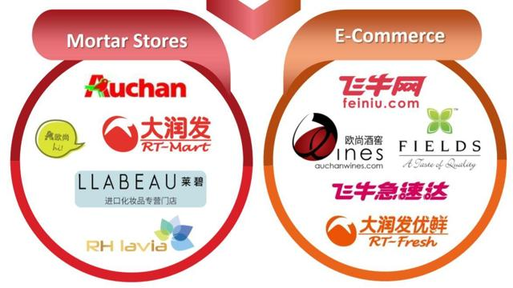

From the strategic perspective, Alibaba Group's US$2.9 billion investment into Chinese hypermarket operator Sun Art Retail Group marked an ongoing trend in the integration of e-commerce and brick-and-mortar businesses. A 36.16% stake in Sun Art further extended the Chinese online giant's reach into offline retail. This initial equity tie granted Alibaba to get access to superstores, unmanned stores and more than 440 big-box stores operating under the Auchan and RT-Mart banners across China.

Alibaba's agreement comes just months after Amazon.com Inc.'s US$13.7 billion acquisition of Whole Foods Market in 2017. Both deals reflected efforts by online majors to court shoppers through sales channels for consumer staples.

For e-commerce platforms, expanding the product selection in supermarkets, fresh food or fast-moving consumer goods is very important because it brings users back to the platforms more frequently. That's the appeal, that you can integrate offline retailers in some of that product selection with your online platform.

However, the two deals differ in terms of the targets' business focus and strategic significance to the buyers. Whole Foods seems to focus more on premium foods rather than convenience. Over 370 stores in Sun Art's network can provide one-hour delivery within 3 miles, but hypermarkets are not a premium channel.

This first-stage equity investment led to the digitization of RT-Mart's operations in line with Alibaba's Freshippo, which included omnichannel features such as in-store fulfillment of online orders and interactive kiosks. All of Sun Art's hypermarkets and supermarkets are now integrated into Alibaba's platforms, including its online grocery platform Taoxianda, online food delivery platform Ele.me and logistics arm Cainiao. Alibaba said that Cainiao’s half-day delivery service helped Sun Art capture new online customers and accounted for about 15% of revenue.

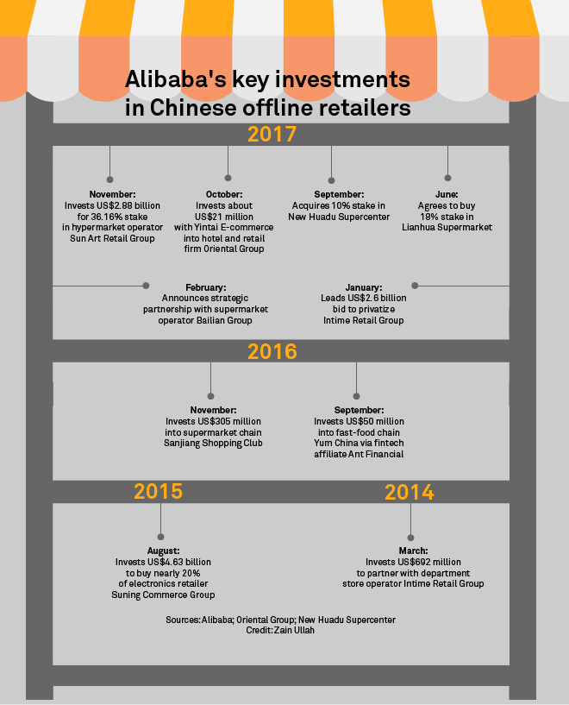

Nevertheless, Sun Art found itself jostling with other Alibaba-backed supermarket entities and rivals in an increasingly crowded space. It is unlikely that Freshippo and Sun Art's stores got merged in the future, given their vastly different positioning and operations. With its slick cashless checkouts and greater variety in the fresh produce category, Freshippo is aimed at higher-end consumers.

Emerging players have flocked in, such as Tencent Holdings-backed online grocery platform Missfresh, online food delivery company Meituan Dianping, and Byte Dance-owned news aggregation app Jinri Toutiao. This is an inevitable trend for the online services providers to meet the increasing demand for online fresh produce groceries in amid the COVID-19 Pandemic.

On October 19, 2020, Alibaba Group Holding Ltd announced to make its second stage investment in Sun Art: A $3.6 billion offer for acquiring a controlling stake in Sun Art Retail Group. Alibaba could attain an additional 51% equity ownership through the purchase of a 71% share in A-RT Retail Holdings from France-based Auchan Retail International. Post-transaction, Alibaba’s stake increased from the initial 21% to 72%.
The deal is in line with Alibaba’s “New Retail” strategy of creating a seamlessly integrated shopping experience that blurs the boundaries between online and offline commerce. As such, Alibaba will allow offline retail customers to pay with the same digital payment methods that are also available online and enable shoppers to view relevant product information by scanning QR codes. Also, customers can use the physical retail stores as pickup points for online orders.

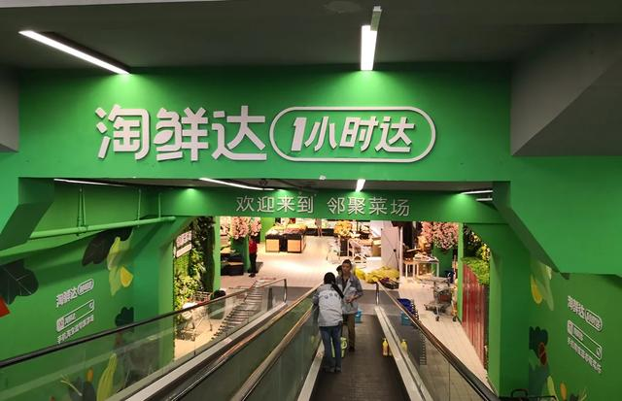
After the transaction, all of Sun Art’s 484 Chinese physical retail stores will be integrated into Alibaba’s Tmall and Taoxianda supermarket platforms, as well as other key businesses across the Alibaba ecosystem. These include the food delivery app Ele.me and the logistics business Cainiao. For instance, Taoxianda, which is Alibaba’s online-offline retail integration service solution for FMCG brands and third-party grocery retail partners, has driven Sun Art’s digitalization of its hypermarkets and, along with Alibaba’s other businesses, facilitated the growth of Sun Art’s online revenue.

As a result, Alibaba can ensure fast deliveries and an extensive product offering while collecting actionable customer insights that can be used to advance its business operations and supply chain.

Competitive Dynamics in China’s Digitalized Retail Landscape
Alibaba is far ahead of its rivals in the game of digitizing brick-and-mortar grocery retail. The company has spent a lot of time building the ecosystem. It is very hard to replicate and that is its strength compared to its rivals. Thus, Alibaba has long enjoyed the first-mover advantage and it hasn't stopped investing, creating a chain effect to its business model.

Since its launch in 2016, Hema has opened over 100 stores across China with the recent promise of a 24-hour delivery service for online orders on the Hema mobile app. Alibaba continues to open Hema stores across China, but did not provide specific numbers. Although Alibaba has no plans to expand its Hema stores into international markets, the supermarket chain is branded with an English name, "Freshippo" outside China.

Every Hema store has a restaurant where customers can reserve a table by scanning a barcode, access the menu and make orders on the Hema app, and get served by robots that greet them after each delivery. Alibaba is also partnering with other local retailers to bring the technology used in Hema locations to their stores. As one of the retailers adopting Hema's payment and fulfillment technology, RT-Mart has attracted more young customers because of it.

On the other hand, JD.com-operated logistics remains its key advantage and it will continue to have lower sourcing costs in the premium categories preferred by consumers in the 1st and 2nd-tier cities. The online retailer also has an inventory partnership with Walmart.

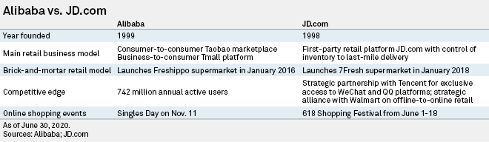

JD.com invested further in its supermarket business amid an accelerating shift toward online grocery in the wake of the COVID-19 outbreak. The company reported a 29.2% revenue increase in its earnings of 3Q 202: Total order volume in the Chinese retailer's supermarket unit grew 48% year over year, contributing to a 35% increase in gross merchandise revenue. The supermarket category is a key growth area that we are very committed to continuing our investment in to further strengthen our consumer mindshare and market leadership.

Strong growth was seen in all fresh produce categories during the 3rd quarter 2020, excluding imported seafood after the COVID-19 outbreak was found on some inbound frozen products. The fresh produce category is a challenge for online retailers, due to its small ticket size and high loss ratio during the production and fulfillment processes.

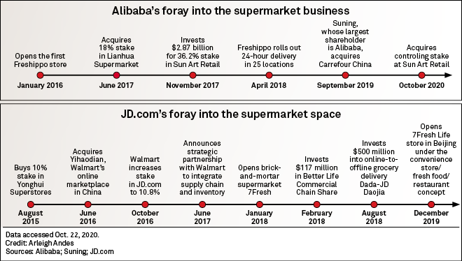

Owning the 7Fresh supermarket chain, JD.com has been experimenting with different business models including community group purchasing and warehouse distribution. Investment was poured into infrastructure and logistics, an area in which JD.com believes it has an edge over its competitors.

By the end of 2021, JD.com plans to have 49 of its own 7Fresh supermarkets operating in China. The company has tweaked the name it gives the strategy – it calls it “Unbounded Retail” – but that’s where the differences end. All 7Fresh stores are equipped with blockchain technology, which enables products to be traced through the supply chain.

Overall, as with Freshippo, all 7Fresh stores double up as fulfillment centers. Doing so has allowed JD.com to overcome a big sticking point when it comes to the profitability of selling groceries online – the resource required to pick items, pack them into bags and transport them to customers. By combining both online and in-store inventory under one roof, and speeding things up with digital technologies that track items and process online orders, it has reduced cost and increased efficiency.

Post-Acquisition Integration: Merging Online with Offline
China has the world’s largest grocery market, overtaking the U.S. in 2012. The merger between an offline retailer and an ecommerce counterpart has become the mainstream strategic move to drive sales across the spectrum. China’s new-generation digitalized retail outlets – e.g., Hema and 7Fresh -- are bridging the gap between online and offline retailers.

By integrating technology into physical stores, these New Retailers enable easier inventory management and seamless customer data. Thus, collaborating across two major sectors could provide more efficient services for customers. By combining warehouse networks and cold storage for online and offline sales, New Retailers can cover far more areas and shorten delivery times.

From the perspective of Sun Art, Year 2020 paid way for transforming the company’s strategic direction and for polishing its business models for multi-formats and omni-channels development. Post the acquisition, Sun Art’s future is an era of Internet and New Retail. The Sun Art network extends to 486 outlets, and this buyout in 2020 has been seen as an extension of Alibaba’s “New Retail” strategy.

As Alibaba becomes the controlling shareholder of Sun Art, it will definitely bring in new vitality and impetus. Looking to the future, 2021 is a year of investment and the first year of launching new business models. Sun Art expects that the revenue will return to a high-speed growth trajectory by 2023. In May 2021, the company also announced the arrival of new CEO, Lin Xiaohai, who previously served as a vice president at Alibaba.

In the post-acquisition integration stage, creating collaborative business models is far more complex than Alibaba’s journey makes it seem. They are not just acquiring new companies and brands; moreover, they’re creating a hybrid of online and offline retail arms. Not only does it involve the implementation of innovative supply chain technology, but also the management of transport networks and customer relationship to create a more personalized shopping experience.

Prospect: Institutional Challenges Ahead for Alibaba’s Retial Ecosystem
The two-stage acquisitions of Sun Art both enhance and stretch Alibaba’s retail ecosystem. In parallel with this acquisitive growth path, Alibaba has well-crafted its New Retail strategy since 2016, such as its internally-developed Fresh Produce Supermarket Chain – Hema. The servicing capabilities for such New Retail ventures include shopping bag conveyer belts, personalized food recommendations, and facial recognition payments.

There are now more than 200 Freshippo supermarkets up and running in China, all serving as both ultra-high-tech supermarkets and state-of-the-art fulfillment centers. They are all owned and operated by Alibaba as part of its plan to take the lead on what it calls “New Retail”. And as supermarkets in the west emerge from the effects of the pandemic, Freshippo may well provide a blueprint for how they’ll reimagine their own stores too.
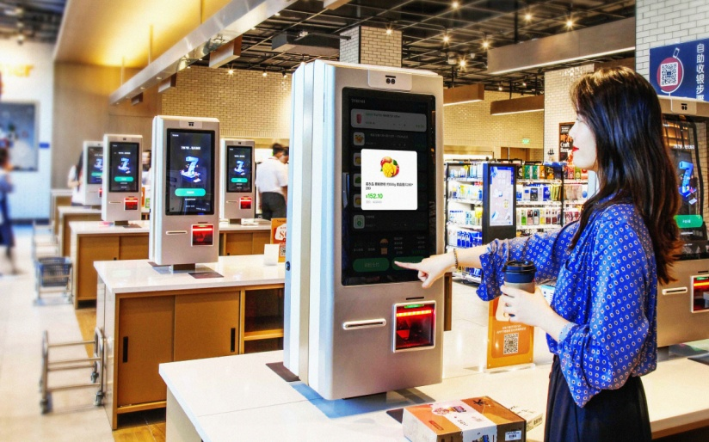

On January 15th, 2021, Sun Art announced that its subsidiary RT Mart China has concluded an agreement with Alibaba Network Technology for the transfer of equity shares. RT Mart China agrees to purchase and Alibaba Network Technology agrees to sell 51% of the shares in Hema Fresh. The price is 25.5 million yuan (3.94 million USD).

Prior to the deal RT Mart China held 49% of the shares and Alibaba Network Technology held 51% of the shares. After the deal concluded, RT Mart China held all of the shares, turning Hema Fresh into a wholly owned subsidiary of Sun Art Retail Group. The combination of Hema Fresh stores and RT Mini Mart stores creates a network of distribution nodes. Many clients currently have their products delivered at home, but distribution cost is high and full coverage is difficult to achieve. Turning convenience stores into distribution points is a way of integrating online and offline retail, which reduces distribution cost and enhances coverage.

Turn to the anti-trust concerns side. For the quarter ended March 31, 2021, Alibaba reported a $1.2 billion operating loss as a result of the $2.8 billion fine levied by China’s State Administration for Market Regulation (SAMR). Calling the fine a “one-time impact,” Alibaba said that its income for the quarter would have been $1.6 billion—a 48% increase year over year—had it not been for the penalty. For the full fiscal year 2021, Alibaba recorded 41% growth in revenue to $109 billion.

The antitrust fine, levied in April 2021, resulted from a probe that state regulators launched in November 2020. The investigation came after founder Jack Ma publicly criticized China’s financial regulators, and regulators scuttled the planned $37 billion IPO of Ant Financial, Alibaba’s fintech affiliate that Ma also founded. Regulators have forced Ant to restructure as a financial holding company, a move that will subject Ant to regulations similar to those applied to banks.

In addition to its online payment business, there’s other concern among analysts that growth in its burgeoning cloud-computing segment. This business segment is central to the big-data analytics capability of Alibaba’s Retail Ecosystem. Revenue of Fiscal Year 2021 from Alibaba Cloud grew by 50% year on year to RMB 60 billion ($9.2 billion), which could open it up to more government oversight.

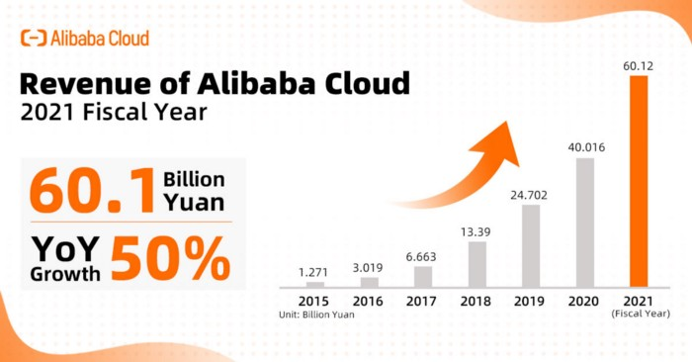

In specific, there are risks in cloud computing related to cybersecurity, data ownership, and difficulties in data protection. China is expected to enact a revised Data Security Law (DSL) sometime this year, providing the Cyberspace Administration of China with rule-making powers to govern cross-border data transfers by other holders or processors of data, like e-commerce providers, and to increase penalties for breaches of the DSL law.

