English Writing for Academic Purposes
Poster Layout

Task 1
Directions: With a partner, try to decide how you would read this poster based its format? Label which boxes you would look at from 1-9
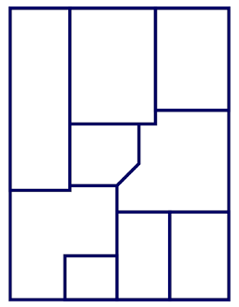

Task 2
Directions: With a partner, discuss what you like and dislike about each of the following posters
