Write 7010
English Writing for Academic Purposes
Worksheet 1

Task 1
- Compare these two versions of text.
  - Which would be a paper, and which might be a script for a presentation?
    - How can you tell?

A | B
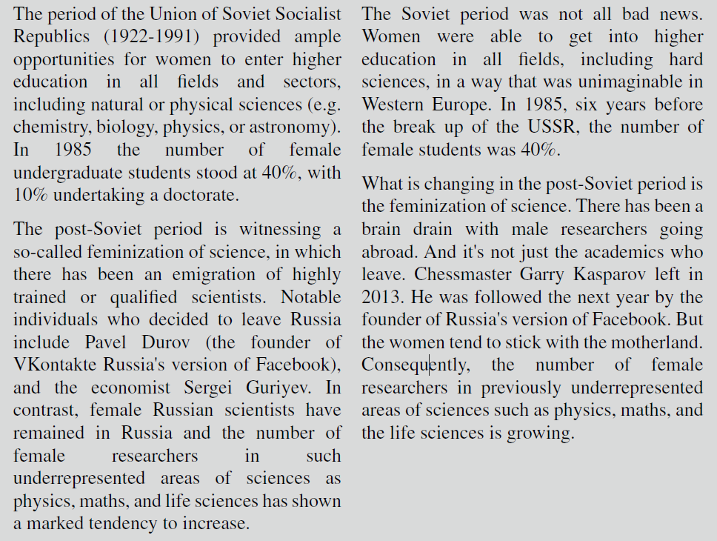

Task 2
- How would you simplify the original text so that it is easier to say? Work with a partner and produce a version that is easier for you to say out loud. Consider the things discussed in class thus far.

In 2016, Kay proved that most people speak at a speed of one hundred and twenty to two
hundred words per minute, but that the mind can absorb information at six hundred words
per minute.

Task 3
- Work with a partner Identify what words or phrases are deserving of more emphasis or contrast in comparison to the rest of the sentence(s). How might you emphasize these words to convey some level of meaning? Meaning can be things such as importance, reaction, feelings. Be emotionally prepared to perform your version.

- The entire world can take enormous pride in these historic achievements

- We can break the cycle of poverty

- Despite the cruelties of our world and the ravages of disease, millions of lives can be saved if we are focused, and if we work together

- And yet, we are also here today because we understand that our work is nowhere near done

- The wealthiest and most powerful in our societies oftentimes like to keep things as they are, and they often have disproportionate political influences

