True / False

1. According to classical macroeconomic theory, changes in the money supply change nominal but not real variables.
 | a. | True
 | b. | False

ANSWER: | True

2. According to classical macroeconomic theory, changes in the money supply change real GDP but not the price level.
 | a. | True
 | b. | False

ANSWER: | False

3. Because economists understand what things change GDP, they can predict recessions with a fair amount of accuracy.
 | a. | True
 | b. | False

ANSWER: | False

4. Recessions occur at irregular intervals and are almost impossible to predict with much accuracy.
 | a. | True
 | b. | False

ANSWER: | True

5. The recessions associated with the business cycle come at regular intervals.
 | a. | True
 | b. | False

ANSWER: | False

6. Most macroeconomic variables that measure some type of income, spending, or production fluctuate closely together.
 | a. | True
 | b. | False

ANSWER: | True

7. Like real GDP, investment fluctuates, but it fluctuates much less than real GDP.
 | a. | True
 | b. | False

ANSWER: | False

8. When output rises, unemployment falls.
 | a. | True
 | b. | False

ANSWER: | True

9. An increase in the money supply causes output to rise in the long run.
 | a. | True
 | b. | False

ANSWER: | False

10. Although wages, incomes, and interest rates are most often discussed in nominal terms, what matters most are their real values.
 | a. | True
 | b. | False

ANSWER: | True

11. Most economists believe that classical theory describes the world in the short run but not in the long run.
 | a. | True
 | b. | False

ANSWER: | False

12. A change in the money supply changes only nominal variables in the long run.
 | a. | True
 | b. | False

ANSWER: | True

13. Most economist agree that money changes real GDP in both the short and long run.
 | a. | True
 | b. | False

ANSWER: | False

14. The explanations for the slopes of the aggregate demand and short-run aggregate supply curves are the same as the explanations for the slopes of demand and supply curves for specific goods and services.
 | a. | True
 | b. | False

ANSWER: | False

15. The aggregate-demand curve shows the quantity of domestic goods and services that households, firms, the government, and customers abroad want to buy at each price level.
 | a. | True
 | b. | False

ANSWER: | True

16. The aggregate demand and aggregate supply model helps us to understand both short-run economic fluctuations and how the economy moves from the short to the long run.
 | a. | True
 | b. | False

ANSWER: | True

17. A decrease in the price level makes consumers feel wealthier, so they purchase more. This logic helps explain why the aggregate demand curve slopes downward.
 | a. | True
 | b. | False

ANSWER: | True

18. The logic of the exchange-rate effect begins with a change in the price level changing the interest rate.
 | a. | True
 | b. | False

ANSWER: | True

19. Other things the same, a decrease in the price level makes the interest rate decrease, which leads to a depreciation of the dollar in the market for foreign-currency exchange.
 | a. | True
 | b. | False

ANSWER: | True

20. Other things the same, as the price level falls, the exchange rate rises. A rise in the exchange rate leads to a decrease in net exports.
 | a. | True
 | b. | False

ANSWER: | False

21. The exchange-rate effect is the idea that a higher U.S. price level causes the value of the dollar to increase in foreign exchange markets, and this effect contributes to the downward slope of the aggregate-demand curve.
 | a. | True
 | b. | False

ANSWER: | True

22. The downward slope of the aggregate demand curve is based on logic that as the price level rises, consumption, investment, and net exports all fall.
 | a. | True
 | b. | False

ANSWER: | True

23. Aggregate demand shifts to the left if the money supply increases.
 | a. | True
 | b. | False

ANSWER: | False

24. A decrease in the money supply causes the interest rate to rise so that investment falls.
 | a. | True
 | b. | False

ANSWER: | True

25. An increase in the money supply causes the interest rate to fall, investment spending to rise, and aggregate demand to shift right.
 | a. | True
 | b. | False

ANSWER: | True

26. If speculators bid up the value of the dollar in the market for foreign-currency exchange, U.S. aggregate demand would shift to the left.
 | a. | True
 | b. | False

ANSWER: | True

27. The effect of a change in the value of the dollar in the foreign exchange market due to a change in the price level helps explain the slope of aggregate demand, but does not shift it. The effects of a change in the value of the dollar in the foreign exchange market due to speculation is shown by shifting the aggregate demand curve.
 | a. | True
 | b. | False

ANSWER: | True

28. An increase in the money supply shifts the long-run aggregate supply curve to the right.
 | a. | True
 | b. | False

ANSWER: | False

29. Technological progress shifts the long-run aggregate supply curve to the right.
 | a. | True
 | b. | False

ANSWER: | True

30. Other things the same, technological progress raises the price level.
 | a. | True
 | b. | False

ANSWER: | False

31. Because the price level does not affect the long-run determinants of real GDP, the long-run aggregate-supply is vertical.
 | a. | True
 | b. | False

ANSWER: | True

32. We can explain continued increases in both output and the price level by supposing that only aggregate demand shifted right over time.
 | a. | True
 | b. | False

ANSWER: | False

33. If not all prices adjust instantly to changing economic circumstances, an unexpected fall in the price level leaves some firms with higher-than-desired prices, and these higher-than-desired prices depress sales and induce firms to reduce the quantity of goods and services they produce.
 | a. | True
 | b. | False

ANSWER: | True

34. When the price level rises unexpectedly, some businesses may mistake part of the increase for an increase in the price of their product relative to others and so decrease their production.
 | a. | True
 | b. | False

ANSWER: | False

35. All explanations for the upward slope of the short-run aggregate supply curve suppose that the quantity of output supplied increases when the actual price level exceeds the expected price level.
 | a. | True
 | b. | False

ANSWER: | True

36. The only way to rationalize an upward slope for the short-run aggregate-supply curve is to argue that wages are sticky in the short run.
 | a. | True
 | b. | False

ANSWER: | False

37. An increase in the expected price level shifts the short-run aggregate supply curve to the right.
 | a. | True
 | b. | False

ANSWER: | False

38. An increase in the actual price level does not shift the short-run aggregate supply curve, but an expected increase in the price level shifts the short-run aggregate supply curve to the left.
 | a. | True
 | b. | False

ANSWER: | True

39. Fluctuations in real GDP are caused only by changes in aggregate demand and not by changes in aggregate supply.
 | a. | True
 | b. | False

ANSWER: | False

40. Increased uncertainty and pessimism about the future of the economy lead firms to desire less investment spending which shifts the aggregate-demand curve to the left.
 | a. | True
 | b. | False

ANSWER: | True

41. Increased optimism about the future leads to rising prices and falling unemployment in the short run.
 | a. | True
 | b. | False

ANSWER: | True

42. In response to a decrease in output, the economy would revert to its original level of prices and output whether the decrease in output was caused by a decrease in aggregate demand or a decrease in short-run aggregate supply.
 | a. | True
 | b. | False

ANSWER: | False

43. If aggregate demand shifts right, then eventually price level expectations rise. The increase in price level expectations causes the short-run aggregate-supply curve to shift to the left.
 | a. | True
 | b. | False

ANSWER: | True

44. If aggregate demand shifts right, then eventually price level expectations rise. This increase in price level expectations causes the aggregate demand curve to shift to the left back to its original position.
 | a. | True
 | b. | False

ANSWER: | False

45. If aggregate demand and aggregate supply both shift right, we can be sure that the price level is higher in the short run.
 | a. | True
 | b. | False

ANSWER: | False

46. In the long-run, an increase in aggregate demand increases the price level, but not real GDP.
 | a. | True
 | b. | False

ANSWER: | True

47. Economists mostly agree that the Great Depression was principally caused by factors that shifted short-run aggregate supply left.
 | a. | True
 | b. | False

ANSWER: | False

48. The primary purpose of the aggregate demand and aggregate supply model is to demonstrate the classical dichotomy.
 | a. | True
 | b. | False

ANSWER: | False

49. Increased output and prices in the United States in the early 1940s were mostly the result of increased government expenditures.
 | a. | True
 | b. | False

ANSWER: | True

50. During World War II government expenditures increased almost five-fold and output almost doubled.
 | a. | True
 | b. | False

ANSWER: | True

51. The recession of 2008-2009 was in many ways the worst macroeconomic event in more than half a century.
 | a. | True
 | b. | False

ANSWER: | True

52. The recession of 2008-2009 was associated with a fall in housing prices which shifted aggregate demand to the left.
 | a. | True
 | b. | False

ANSWER: | True

53. Policymakers who influence aggregate demand can potentially mitigate the severity of economic fluctuations.
 | a. | True
 | b. | False

ANSWER: | True

54. Stagflation results from continued decreases in aggregate demand.
 | a. | True
 | b. | False

ANSWER: | False

55. If the central bank increased the money supply in response to a decrease in short-run aggregate supply, unemployment would return towards its natural rate, but prices would rise even more.
 | a. | True
 | b. | False

ANSWER: | True

56. John Maynard Keynes advocated policies that would increase aggregate demand as a way to decrease unemployment caused by recessions.
 | a. | True
 | b. | False

ANSWER: | True

57. The theory of short-run economic fluctuations is uncontroversial.​
 | a. | True
 | b. | False

ANSWER: | False

58. The model of aggregate demand and aggregate supply is nothing more than a large version of the model of market demand and market supply.​
 | a. | True
 | b. | False

ANSWER: | False

59. The term ​business cycle​ implies that economic fluctuations follow a regular, predictable pattern.​
 | a. | True
 | b. | False

ANSWER: | False

60. A change in the supply of labor, all else remaining the same, will shift the short-run aggregate-supply curve.​
 | a. | True
 | b. | False

ANSWER: | True

61. A decrease in the money supply will shift the long-run aggregate-supply curve to the left.​
 | a. | True
 | b. | False

ANSWER: | False

Subjective Short Answer

62. Explain how a recession differs from a depression.
ANSWER: | Recessions are relatively mild periods of declining real incomes and rising unemployment. Depressions are severe recessions.

63. Identify the direction of the change during a recession in each of the following: consumption expenditures, investment expenditures, and unemployment.
ANSWER: | Consumption expenditures decrease, investment expenditures decrease, and unemployment increases.

64. Name two macroeconomic variables that decline when an economy goes into recession, and name one macroeconomic variable that rises.
ANSWER: | Real GDP and investment both decline, unemployment rises.

65. Briefly state the three key facts about economic fluctuations.
ANSWER: | (1) Economic fluctuations are irregular and unpredictable, (2) most macroeconomic quantities fluctuate together, and (3) as output falls, unemployment rises.

Figure 33-8
​
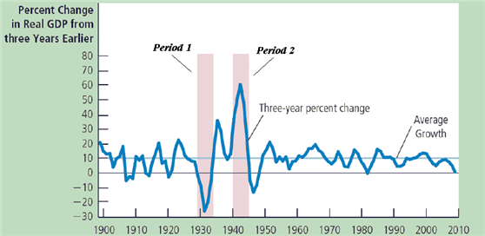
​

66. Refer to Figure 33-8. Identify periods 1 and 2.
ANSWER: | Period 1 is the Great Depression, period 2 is World War II.

67. Refer to Figure 33-8. Explain how the aggregate demand and aggregate supply model changed during periods 1 and 2.
ANSWER: | The aggregate-demand curve declined during period 1, and increased during period 2.

68. What curve shows the quantity of goods and services that households, firms, the government, and customers abroad want to buy at each price level?
ANSWER: | The aggregate demand curve

69. What curve shows the quantity of goods and services that firms choose to produce and sell at each price level?
ANSWER: | The aggregate supply curve

70. List the three reasons for why the aggregate-demand curve slopes downward.
ANSWER: | The wealth effect, the interest-rate effect, and the exchange-rate effect.

71. The wealth effect helps explain what feature in the aggregate demand and aggregate supply model?
ANSWER: | why the aggregate-demand curve slopes downward

72. The exchange-rate effect helps explain what feature in the aggregate demand and aggregate supply model?
ANSWER: | why the aggregate-demand curve slopes downward

73. Suppose a boom in stock market prices helps make people feel wealthier. Using the model of aggregate demand and aggregate supply, identify the curves that are affected, and which way these curves would shift.
ANSWER: | The aggregate demand curve would shift to the right.

74. Suppose the government raises taxes. Which curves in the aggregate demand and aggregate supply model would be affected, and which way would they shift?
ANSWER: | The aggregate demand curve would shift left.

75. Suppose speculators lost confidence in foreign economies and bought more U.S. bonds. How would this affect net exports in the U.S., and which way would this cause the aggregate demand curve to shift?
ANSWER: | Net exports would fall and the aggregate demand curve would shift to the left.

76. Suppose a recession overseas reduces a country’s exports. Which curve(s) in the aggregate demand and aggregate supply model would be affected, and which way would it (they) shift?
ANSWER: | The aggregate-demand curve would shift to the left.

77. Suppose a country offers a new investment tax credit. Which curve(s) in the aggregate demand and aggregate supply model would be affected, and which way would it (they) shift?
ANSWER: | The aggregate-demand curve would shift to the right.

78. Suppose technology advances within a nation. Which curves in the aggregate demand and aggregate supply model would be affected, and which way would they shift?
ANSWER: | The short run and long run aggregate supply curves shift to the right

79. Suppose a nation experiences increased immigration from abroad. Which curves in the aggregate demand and aggregate supply model would be affected, and which way would they shift?
ANSWER: | The short run and long run aggregate supply curves would shift to the right

80. List the three alternative explanations for the upward slope of the short run aggregate supply curve.
ANSWER: | Sticky wages, sticky prices, and misperceptions about relative prices

81. The sticky-price theory helps explain what feature of the aggregate demand and aggregate supply model?
ANSWER: | why the short run aggregate-supply curve slopes upward

82. Misperceptions theory helps explain what feature of the aggregate demand and aggregate supply model?
ANSWER: | why the short run aggregate-supply curve slopes upward

83. Identify the variables that could cause shifts in both the short-run and long-run aggregate-supply curves.
ANSWER: | labor, capital, natural resources, and technology

84. Explain how a change in the expected price level would shift the short-run and long-run aggregate-supply curves.
ANSWER: | Expected price level changes would shift the short-run aggregate-supply curve, but would not shift the long-run aggregate-supply curve.

85. Suppose a country experiences an increase in its capital stock. Which curve(s) in the aggregate demand and aggregate supply model would be affected, and which way would it (they) shift?
ANSWER: | The short-run and long-run aggregate-supply curves would shift to the right.

86. Suppose a country experiences a change in weather patterns that makes farming more difficult. Which curve(s) in the aggregate demand and aggregate supply model would be affected, and which way would it (they) shift?
ANSWER: | The short-run and long-run aggregate-supply curves would shift to the right.

87. Suppose people anticipate an increase in the expected price level. Which curve(s) in the aggregate demand and aggregate supply model would be affected, and which way would it (they) shift?
ANSWER: | The short-run aggregate-supply curve would shift to the left.

88. A decrease in what variable will raise the quantity of goods and services supplied, and shift only the short run aggregate supply curve to the right?
ANSWER: | The expected price level

89. Other things the same, what happens to the price level and the quantity of output when the short run aggregate supply curve shifts to the right?
ANSWER: | The price level decreases and output increases

90. Changes in what four variables will shift the long run aggregate supply curve?
ANSWER: | Labor, capital, natural resources and technological knowledge

91. Suppose the expected price level increases. Which curves in the aggregate demand and aggregate supply model would be affected, and which way would they shift?
ANSWER: | The short run aggregate supply curve shifts to the left

92. Write the mathematical expression that summarizes the three alternative explanations for the upward slope of the short run aggregate supply curve.
ANSWER: | Quantity of output supplied = natural rate of output + a(actual price level - expected price level)

93. A recession with inflation is know by what term?
ANSWER: | stagflation

Figure 33-9
​
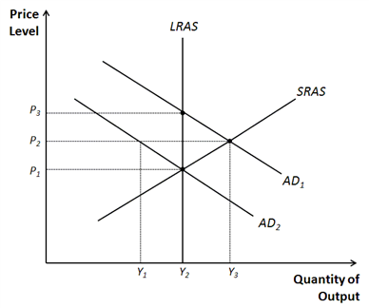
​

94. Refer to Figure 33-9. Identify the price and output levels consistent with long-run equilibrium.
ANSWER: | P₁ and Y₂

Figure 33-10
​
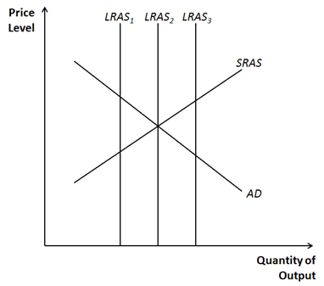
​

95. Refer to Figure 33-10. Identify which long run aggregate-supply curve(s) would be consistent with long-run equilibrium.
ANSWER: | LRAS₂

96. Other things the same, what happens in the short run to the price level and quantity of output when the aggregate demand curve shifts to the left?
ANSWER: | The price level decreases and output decreases.

97. Other things the same, what happens in the long run to the price level and quantity of output after a contraction in aggregate demand?
ANSWER: | The price level decreases and output is unchanged (returns to its natural rate).

98. Other things the same, what happens to the price level and quantity of output when an adverse shift in the short run aggregate supply curve occurs?
ANSWER: | Price level increases and output decreases

99. Explain the short-run effects on output and the price level from a decrease in the aggregate-demand curve.
ANSWER: | The price level and output both decrease.

Figure 33-11
​
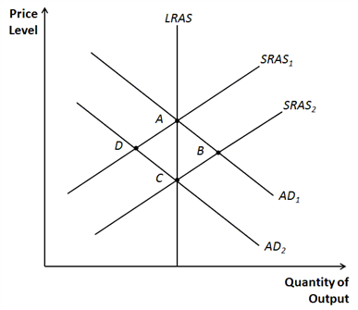
​

100. Refer to Figure 33-11. Suppose the economy begins at point A. Decreases in what four variables could result in a movement to point D?
ANSWER: | consumption, investment, government purchases, and net exports

Figure 33-12
​
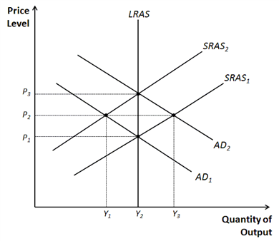
​

101. Refer to Figure 33-12. Suppose the economy starts at P₃ and Y₂. If there is a decrease in government purchases, identify the price and output levels that the economy would move to in the short run.
ANSWER: | P₂ and Y₁

Figure 33-13
​
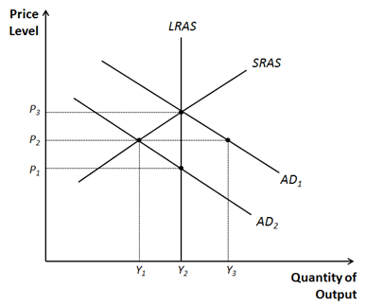
​

102. Refer to Figure 33-13. Suppose the economy starts at P₃ and Y₂. Explain how government purchases would need to change to move the economy to P₂ and Y₁. What about taxes?
ANSWER: | decrease in government purchases, increase in taxes

103. Using the aggregate demand and aggregate supply model, a decrease of what curve is by itself consistent with the changes in prices and output that occurred during the onset of the Great Depression?
ANSWER: | Aggregate demand

104. Using the aggregate demand and aggregate supply model, an increase in what curve is by itself consistent with the changes in prices and output that occurred during World War II?
ANSWER: | Aggregate demand

105. In the aggregate demand and aggregate supply model, the point where the aggregate demand curve crosses the long run aggregate supply curve, and the expected price level equals the actual price level, is known as what?
ANSWER: | Long run equilibrium

106. Explain the effect on output and price level from an increase in the short-run aggregate-supply curve.
ANSWER: | The price level would fall, output would increase.

107. During periods of stagflation, what happens to output and prices in the economy?
ANSWER: | Output falls and prices increase

108. Compare changes in the price level for a recession resulting from a shift in aggregate demand to that of a recession resulting from a shift in short run aggregate supply.
ANSWER: | the price level decreases when aggregate demand shifts, but increases when short run aggregate supply shifts

109. Who is credited for the original development of the model of aggregate demand and aggregate supply?
ANSWER: | John Maynard Keynes

110. Who wrote the 1936 book titled The General Theory of Employment, Interest, and Money?
ANSWER: | John Maynard Keynes

111. Who said about classical economic theory: “the long run is a misleading guide to current affairs. In the long run we are all dead”?
ANSWER: | John Maynard Keynes

112. The long-run trend in real GDP is upward. How is this possible given business cycles? What explains the upward trend?
ANSWER: | There are occasional short-lived periods of negative real GDP growth. However, in most years real GDP increases. The years of increase are more frequent and the increases large enough that over long periods of time real GDP increases despite the occasional declines. The long-run upward trend in real GDP is due to increases in the labor force and capital stock and advances in technological knowledge.

113. What variables besides real GDP tend to decline during recessions? Given the definition of real GDP, argue that declines in these variables are to be expected.
ANSWER: | Variables that fall along with real GDP include employment, incomes, investment, sales, and home purchases. GDP may be measured as either the production of, expenditures on, or income generated from final goods and services. It follows that any other variable that could be used to measure production, expenditures, or income will generally move in the same direction as GDP.

114. What do most economists believe concerning the relation between the price level and real output?
ANSWER: | Most economists believe that in the long run, real variables are not affected by nominal variables. So, for example, changes in the money supply do not change real variables in the long run. However, most economists believe that nominal variables do change real variables in the short run. In the short-run prices and wages may be fixed based on the expected price level. If the actual price level differs from the expected price level, real variables are affected.

115. Make a list of expenditures whose sum equals GDP.
ANSWER: | consumption, investment, government expenditures, and net exports.

116. Explain how an increase in the price level changes interest rates. How does this change in interest rates lead to changes in investment and net exports?
ANSWER: | When the price level increases, the purchasing power of money held on hand and in bank accounts declines. This decline makes people feel less wealthy so that they lend less. The reduction in lending causes the interest rate to rise. The rise in interest rates discourages spending on investment goods so that the aggregate quantity of goods and services demanded decreases. As the interest rate increases, the supply of dollars in the market for foreign-currency exchange falls as people wish to purchase fewer foreign assets. This makes the dollar appreciate which decreases net exports.

117. Make a list of things that would shift the aggregate demand curve to the right.
ANSWER: | Examples (and variations on examples) in the text include a stock market boom that increases consumption spending, a tax cut that increases consumption, improvements in capital goods such as computers that increase investment, increased optimism about the future of the economy induces increased investment, an investment tax credit, an increase in the money supply, an increase in government defense expenditures, and economic expansions overseas that create increases in net exports.

118. Make a list of things that would shift the long-run aggregate supply curve to the right.
ANSWER: | Examples in the text (or variations) include increased immigration, a decrease in the minimum wage, less generous unemployment insurance, an increase in the capital stock, an increase in the average level of education, a discovery of new mineral deposits, advances in technology, and removal of barriers to international trade.

119. Illustrate the classical analysis of growth and inflation with aggregate demand and long-run aggregate supply curves.
ANSWER: | See graph.  ​  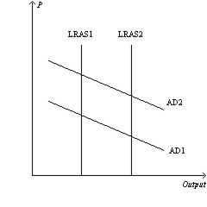  ​  Over time, technological advances cause the long-run aggregate supply curve to shift right. Increases in the money supply cause the aggregate demand curve to shift right. Output growth puts downward pressure on the price level, but money supply growth contributes to rising prices.

120. Use sticky-wage theory to explain why an increase in the expected price level shifts the aggregate supply curve.
ANSWER: | When people expect the price level to increase, wage bargaining will lead to higher wages. The increase in wages raises the costs of production. So firms will supply less at any actual price level.

121. Keynes thought that the behavior of the economy in the short run was influenced by what he called "animal spirits." By this he meant that business people sometimes felt good about the economy, and carried out lots of investment, and at other times felt bad about the economy, and so cut back on their investment spending. Explain how such fluctuations in investment would lead to fluctuations in real GDP and prices.
ANSWER: | Fluctuations in investment cause the aggregate demand curve to shift. If the aggregate demand curve shifts to the right, real GDP and the price level rise. If the aggregate demand curve shifts to the left, real GDP and the price level fall. So erratic movements in investment can cause fluctuations in output.

122. Suppose that a decrease in the demand for goods and services pushes the economy into recession. What happens to the price level? If the government does nothing, what ensures that the economy still eventually gets back to the natural rate of output?
ANSWER: | A decrease in aggregate demand causes the price level to fall. If the government takes no action to counter this, then the actual price level will be below the price level that people expected. Individuals will eventually correct their expectations about the price level. As they do so, prices and wages will adjust accordingly, shifting the aggregate supply curve to the right. For example if wages are sticky, in light of the lower price level, firms and workers will eventually make bargains for lower nominal wages. The reduction in wages lowers costs of production, so firms are willing to produce more at any given price level. Consequently, the short-run aggregate supply curve shifts right. The rightward shift in aggregate supply eventually causes output to rise back to the natural rate.

